Transgenic Plants

Describe This Technology
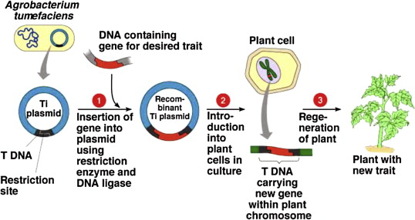
When we look at plants, they hold several traits which are both good and bad, but what if we took only the good of several plants and put it together to create a “super” plant? In a nutshell, this is what transgenic plants are. “Through the use of transgenics, one can produce plants with desired traits and even increased yields” (USHA, 2013). By usually adding one or more genes to a plant’s genetic makeup, its DNA is rewritten and thus creating a unique trait for the plant. Now there are 2 main possible methods for this process. First, there is the “Gene Gun” method. In this situation, DNA strands are attached to minimalistic particles of gold. Moving on, these particles become subjected to high-pressure guns where they are shot directly into the plant cells (USHA, 2013). This allows penetration as far as to the nucleus, where the traits are forcefully added. Although this might result in the severe or perhaps the complete destruction of the tissues, this process is deemed to be safe and effective. Now furthermore, the second method capitalizes on the fact that soil-dwelling bacteria such as the Agrobacterium tumefaciens can infect the cell of plants with its own DNA. Widely known as the Agrobacterium method, the DNA piece is then attached to a plant chromosome with a Ti plasmid. This plasmid becomes relevant because it holds sections of transfer DNA. This opens the possibility of inserting a gene that can be moved to a plant cell through a “floral dip”. This method involves the dipping of plants into a solution that contains Agrobacterium which is also carrying a specific gene integrated. The final step only requires the collection of the seeds that holds new beneficial traits. Overall, this technology is something that is not too complicated and is very beneficial to agriculture.

The Greatest Advancements/Examples
Through science being implied to the evolution of plants, many scientific achievements have been accomplished regarding transgenic plants. For example, we now have herbicide, insect, virus, and pest resistant plants. Furthermore, another major advancement is the creation of plants with multiple folds of extra nutritional value. For an example, there is the problem of the lack of vitamin A that affects many people. Through this biotechnology, this problem is being solved one step at a time with things like rice with high ratios of vitamin A. Day by day, science is allowing these types of accomplishments to be reached. With a few more years of extensive research and trial and error, I believe something much greater will be accomplished regarding transgenic plants.

How is This Form of Biotechnology Best Used?
Transgenic plants mostly revolve around one theme: getting more “bang for your buck”. Through either improving production, enhancing nutritional value, lowering maintaining cost, and making the plant more “sturdy”, it results in raising the ratio between sales and lowering cost of production. In a way, lowering production cost is the central idea that transgenic plants are best used for.

How is This Form of Biotechnology Changing the World as we Continue to Advance Towards the Future?
As we continue to advance towards the future, transgenic plants are creating more opportunities for the growth of science itself, rather than the benefits of transgenic plants itself. With the methods and ideas of creating transgenic plants, we are learning much more about the central idea of transferring preferred traits to other organisms. This opens the possibilities of moving around genes where it is immune to certain diseases or one that forces the growth of a destroyed limb within the subject of even humans. In the future, a regular shot that contains DNA/genes may just be enough to fight off something like HIV or force your own DNA to be “overwritten” and allow your body to regrow certain parts of your body that would be otherwise impossible (ex. a finger). In conclusion, as we learn more about the biotechnology of transgenic plants, it creates more opportunities of advancement to different and more impactful fields of science.

Reference/Citation
Akdemir, Hülya, et al. “Recent Advances in Fruit Species Transformation.” Recent Advances in Fruit Species Transformation | IntechOpen, InTech, 7 Mar. 2012, www.intechopen.com/books/transgenic-plants-advances-and-limitations/recent-advances-in-fruit-species-transformation.
Layton, Julia. “Can humans regrow fingers?” HowStuffWorks, HowStuffWorks, 21 Feb. 2007, health.howstuffworks.com/human-body/systems/musculoskeletal/extracellular-matrix.htm.
Transgenic plants: Types, benefits, public concerns and future. (2013, August 27). Retrieved March 11, 2018, from https://www.sciencedirect.com/science/article/pii/S0974694313003289#bib3
Genetically Modified Foods, learn.genetics.utah.edu/content/science/gmfoods/.
“Genetically modified crops.” Wikipedia, Wikimedia Foundation, 9 Mar. 2018, en.wikipedia.org/wiki/Genetically_modified_crops.

