My Dream Collage
My salary-$250,000 a year

824 Flamingo drive Lexus NX Hybrid
Qualicum Beach BC
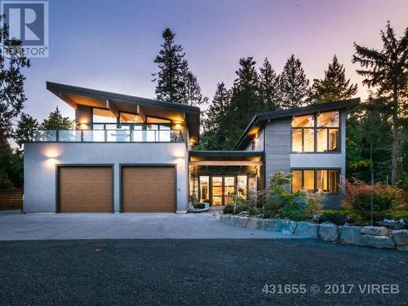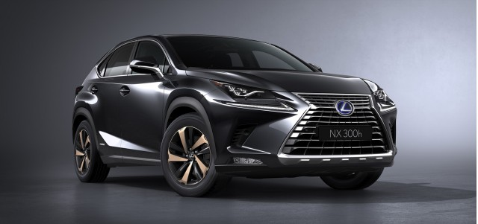
$1,550,000 $80,000
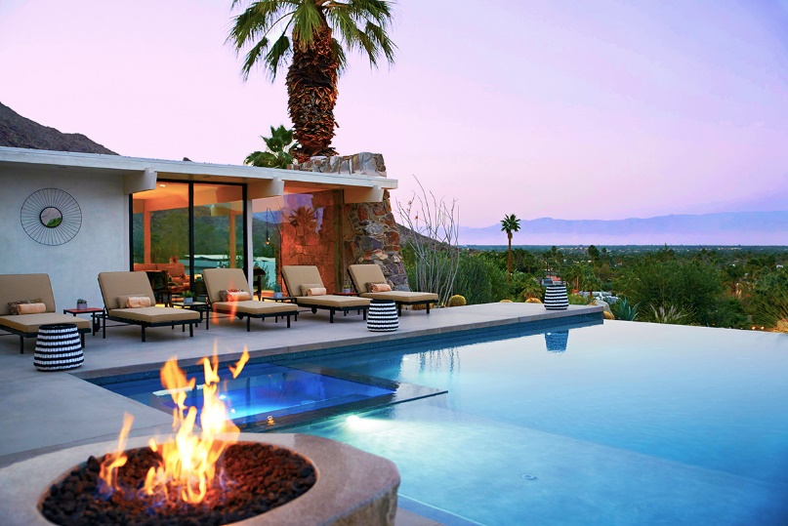
Palm springs Vacation home Chocolate Lab- $800
$600,000
My future Lifestyle
In my future lifestyle I would love to travel around the world. I would work for a set period of time to accumulate enough money while putting some money into long term savings and CPP. I would have one dog that I would keep at home and send it to a kennel when I travel. I would usually travel about 5 times a years and I would go stay in Palm springs at my Villa. I would probably want to have one kid that would cost around 20,000$ a year as a combined cost of clothes, food, sports etc.

In conclusion I believe that my life would be fulfilled but it would be hard starting off because I would need to work up a healthy liveable amount of money to afford all of my luxuries that I would like.

