Experimental Inquiry Project

How does acid rain affect plants?

Acid Rain Hypothesis
Acid rain is a natural phenomenon in our ecological system that is affected by what we are doing right now with our pollution. We produce waste and pollution from the power we use and the cars we drive. Some of this pollution that we create is turned into acid rain. It is mixed with Sulphur dioxide and rain water to be turned into acid rain. It all goes up into the atmosphere to get rained back down onto the surface and makes its way into our water cycle. My hypothesis for this project is: Acid rain will affect the growth of the plant, through being absorbed through the roots. You wont be able to notice anything on the outside of the plant, for example the leaves. I think that the acid rain will start to affect the roots and the stem of the plant then move to the outer layer because the plants drink the acid rain like water.

How will the acid rain affect the Plants?
We will use a formula for acid rain and I will make some to test on water. The formula for acid rain is: 20 ml (4 tsp) of vinegar + 2 liters (2 qt) of water= acid rain with a pH of 4.0. The issue with creating the acid rain out of vinegar is that it won’t be as corrosive as actual acid rain. If it were to get into your eyes it could burn so I need to be safe and wear eye protection. I will use a camera to document the pictures and changes in the plant with the acid rain used on it. I will use a spray bottle to apply the acid rain. The spray bottle replicates the same effect as rain meaning that I am not pouring the acid rain substitute straight onto the plant. It is a thicker mixture of chemicals so the plant will absorb the acid rain through the roots and bring it into the center of the plant before breaking down into energy.

Planning and Conducting the Experiment
I selected 2 plants that were similar in size and appearance for this experiment. I took pictures of the plants at the beginning, middle and end of the experiment to monitor any changes.
The plant with three leaves is the test. Other plant was the control.
- Sprayed plant with acid rain at 10:55 on June 7, 2017. Sprayed the control plant with water.
- Sprayed plant with acid rain at 9:40 on June 8, 2017. There is little visual change acid doesn’t seem to be affecting the plants yet
- Sprayed plant with acid rain at 3:45 on June 11, 2017.
- Sprayed plant with acid rain at 9:12 on June 12, 2017
- Sprayed plant with acid rain at 10:10 on June 13, 2017

Acid Rain Chart development

Day 1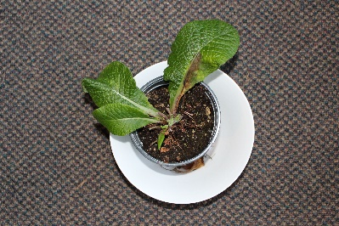 Day 2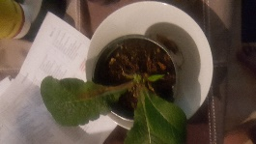 Day 3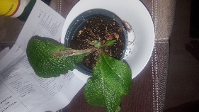

Day 4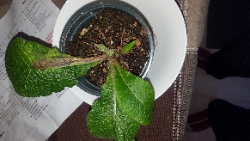 Day 5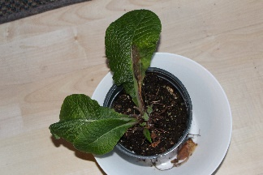
There was little noticeable plant development after watering the plant with the acid rain for four days. We increased the potency of the acid rain on day 3 to see if that would create any changes. We started to notice a brown spot grow larger on the plant after we kept watering it for three days with the acid rain. This development is inclusive. More testing is required.

First people’s principles of learning
In our day to day lives we don’t see many examples of acid rain in our ecosystem but scientists know its there. We are the main producers of acid rain with our cars and our industrial coal power plants. Acid rain is caused by our Co emission. Co is not that acidic by itself but when it is released into our atmosphere, the Co bonds with the Sulfur molecules that occur naturally in nature and reacts in the clouds to create an acid with a potency of about 3.0ph, which has been shown to affect plants.

