
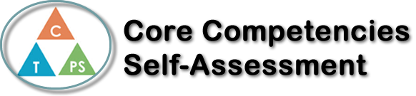
Name: Odett Maris | Date: October 18th 2017

  How does the artifact you selected demonstrate strengths & growth in the communication competency?  In what ways might you further develop your communication competency? | Self-Reflection  Describe how the artifact you selected shows your strengths & growth in specific core competencies. The prompt questions on the left - or other self-assessment activities you may have done - may guide your reflection process.  I chose my political inquiry project to improve Canada because it is the one I am most proud of and worked the most on. It demonstrates strengths and growth because I had to develop ideas of how to make Canada's education on politics better, then I had to trouble shoot any obstacles or cons for the alternate options that I chose. I had to think critically to select the very best options. I would like to further develop my thinking competencies by doing more research on projects and working towards a successful project that will not only satisfy me but also the teachers criteria.


How does the artifact you selected demonstrate strengths & growth in the thinking competencies?

In what ways might you further develop your thinking competencies?


How does the artifact you selected demonstrate strengths & growth in the personal & social competencies?

In what ways might you further develop your personal & social competencies?

Publish Your Self Assessment
You will now attach and/or embed your self-assessment to the bottom of the blog post with the artifact you have chosen. You may choose to make this post private or public. After placing your artifact on a blog post, follow the instructions below.
- Categories - Self-Assessment
- Tags - Now tag your post using the tag that corresponds to the competency that you have written about. You can choose more than one. Please use lower case letters and be exact.
  - #creativethinkingcc
  - #communicationcc
  - #criticalthinkingcc
  - #socialresponsibilitycc
  - #personalidentitycc
  - #personalawarenesscc
- Use the Add Document button located at the top of your post page and embed your self-assessment at the bottom of your blog post.
- Publish

