What Darwin never knew video blog post
Darwins theory of when there is “variation within each species” can relate back to a sequence of DNA. Every single gene in humans are the same, but the small difference of 2 or 3 bases can make a human or a completely different organism. Mutations is what creates specific traits for organisms some for the better and some for the worse. One of Darwin’s theories is that “some traits are more favourable for survival than others” that shows he knew something in their DNA was causing these favourable traits.
One of Darwin’s most obvious theory, “there is variation within each species” relates to DNA as in each strand is the same but small differences in nitrogenous bases (A, T, G, C) create variation. We know from the video that “switches” are pieces of DNA that can turn genes on or off that ultimately creates life forms, but they evolve to become completely different organisms. These switches relate to DNA genes and genomes and how small differences can change the shape and function of a protein leading to different structures of muscles and tissues that create variation between each species. This discovery in my opinion was one the most significant piece of information from the video since it provides a big step in how we are all different from one another.
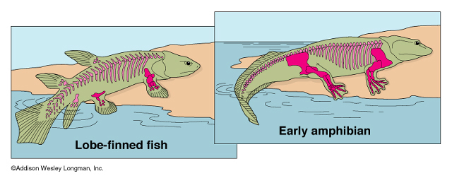
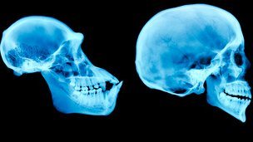
Mutations were another discovery in DNA that effected the base sequence and created specific traits that give organisms advantages, disadvantages or neutral mutations. Darwin predicted that “some traits are more favourable for survival than others” which connects with mutations. At the middle-end of the video scientists explain the difference between humans and chimps and found that the difference in our DNA was 99%. They also talked about their head shape and how our skulls are much bigger than chimps. They discovered a mutation in the jaw muscle caused their skull to stop expanding as they matured creating less space for their brain. This mutation helped humans have a more favourable trait of a bigger brain that gave us an enormous advantage for survival.
I think the way we think about evolution today is how monkey became man or how a gilled fish became a territory animal. Darwin’s theories gave a new understanding of evolution that allowed scientists today to move forward with the study of evolution. For example, Darwin’s study with the Galapagos finches and how their beaks changed based on their diet might have assisted in the prediction of how fish ended up evolving into land creatures and substituting their gills for limbs.
Without Darwin’s help I believe the study of evolution wouldn’t be as relevant as it is today. His theory struck a new beginning for evolution and a better understanding of living organisms of how they evolved to become what they are today. I do wonder why are humans capable to speak multiple languages while all other animals aren’t, was it a mutation? Did a switch turn off a vital gene for speech?

Sources:
Himme, Ben. “APE VS. HOMININ SKULLS.” BIOCHEMISTRY / PHOTOSYNTHESIS -STAGES - Pathwayz, www.pathwayz.org/Tree/Plain/APE+VS.+HOMININ+SKULLS.
“Trends in Chordate Evolution.” Protists, www.bio.utexas.edu/faculty/sjasper/Bio213/chordates.html.
In-text Citation

