Week 1 of Precalc 11

The first week of Precalc 11 went by fast. We started to learn arithmetic sequences and how to use formulas to solve different types of problems. The most challenging part was using given formulas and manipulating them to solve different questions. It’s important to really understand the problem and how you can use the formulas to find the solution. I realised that algebra plays a very important role in this unit. The arithmetic series formula helped me determine the common difference using two given terms.
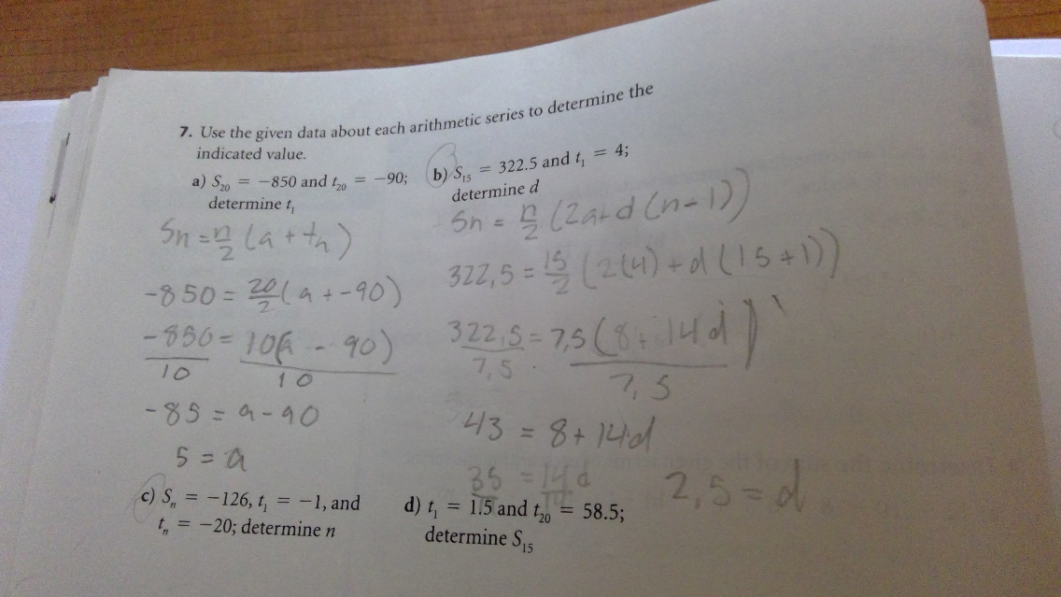
The question to the left demonstrates how to use the Arithmetic series formula and two terms to determine the common difference which was a difficult question.

