Nanoarchaeum equitans :

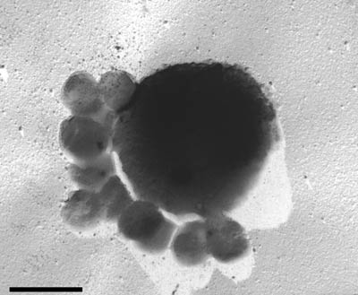Nanoarchaeum Equitans is a species of marine archaea that was found in 2002 by Karl Stetter. It is known to be one of the smallest living organisms with a measure of 400nm in diameter.

Reinert , Birgit. “Nanoarchaeota: New Life under the Sea.” *GNN - Genome News Network*, 9 May 2002, www.genomenewsnetwork.org/articles/05_02/undersea_art.shtml.

Thaumarchaeota:

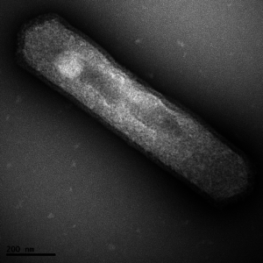

Thaumarchaeota is the most dominant archaea in the soil systems that plays a major role in the global nitrogen cycle. They can constitute up to 5% of prokaryotes. A numerous number of archaea can cause ammonia oxidation in soil.

Silgaillis, Mara. “Tag: Thaumarchaeota.” *Lacto Bacto*, Lacto Bacto Health, Microbes, and More, 30 June 2017, lactobacto.com/tag/thaumarchaeota/.

archaebacteria

new

Eubacteria

Acidobacteria :

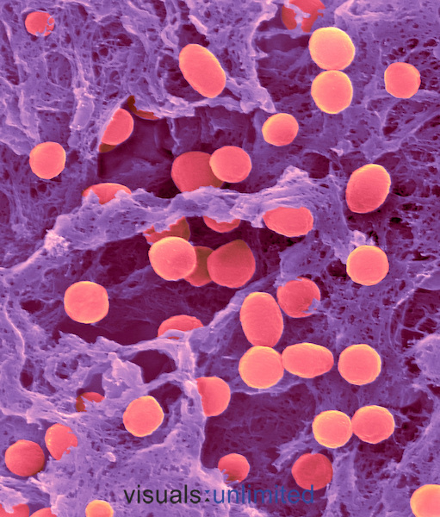

This phylym is one of the most abundant and diverse. It is most present in soil habitats. It has 26 subdivisions from all the different populations from uranium contaminated soils.

Fadzilah. “PHYLUM ACIDOBACTERIA by FADZILAH.” *ThingLink*, 2015, www.thinglink.com/scene/701779603668074496.

Aquificae:

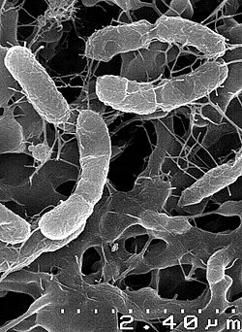

This bacteria flourishes in marine and terrestrial hydrothermal environments. They can be found in hot springs, sulfur pools and thermal ocean vents (80 to 95 degrees Celsius).

Hetzer, Adam. “Aquificae.” *Wikipedia*, Wikimedia Foundation, 11 Sept. 2018, pt.wikipedia.org/wiki/Aquificae.

In-text Citation

Sea urchin:

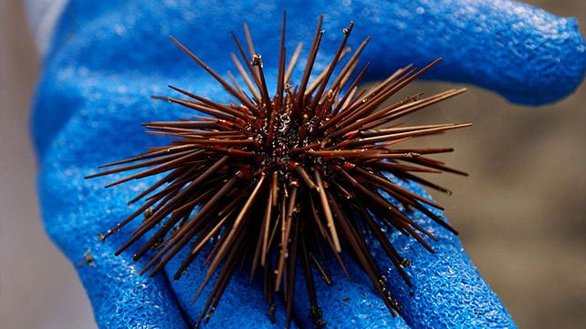

Sea urchins are spiky, globular animals that live in all depths of the sea. There are over 200 species. They are omnivorous animals that eat plant and animal matter.

Gotter, Anna. “Sea Urchin Sting: Treatment, Removal, and Long-Term Effects.” *Healthline*, Healthline Media, 29 Aug. 2017, www.healthline.com/health/sea-urchin-sting.

animalia

Ascidians:

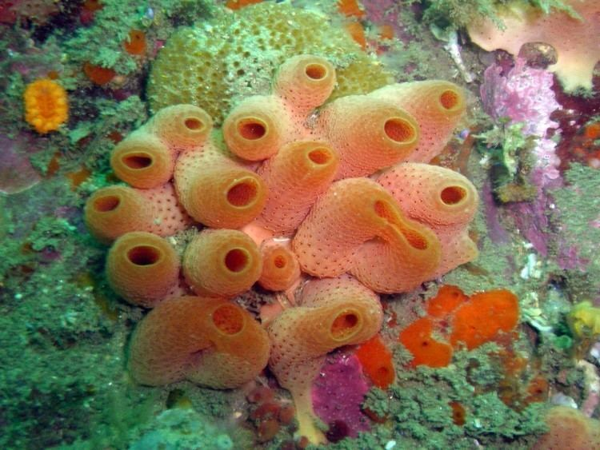

Ascidians or sea squirts are commonly found in deep sea waters. They can range from 1mm long to 10cm long. It has a one-way current through its body that can pump a hundred litres of water in 24hours.

Jaiswal, Samiksha. “Ascidiacea- Alchetron, The Free Social Encyclopedia.” *Alchetron.com*, 4 May 2018, alchetron.com/Ascidiacea.

plantae

Charophyte algae:

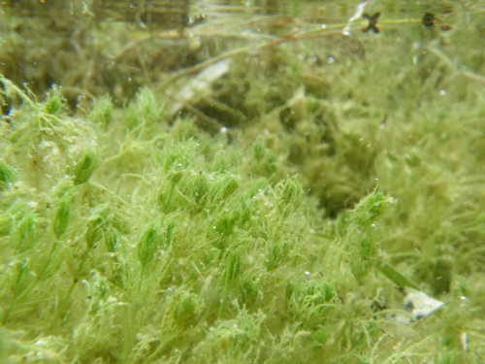

Charophyte also known as stoneworts or brittleworts is a group of freshwater green algae. Many species of them are heavily calcified. They can reproduce both asexual and sexually.

Keo, Pitter. “Friday Fellow: Common Stonewort.” *Earthling Nature*, 16 Dec. 2016, earthlingnature.wordpress.com/2016/12/16/friday-fellow-common-stonewort/.

Red algae:

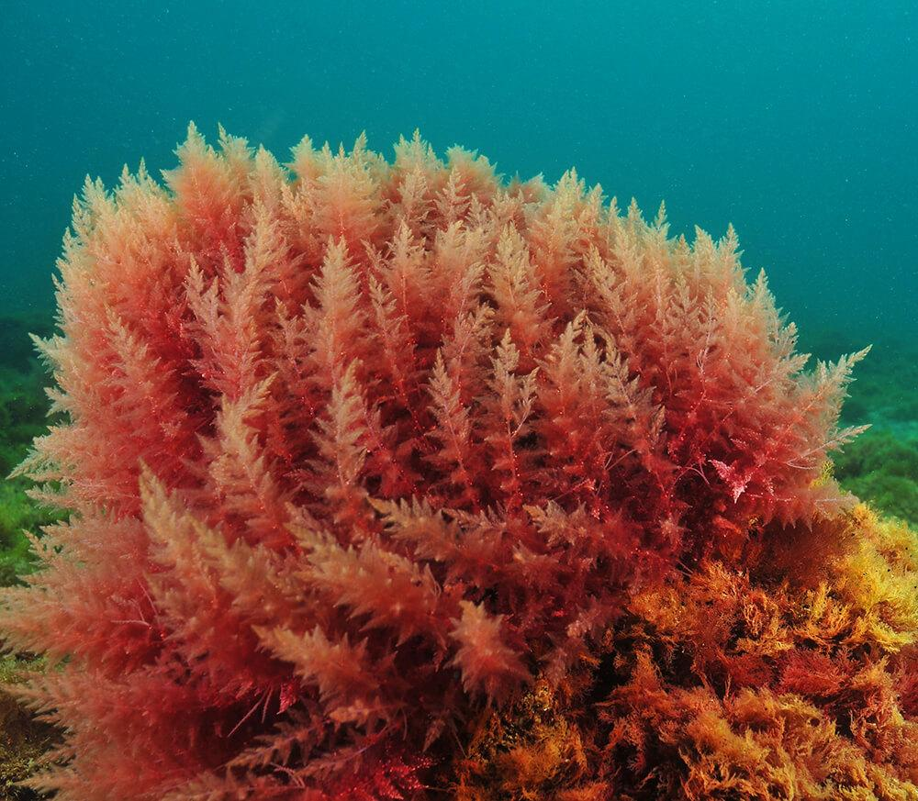

Red algae are one of the oldest groups of eukaryotic algae. They are red because the pigment phycoerythrin reflects red and absorbs blue light. This algae is still a popular source of food in Asia.

100%pure. “What Is Red Algae?” *100% PURE*, 100% PURE, 18 Dec. 2016, www.100percentpure.com/blogs/feed/what-is-red-algae.

fungi

Chytridiomycota:

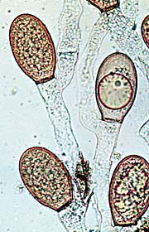

This fungus is distinguished by zoopores with a whiplash structure. They are found in wet soils or fresh water. Most are parasites that live on animals or debris and lead to diseases that infect frogs and amphibians.

Microsporidia:

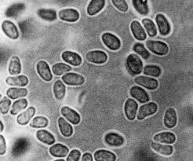

Microsporidia are unicellular organisms belonging to the phylum microspore. They have been documented to parasite humans with an infectious disease like HIV.

Melissa, Anna. “Microsporidia Infection.” *OMICS International*, OMICS International, www.omicsonline.org/france/microsporidia-infection-peer-reviewed-pdf-ppt-articles/.

protists

Radiolaria:

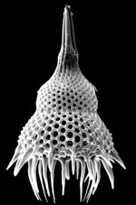

Radiolaria are holoplanktonic protozoa and form part of the zooplankton which means that they are a drifting animal and do not move. When classifying fossils, the preservable skeleton and soft part are featured which makes it difficult to classify.

Goll, Robert, and Kjell R. Bjorklund. “What Are Radiolarians?” *Radiolaria.org*, 2002, www.radiolaria.org/.

Wakame :

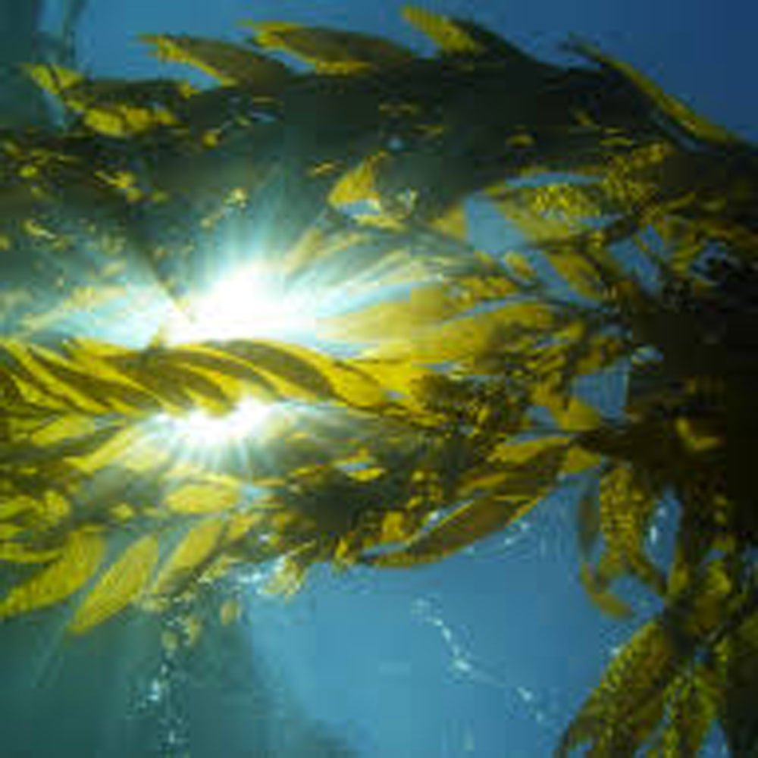

Wakame is a common ingredient used in Asian cooking. It is an economically important food crop that provides habitats, nursery areas and protection.

HealthPost. “Wakame: A Seaweed Packing a Mean, Nutritious Punch | NZ Health Article.” *HealthPost*, 7 Mar. 2018, blog.healthpost.co.nz/2014/wakame-seaweed-packing-mean-nutritious-punch/.