6 kingdoms

Archaebacteria:

Pyrolobus fumarii
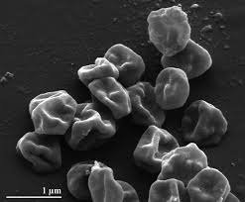
Sulfolobus solfataricus
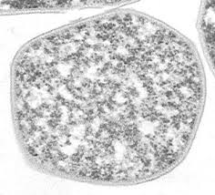

Both can live in harsh conditions.

Eubacteria:
Aquificae
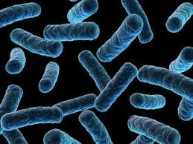
Acidobacteria
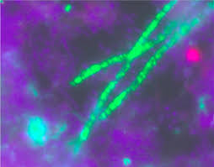

Found in a variety of environments such as: soil, hot springs, oceans, caves, and metal contaminated soils.

Protists:
Theileria parva
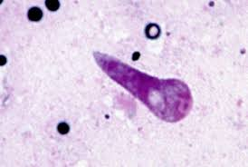
Plasmodium vivax
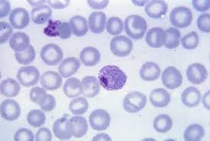

Both cause diseases.

Fungi:
Zygomycota
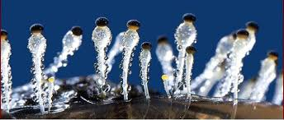
Eomycota
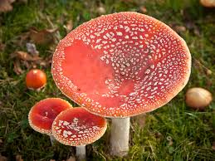

Both multicellular, and can reproduce asexually. Although Zygomycota can also reproduce sexually.

Plantae:
Vaccinium macrocarpon
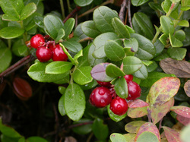

Palm trees

Both need sunlight, water minerals and nutrients to survive.

Animalia:
Varanus komodoensis
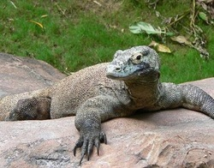
Potoo
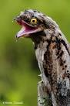

Both have organs and reproduce sexually.

