Object letter & upload picture | observation | Inference
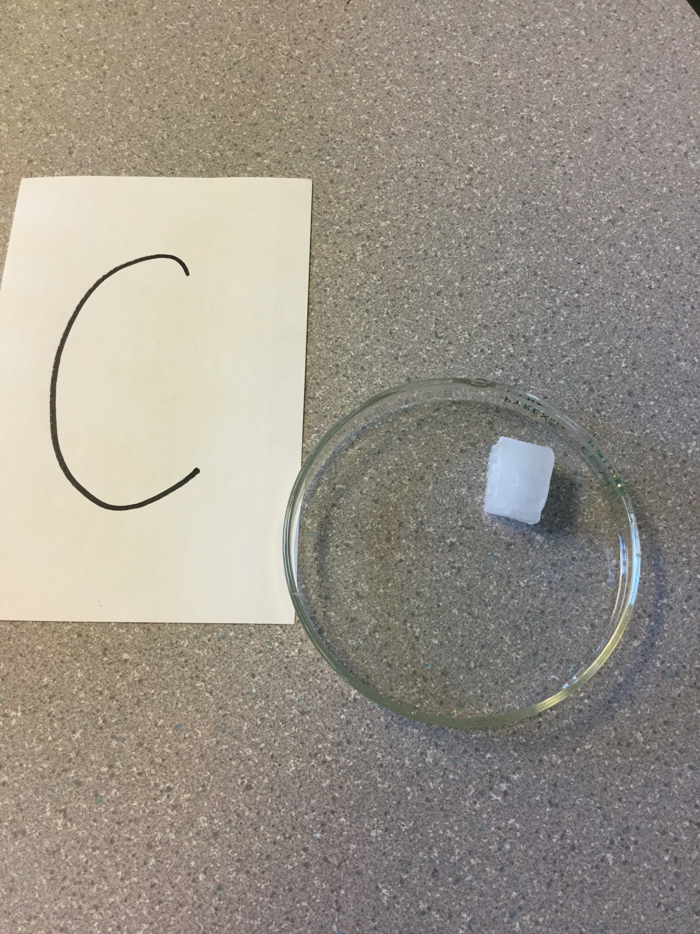 | waxy  Translucent  solid  It has no smell  Breaks easily  larger than a sugar cube  cube shape | I believe that the object is wax because of the waxy feel it leaves on my fingers.
F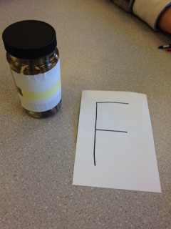 | long  Slimy  Brown grey  Smells sour/gross  feels squishy/dried up  looks like worms  in a liquid | I think that it is a worm because of how it looks and because of how long it is.
D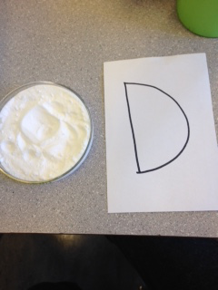 | Sticks to your finger  soft  It's white  Smells soury  Very fine | I inference that this is baking soda because of the powdery shape and the smell.
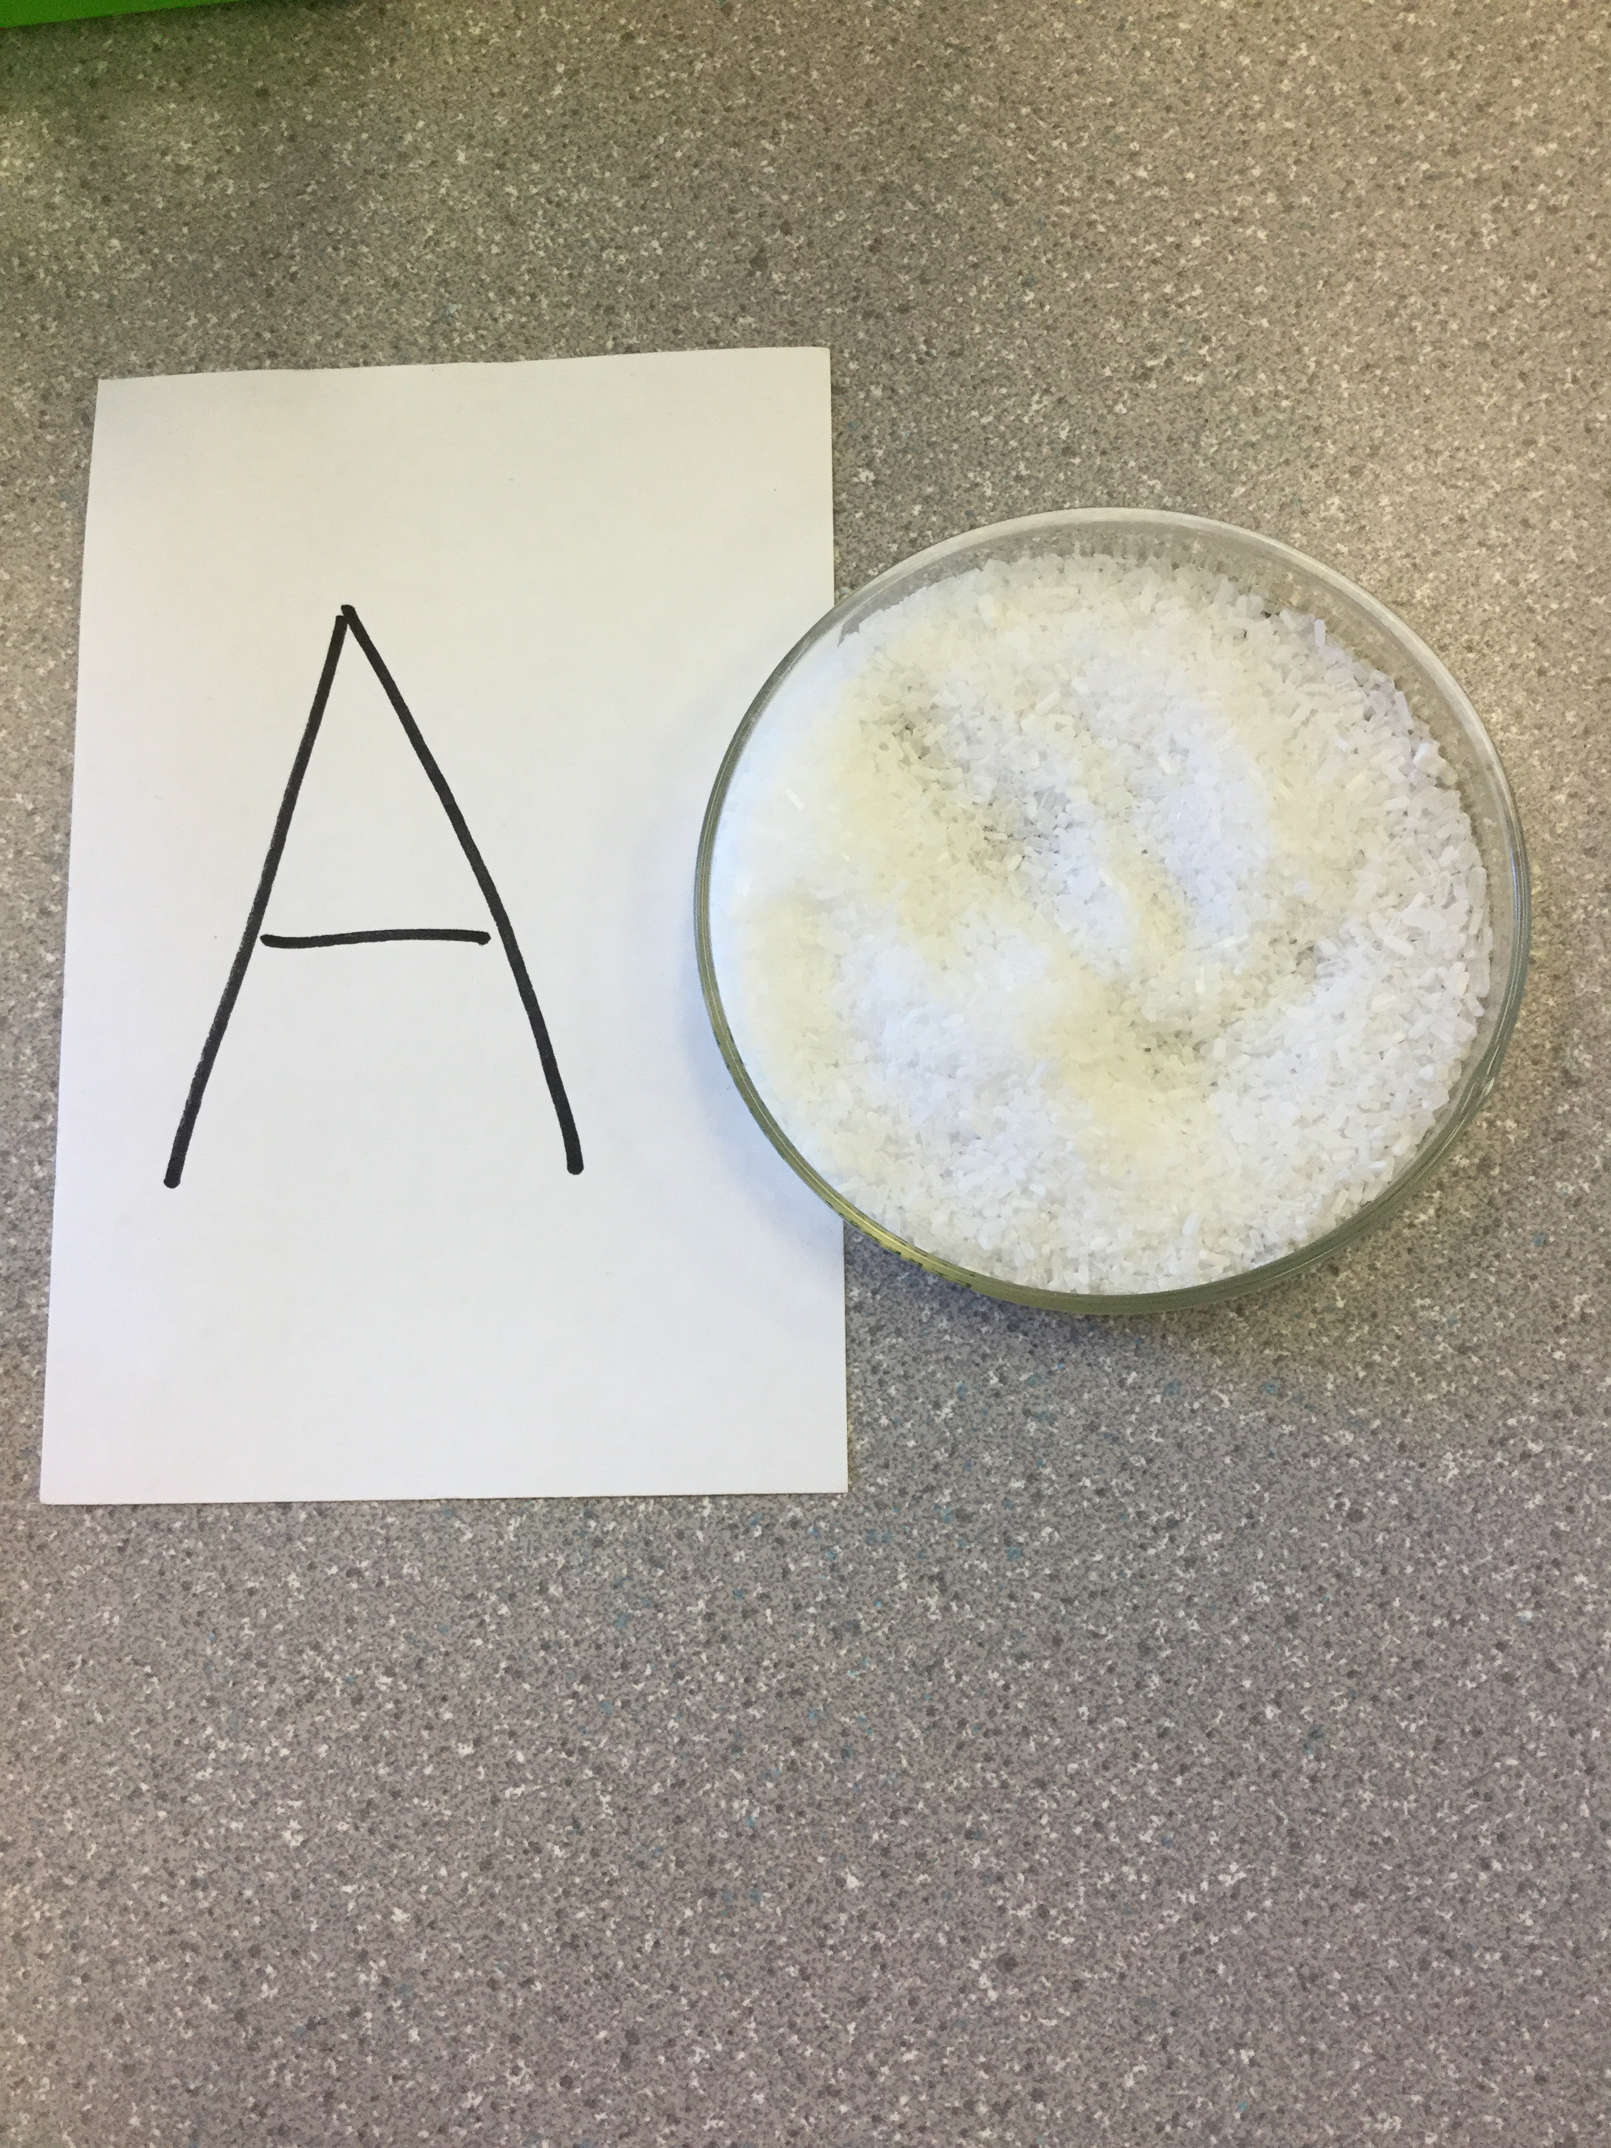 | Smells like a bath  Small pieces  It's white  Leaves a powder on your fingers | I think this is bath salts because of the smell it produces.
B 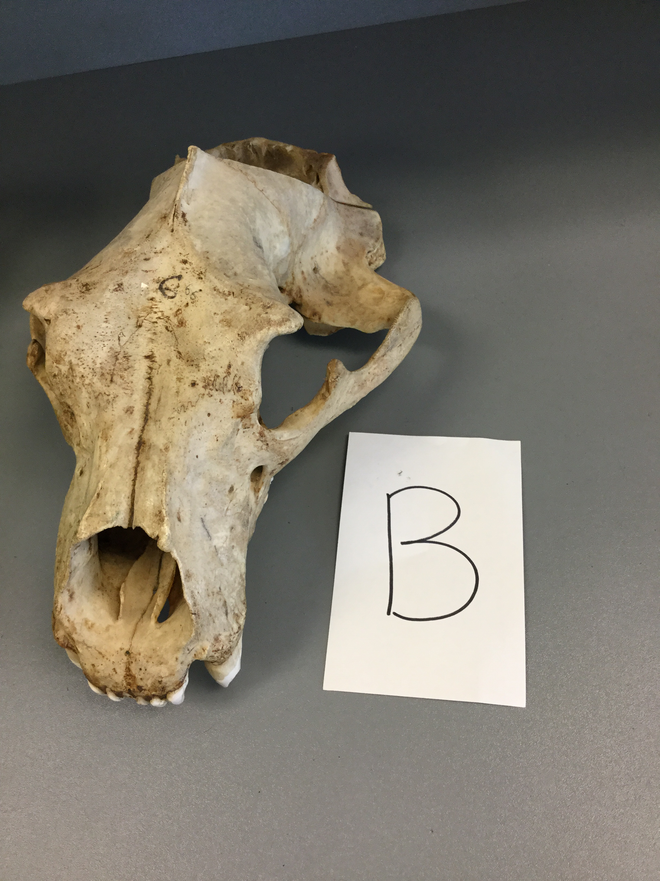 | It's an animal skull  Very big  Huge front teeth  It's the top jaw  Big eye sockets  fossil | I think it is a moose because of the shape of its head and because of the big front teeth., It’s also too small to be a bears head.

