
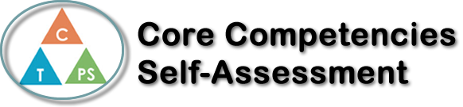
Name: Kirby Pham | Date: Monday, Janruary 15th 2018

  How does the artifact you selected demonstrate strengths & growth in the communication competency?  In what ways might you further develop your communication competency? | Self-Reflection  Describe how the artifact you selected shows your strengths & growth in specific core competencies. The prompt questions on the left - or other self-assessment activities you may have done - may guide your reflection process.  How do you show that you are listening thoughtfully?  For this project, That is when I can summarize the content I have heard with the important content  What helps you get new ideas?  In doing this project, i researched creative on Google, picuture from Printest and some idea in the book i ever read before  What are your strengths as a learner and how do you learn best?  In the future, if my English can improve well, I can understand the content and summarize it after the teacher has presented in the class. I have the ability to grasp the problem quickly. And especially observing people when I have language difficulties. With me, if we want learn well , we need to be interested in the subject and then to be hardworking, cultivate skills, improve experience in class. AND DONT GIVE UP WHEN WE MEET DIFFICULTIES.


How does the artifact you selected demonstrate strengths & growth in the thinking competencies?

In what ways might you further develop your thinking competencies?


How does the artifact you selected demonstrate strengths & growth in the personal & social competencies?

In what ways might you further develop your personal & social competencies?

Publish Your Self Assessment
You will now attach and/or embed your self-assessment to the bottom of the blog post with the artifact you have chosen. You may choose to make this post private or public. After placing your artifact on a blog post, follow the instructions below.
- Categories - Self-Assessment
- Tags - Now tag your post using the tag that corresponds to the competency that you have written about. You can choose more than one. Please use lower case letters and be exact.
  - #creativethinkingcc
  - #communicationcc
  - #criticalthinkingcc
  - #socialresponsibilitycc
  - #personalidentitycc
  - #personalawarenesscc
- Use the Add Document button located at the top of your post page and embed your self-assessment at the bottom of your blog post.
- Publish

