Pedigree Analysis: A Family Tree of Traits

PURPOSE:

To determine what certain human physical traits are inherited using pedigree analysis.

MATERIALS:

- Pedigree
- Paper

PROCEDURE:

- Make an print out a copy of family pedigree.
- On that paper identify the phenotype of each family member.
- Choose 4 human traits that you would like to trace back.
- Indicate if those four traits are dominant or recessive.
- Research which genotype would be associated with each phenotype.
- Set up four trial pedigrees.
- Attempt to indicate whom the traits were inherited from.

Input:

Physical Trait | Dominant or Recessive? | Experimenter’s phenotype | Experimenter’s  phenotype
Eye colour | Recessive | Blue eyes | mm
Hair colour | Dominant | Brown hair | M?
Dimples | Dominant | Has dimples | M?
Attached or Unattached earlobes | Dominant | Attached earlobes | mm

RESULTS:

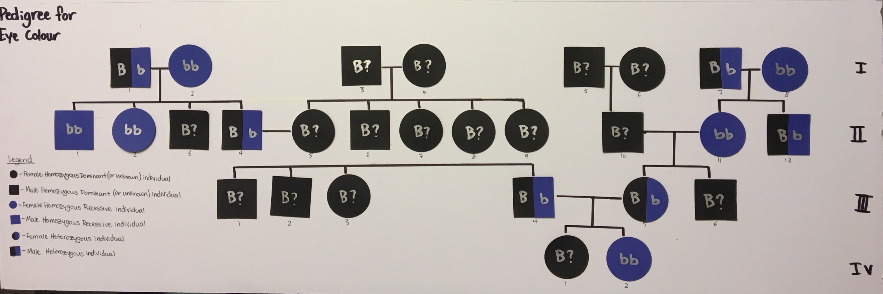

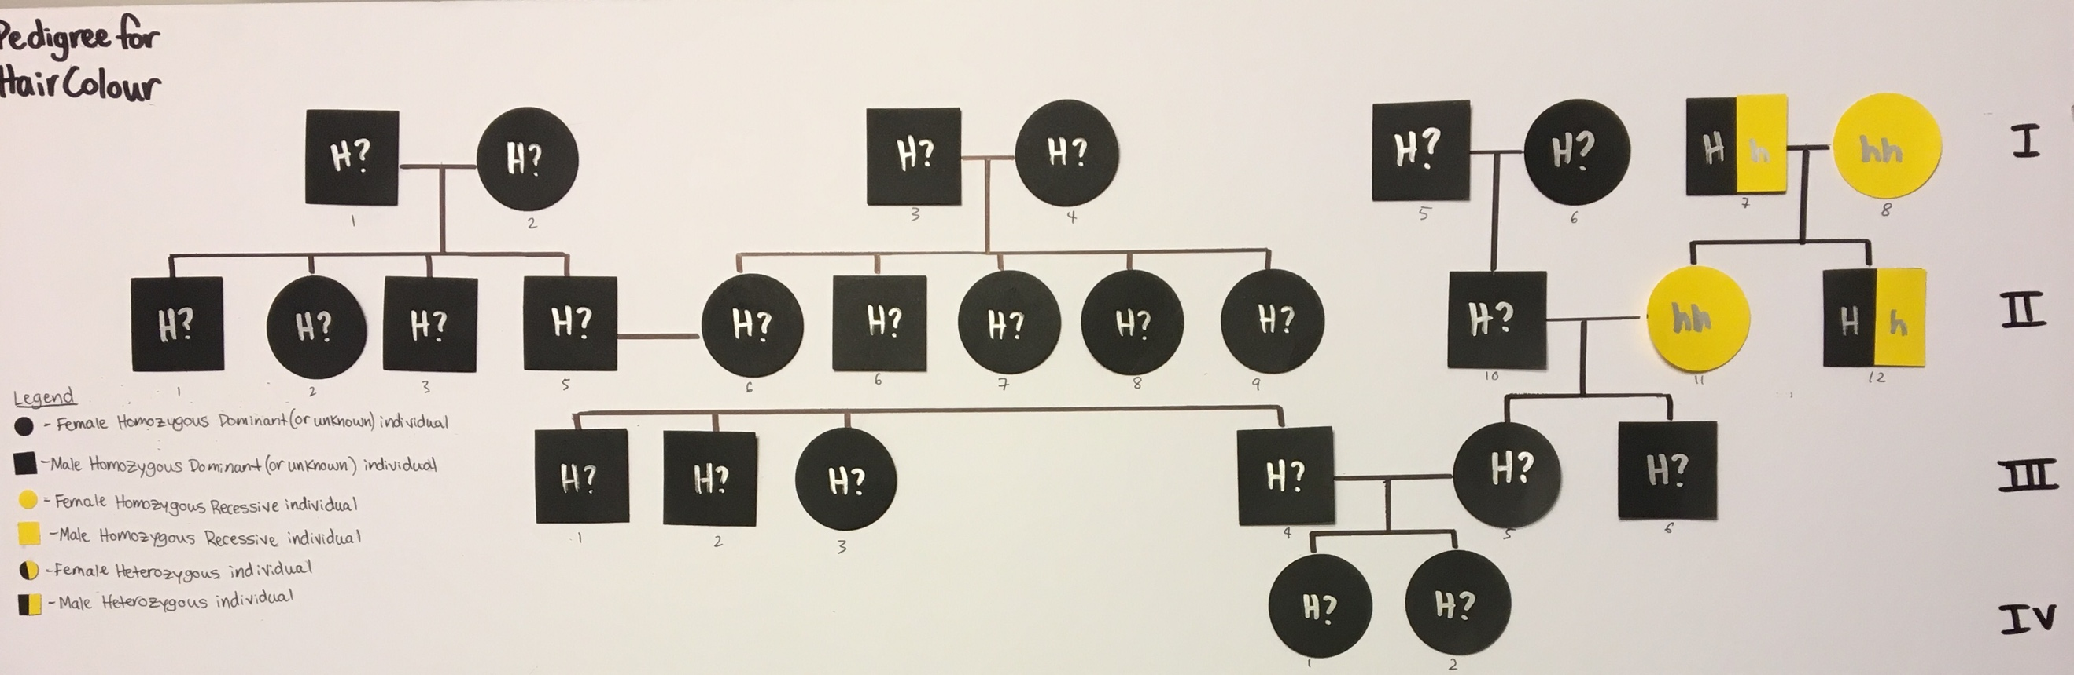

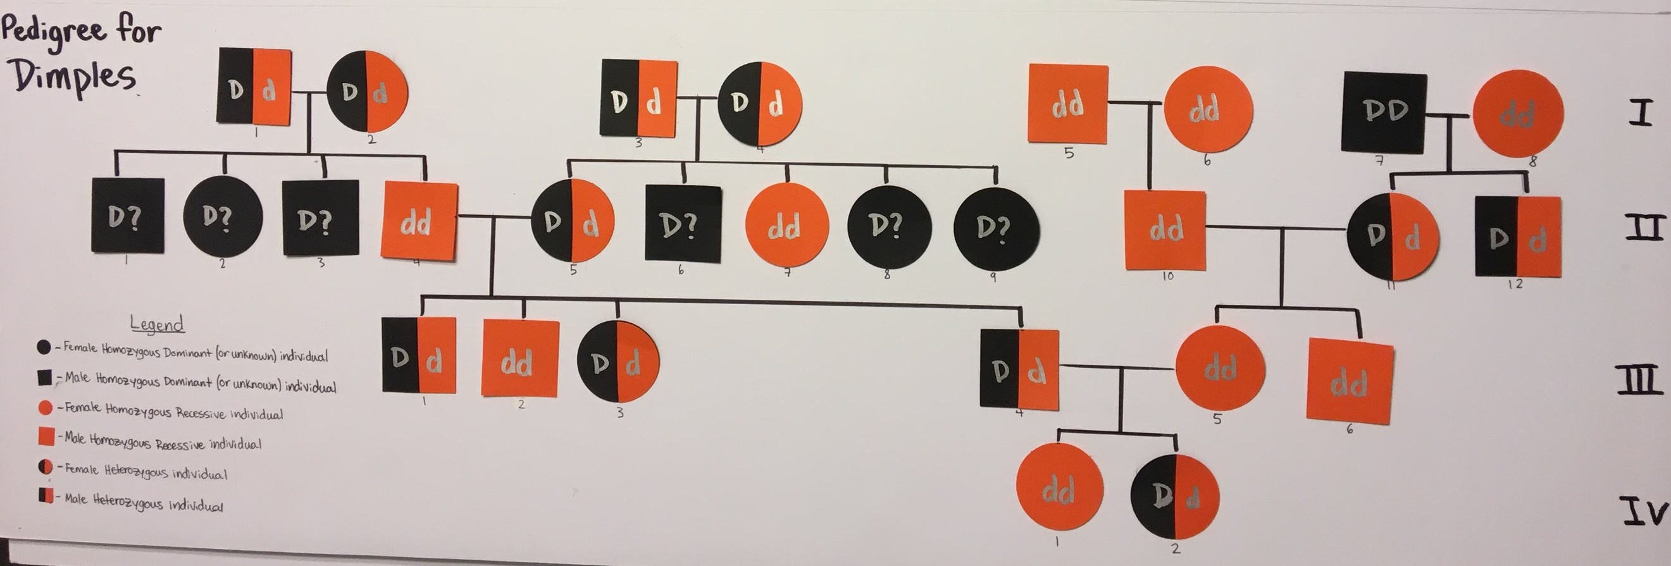

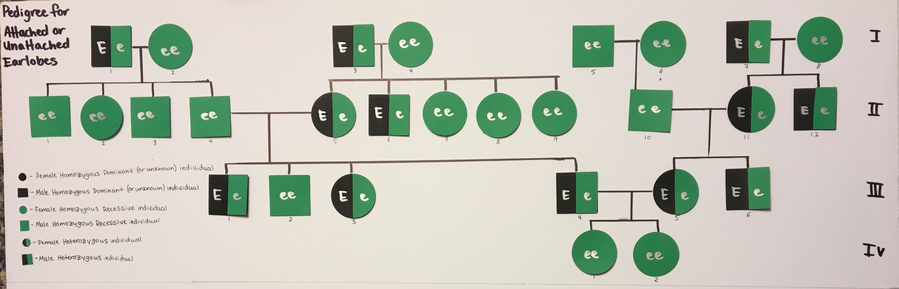
CONCLUSION:

This experiment attempted to determine the inheritance of the experimenter’s physical traits. In order to study the problem, the experimenter picked four different traits to trace back. With the help of family, relatives, and ancestry.ca the inheritance of the traits eye colour, hair colour, presence of dimples and attached or unattached earlobes were traced. The experimenter was represented as individual IV-2. Results showed in the first two trials that the majority of the traits were inherited from those who are dominant for the certain trait. In the last two trials many people had the recessive gene or were carriers of the recessive allele.

Trial one explored the inheritance of hair colour. Hair colour is determined by at least two different genes; hair colour varies depending on those genotypes. Despite this, darker hair colours like black and brown had a higher affinity then lighter colored hair due to being a homozygous dominant or heterozygous individual. A high affinity means the more likely certain gene is to be expressed. The majority of people on this pedigree had the phenotype of brown hair, a physical trait that the experimenter also gained. Although many individuals have dark hair it was almost impossible to guarantee whether or not those individuals carry both dominant alleles or one dominant and one recessive. Further investigation in family ancestry and earlier generations are required to determine this.

Trial two studied the inheritance of eye colour. Eye colour, too, is determined by several different genes but darker and lighter coloured eyes are separated as brown being dominant and colours like blue, green, hazel and grey are recessive. A great number of the people in this trial obtained brown eyes with a small number of recessive individuals, but there were many carriers of the recessive allele. Those who were recessive and had lighter coloured eyes did pass on their genes which skipped two generations onto the experimenter. The experimenter’s blue eye colour was possible due to both parents carrying the recessive allele.

Trial three studied the inheritance of attached and unattached earlobes. People who have unattached earlobes are classified as homozygous dominant and people with attached earlobes are categorized as homozygous recessive. The experimenter is a recessive individual with attached earlobes, and so is a vast majority of the family members. This trial was filled with all recessive and carrier individuals. This trait was also obtained by both of the experimenter’s parents being carriers of the recessive allele.

Trial four studied the inheritance of facial dimples. Dimples occur when a person carries the dominant allele, whether homozygous or heterozygous and those who do not have dimples are homozygous recessive. The number of people with or without dimples were fairly even although some subjects were difficult to determine as a carrier of the trait or not. It was evident that the experiment acquired dimples from the father’s side of the family.

A common challenge throughout these trials were the inconclusive genotypes of many subjects. Many genotypes could be figured out from the genotypes of the parents but several could not. Often, all that could be determined is that those people who could not be classified as a certain genotype were homozygous dominant or heterozygous. Some individual’s traits were evident due to at least one of the parents being heterozygous but it was not possible to know which of the parents it was. A lack of knowledge about additional generations affected the end result of the trials resulting in many individuals’ genotypes undetermined and therefore affected the study of inheritance. If this experiment was repeated in the future it would be crucial to have more knowledge about extended family and to go back at least six generations. This could prove to be very difficult as finding information about family traits has already proven to be very difficult partially due to their scarce number of photos and information of the older generations.

The Study of DNA:

Prior to my experiment on Pedigree analysis, I sent in an ethnicity DNA test to a website called ancestry.ca. This test would tell me my ethnic history stretching back thousands of years. Next, I did a lot of research on my family and also built a family tree to try to get a sense of where my family came from. Most of what I could make out is that my relatives on my father’s side were Scottish, Irish and English and my mother’s side of the family was Norwegian. After a very long wait, my results finally came in.

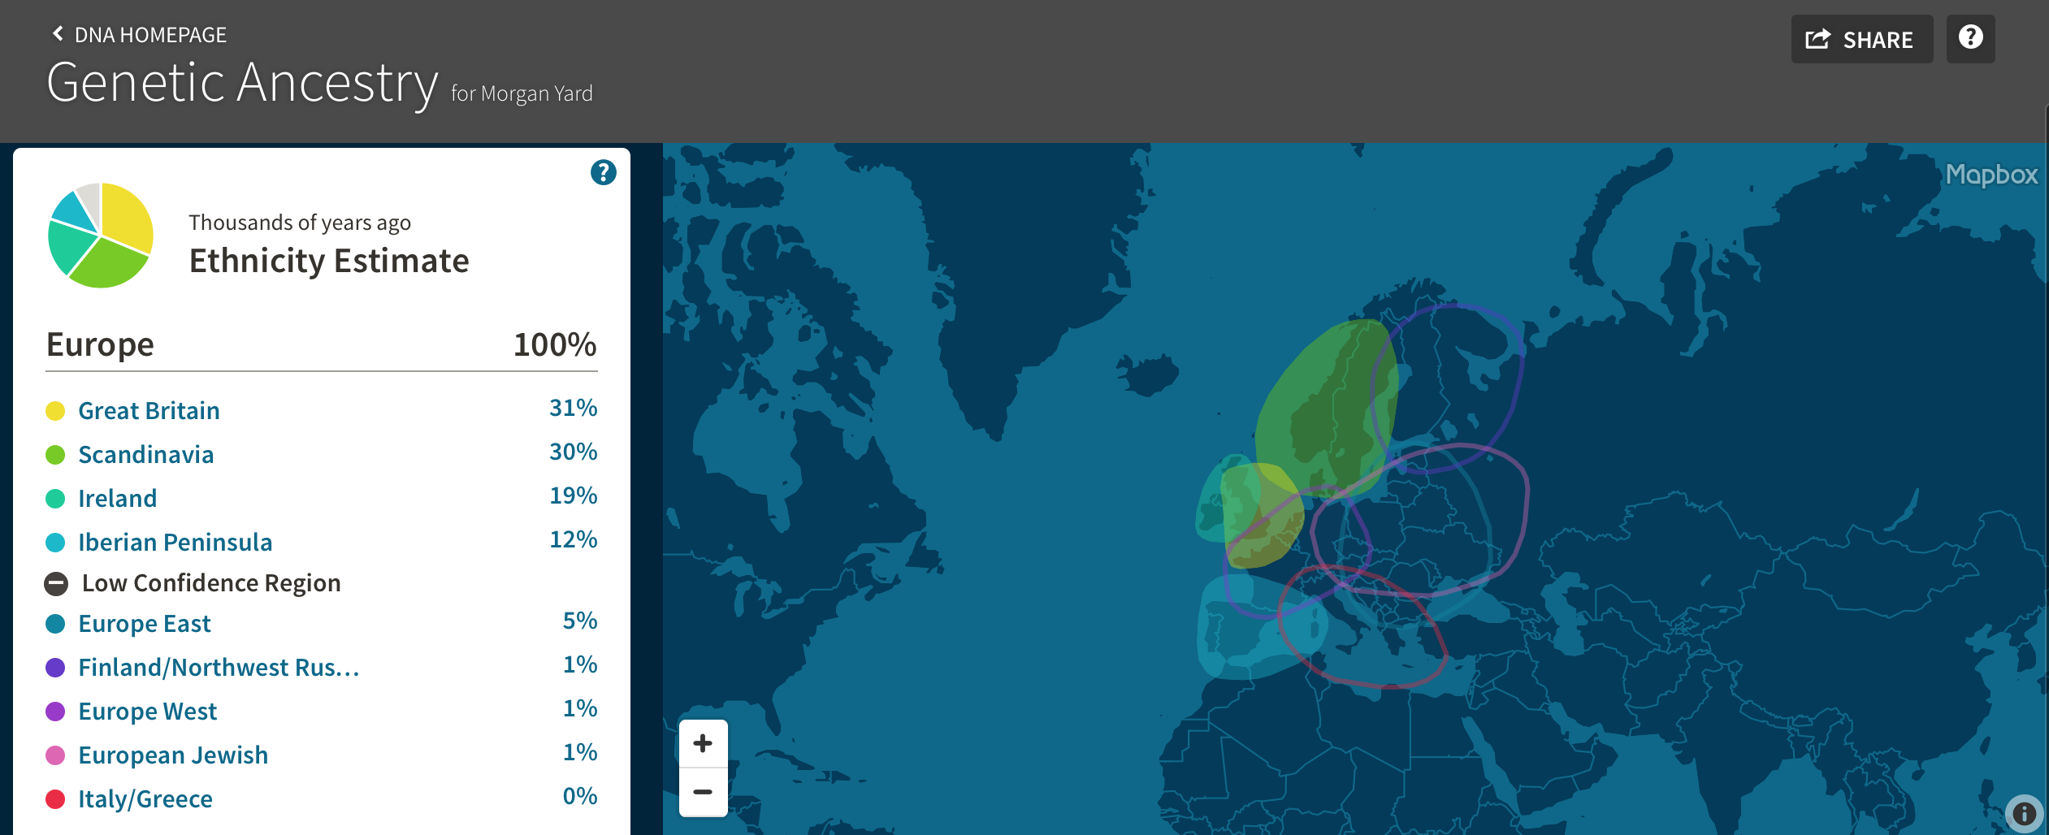

Some results were very similar to what I have researched about my background but some came as a surprise. I was not aware of my heritage coming from the Iberian Peninsula which is either Spain or Portugal. I would be very interested in finding out which relatives were from that area. After receiving my results, I decided to do some research about different areas of where I am from (in the higher confidence percentage areas) and how this could have an effect on my physical traits. I found out that Scandinavian and Scottish people are known for having blue eyes, traits that two of my great grandparents (one of my mother’s side and one on my father’s side) who were born and lived in Scotland and Norway had. It was also interesting to find out that people from Ireland were known to have black hair which occurred in some of my family members on my dad’s side of the family. I was hoping to find some information about the physical traits of people from Spain and Portugal and see if that may have matched up to my family’s traits or mine but I could not find a reliable source. The DNA test was a very fascinating experience as I have always wanted to know more about my ethnic past and family. To date, I have not done a lot of exploration into everything that came with my DNA testing but what I have seen looks very exiting! I would definitely recommend DNA testing to anyone who is also curious as to their family background.

Citations:
https://en.wikipedia.org/wiki/Nordic_race

http://european-celtichistory.weebly.com

Mastering Biology Textbook – Unit 3 (Genetics)

