
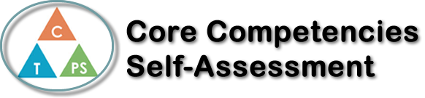
Name: morgan kosola | Date: 9/20/17

  How does the artifact you selected demonstrate strengths & growth in the communication competency?  In what ways might you further develop your communication competency? | Self-Reflection  Describe how the artifact you selected shows your strengths & growth in specific core competencies. The prompt questions on the left - or other self-assessment activities you may have done - may guide your reflection process.  We read a book called Sam the Athlete written by Stuart McLean, in the book a young boy named sam is just going into middle school and he is terrified that he will not fit in. During the first week he sees a flyer for field hockey tryouts. Sam really does want to be an athlete so he decides that he is going to try out. He makes the team but realizes that he had unfortunately joined the girls team when he is referred to as Samantha and is handed a girls skirt uniform. This doesn’t stop sam from doing what he wants to do tho, sam continues to wear his skirt and more than so enjoys it. He likes his skirt and he doesn’t care what anyone else thinks.  When we first started assignments based of the book Sam the Athlete, I didn’t really think much of Sam wearing a skirt. I didn’t really think it was a big deal until I was told to fill in a chart based on weather or not sam should continue to wear his skirt. It really made me think about how our society is so focused on the idea that certain clothing should only be worn by certain genders. Now from this I started thinking more and more into how specific stereotypes can really throw you off of your way to a happy everyday life or how they can prevent you from succeeding in a goal. After thinking about this it made it easier for me to come up with ideas on why sam should continue to wear the skirt, mainly because it makes HIM happy.


How does the artifact you selected demonstrate strengths & growth in the thinking competencies?

In what ways might you further develop your thinking competencies?


How does the artifact you selected demonstrate strengths & growth in the personal & social competencies?

In what ways might you further develop your personal & social competencies?

Publish Your Self Assessment
You will now attach and/or embed your self-assessment to the bottom of the blog post with the artifact you have chosen. You may choose to make this post private or public. After placing your artifact on a blog post, follow the instructions below.
- Categories - Self-Assessment
- Tags - Now tag your post using the tag that corresponds to the competency that you have written about. You can choose more than one. Please use lower case letters and be exact.
  - #creativethinkingcc
  - #communicationcc
  - #criticalthinkingcc
  - #socialresponsibilitycc
  - #personalidentitycc
  - #personalawarenesscc
- Use the Add Document button located at the top of your post page and embed your self-assessment at the bottom of your blog post.
- Publish

