Breakfast fried rice with bacon and egg

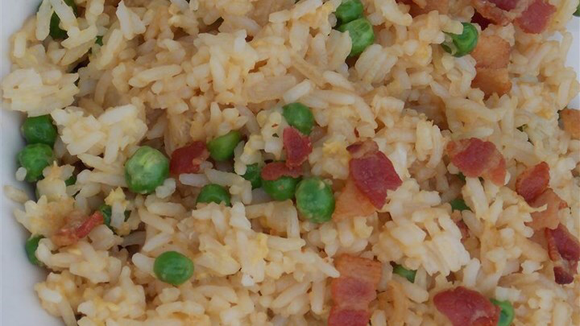
http://allrecipes.com/recipe/240520/breakfast-fried-rice/

Rich creamy mac and cheese with breadcrumbs on top

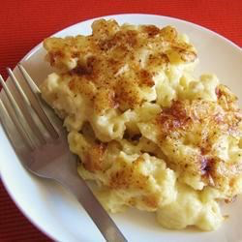
http://allrecipes.com/recipe/11679/homemade-mac-and-cheese/

Chicken ramen noodles

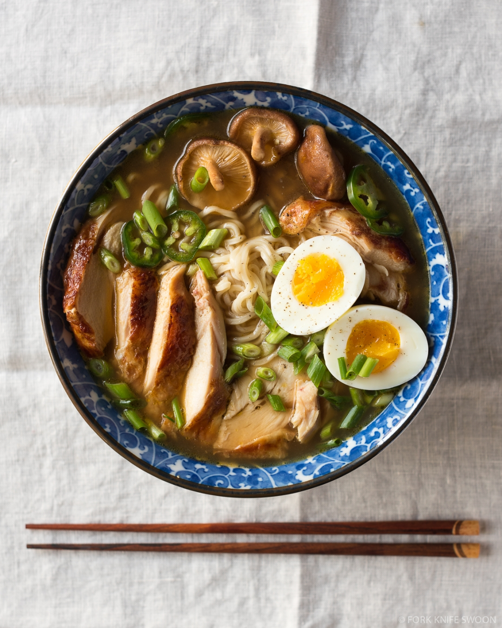
http://www.forkknifeswoon.com/simple-homemade-chamen/

http://allrecipes.com/recipe/11679/homemade-mac-and-cheese/

8oz uncooked elbow macaroni
500ml shredded sharp cheddar cheese
125ml grated Parmesan cheese
750ml milk
60ml butter
38ml flour
30ml butter
125ml bread crumbs
2ml paprika

