Mexican wolf
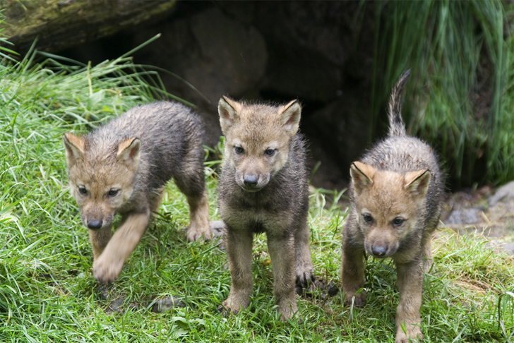
Mexican wolf inhabits North America.
Body color is yellowish brown · gray · black is mixed.

weight | 23kg~36kg(50lb~80lb)
Body length | 167cm(5.5ft)
Height to shoulder | 71cm~81cm(28in~32in)

When hunting animals Mexico wolves you are a large animal hunt with a flock. But it hunts alone when hunting small animals.

They were distributed in Arizona, New Mexico, Texas and Mexico in the past. They attacked livestock and were subject to extermination as having economic damage. They were almost extinct in the 1970s in the United States.

In the United States, the Endangered Species Act was enacted in 1973. It was designated as an endangered species in 1976.

After that, a program directed to breeding and returning to the wild at the shelter was carried out for Mexican wolves.

In 2010, 50 wild Mexican wolves have been confirmed in the wild.

