JAGUAR
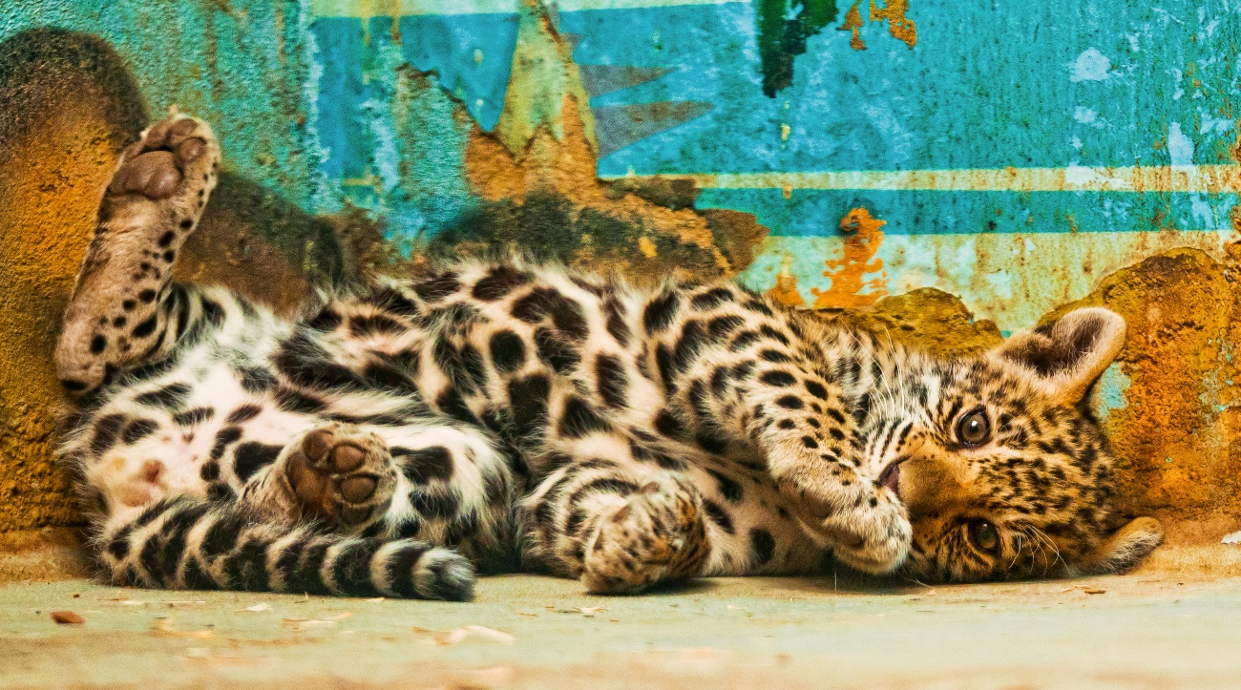

Jaguar is big cat. It is from Mexico around Central South America. The length is 120cm~180cm. weight is 60kg~130kg.
Jaguars are big next to tigers and lions in the feline family.
It origin of the name of Jaguar means to kill it by indigenous people's world.
Most of the Jaguars are nocturnally. Particularly active from the dawn at dusk.
In the South American jungle where it lives, it is reigning as a champion with no enemy
Jaguars prefer to live in waterside and swampy areas of forests at altitudes less than 1,200 m. Besides savanna and wasteland, it also appears in the desert. It lives alone except for breeding season. It goes hunting during the day and during the night as he is hungry. The prey that Jaguar captures and eats are Capybara, Sloth, Monkey, Deer, Armadillo, Crocodile, Turtle, Snake.

Jaguar and Leopard so much alike.

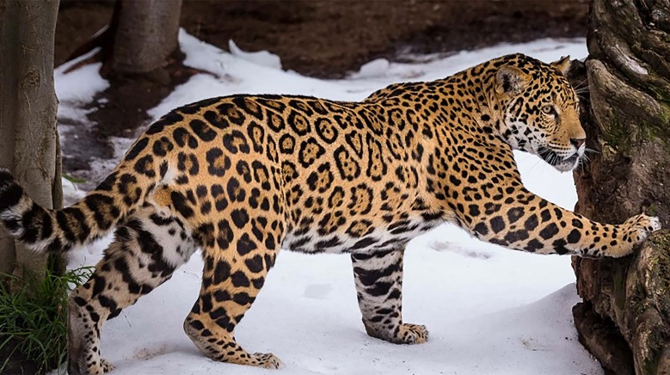
Jaguar

It legs are short and sturdy, but it is good at climbing trees and swimming like leopard.

Leopard

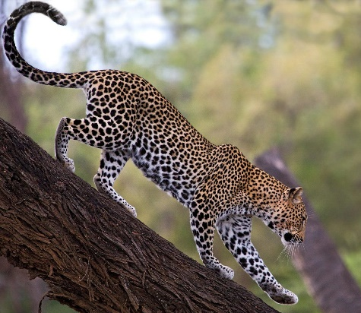
The leopard's body is smaller than Jaguar and shoulder height lower than Jaguar. It is suddenly hunting cats hitting the cat suddenly.
Compared to Jaguar, leopard has long legs and slender.

