Michael Foster, is a character from the short story “Two Fishermen” by Morley Callaghan. He is a younger man, who has a passion towards journalism, with a determination to write for a big newspaper. Michael is “a tall, long-legged, eager young fellow” (Callaghan 1), who lives by a big lake in a small town, filled with many people who he shares close relations too. By the way he is treated from others, and his job status, Michael is a middle-class man. Michael will take his own time to figure out someone. He is very determined once his mind is set towards something. For example, how he wanted to know the background behind the hangman. Michael sees the good beyond the bad, and found that in a man who hangs people for a living, who also enjoys it. He suffers a great weakness which everyone faces; the wanting to fit in. Michael found a friendship within Smitty, but when the towns people turned on him, no act of defending him came to thoughts. His fear of what others will think of him made him lie to the town saying, “He just doesn’t mean anything to me at all” (Callaghan 4). With that said, Michael is a bright man with a planned out future, who also faces internal struggles that caused a friendship to no longer exist.

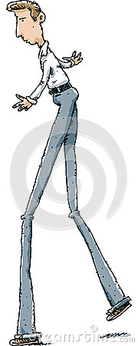

https://thumbs.dreamstime.com/x/long-legs-man-cartoon-41141485.jpg

