
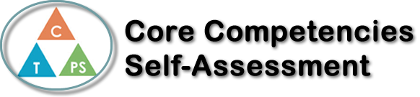
Name: Mike Pan | Date: December, 13, 2017

  ##  How does the artifact you selected demonstrate strengths & growth in the communication competency?  In what ways might you further develop your communication competency? | Self-Reflection  Describe how the artifact you selected shows your strengths & growth in specific core competencies. The prompt questions on the left - or other self-assessment activities you may have done - may guide your reflection process.  My Canadian Studies project helped me with the communication part of the core-competencies. The political platform project allowed me concentrate on listening. I was able to listen to other projects on how to improve the school here at Riverside Secondary. I was curious about how others wanted to improve the school. I used my ear to listen, but I was thinking about my project while listening to others. I enjoy reading books about politics and this helped me in my project. I like projects because they give me the ability to express myself and it shows the other students and teacher that I do understand the content. I do sometimes disagree with others and their opinions, but it is important to listen to their opinions. Communication is important to understanding others.  In this project, I was able to communicate my thoughts about how to improve the school. I came up with problems and how to solve these problems. After doing this project, I feel I am more invested in the school.


How does the artifact you selected demonstrate strengths & growth in the thinking competencies?

In what ways might you further develop your thinking competencies?


How does the artifact you selected demonstrate strengths & growth in the personal & social competencies?

In what ways might you further develop your personal & social competencies?

Publish Your Self Assessment
You will now attach and/or embed your self-assessment to the bottom of the blog post with the artifact you have chosen. You may choose to make this post private or public. After placing your artifact on a blog post, follow the instructions below.
- Categories - Self-Assessment
- Tags - Now tag your post using the tag that corresponds to the competency that you have written about. You can choose more than one. Please use lower case letters and be exact.
  - #creativethinkingcc
  - #communicationcc
  - #criticalthinkingcc
  - #socialresponsibilitycc
  - #personalidentitycc
  - #personalawarenesscc
- Use the Add Document button located at the top of your post page and embed your self-assessment at the bottom of your blog post.
- Publish

