(NOTE: I'm going to talk about someone again, and I have their permission to: say their name, talk about them etc)

So, in this reflection, I'm going to be talking about the one, THE ONLY, CHEESE SOUFFLÉ LAB!! WOO!! (where I actually talk about the lab is on page 2, for those who just want to read the reflection)
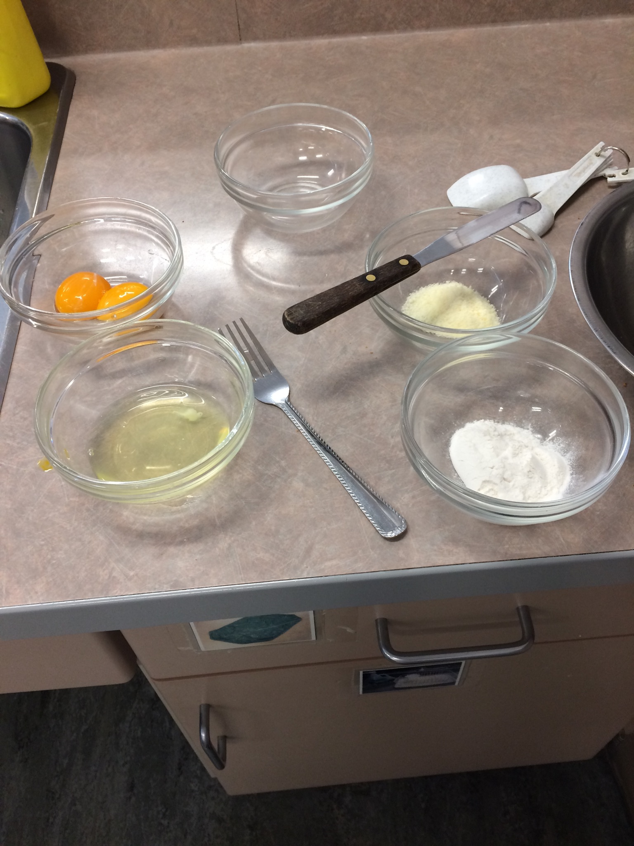

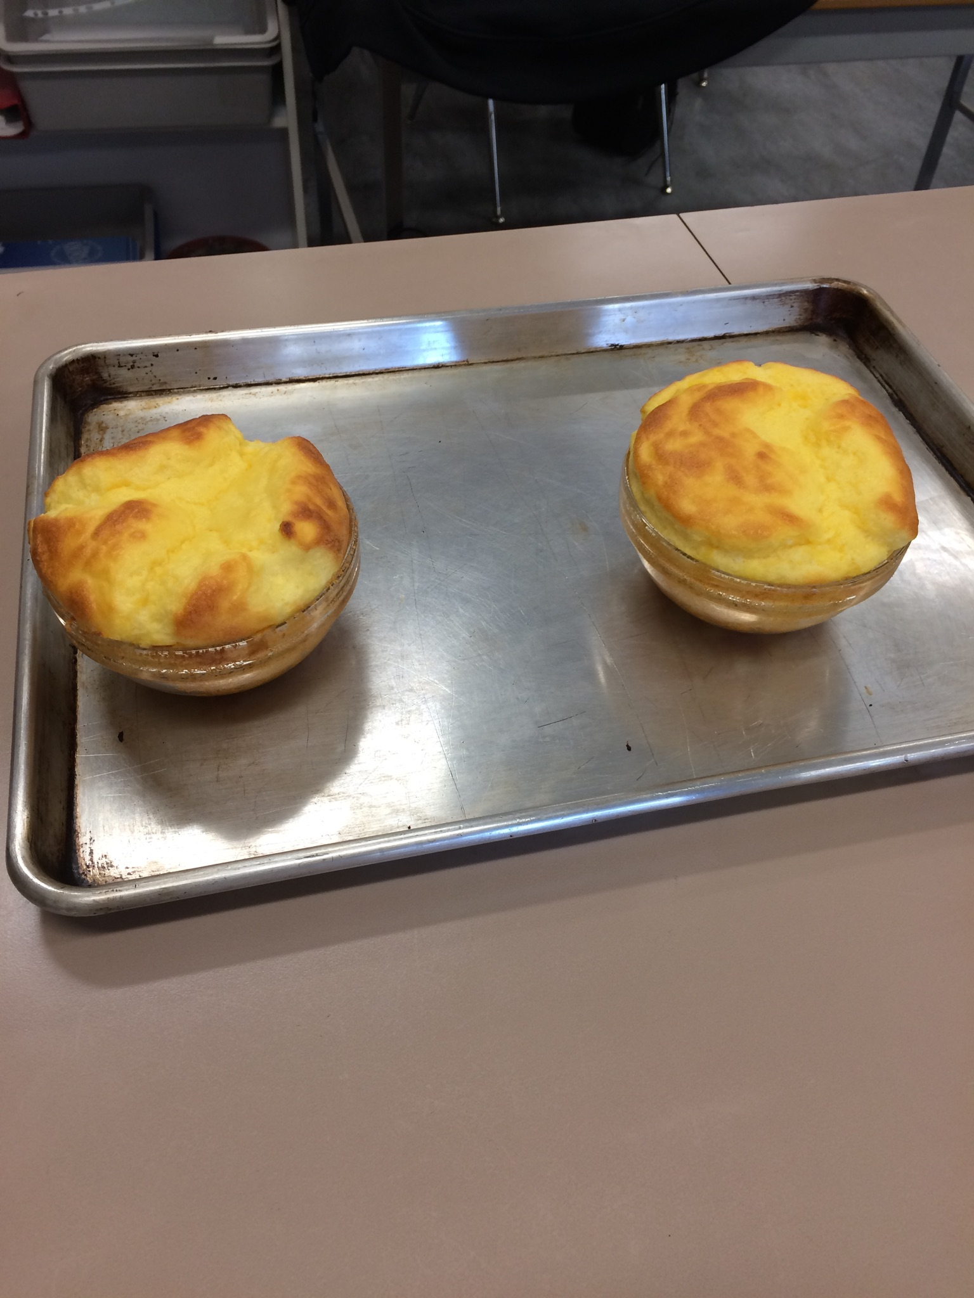

So, out of every lab we did during March and April, why the cheese soufflé? Well, this was the lab I worked the hardest on. The reason wasn't because it was challenging or my personal favourite. I worked the hardest because that day because my group leader, Carmen, wasn't here for this lab. Carmen usually knows what she's doing, and I always follow her lead on every lab. However, she wasn't there for the cheese soufflé, AND my other group member wasn't there for the demo. In other words, I was the only person who was there with the knowledge on how to cook the cheese soufflé. Their were a few bumps along the way, but my group member and I did well in the end. This lab, right here, represents how hard I worked on making sure everything goes well. Not only it showed how good of a leader I can be, it also showed how calm I can be in "certain situations." There were a few times during this lab where I had absolutely no clue whats happening. I do have to admit, I panicked in my head. I was scarred something would happen that would absolutely destroy the unit. I don't know what I was thinking at the time, but hey, it all worked out. After the lab, a friend didn't want his soufflé. So me being a friend, I decided to eat his soufflé in his place. I probably shouldn't have done that because then I had to eat 3 soufflés. Two from what I made (my partner didn't want hers) and one from my friend because he doesn't like cheese. I didn't feel good after that. Back on track, the lab was really fun and memorable. I would definitely do this again. The soufflé my group made were so soft, melts in your mouth, and of course delicious. It also smelled really good too. This would be a dish I would try to make for my family.

With a lot of good things happening in the lab, there is also, some bad things. One of those things was that Carmen, the group leader, was not there. This kinda led me to a panic loop throughout the lab. Another problem was that my other group member, who showed up for the lab, didn't go to the demo. This led to my group member to rely on me for knowledge and the do's and dont's. While this would be good thing for me, to show my leadership skills. This really made me even more worried and panicked during the lab. These were the two main problems in the lab, and what I need to work on as a leader.

This lab had its ups and downs, but this lab is one I will never forget. This is one I will remember throughout my life.

