- Agriculture: Okanagan, lower Fraser Valley, southeastern Vancouver Island, Georgia Basin(agricultural)

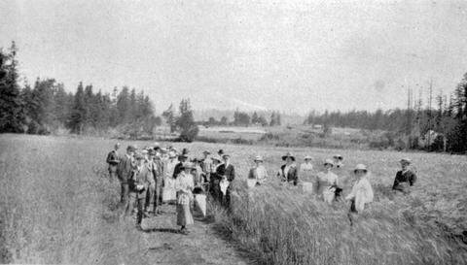

- In the recent years, the transportation costs have been increased. This is a highlight of the benefits of local agricultural production. However, only 1.1 percent of British Columbia;s land area was considered prime arable and about 15 percent has the chance to be arable. In 1990, agriculture has become much more then a big business. It's a hot-house industry that has become a major success and started to expand t our an markets of the lower mainland.
- To expand so we can farm and stuff

- In, 1973 a rising public concern over the loss of farmland led the Provincial government to take course. They made the ALR (Agricultural Land reserve) designed to protect the fertile land from development.

Mining:

- Prince George, Kamloops, Vancouver
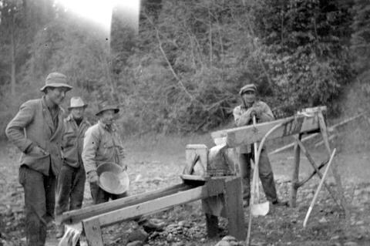

- Mining has been an important part of British Columbia’s reasource based economy. The Aboriginals were mining copper before the Europeans even got there. Coal mining started on a the east coast of Vancouver Island (1850s).
- To extract oil and gas extraction
- Average life span is 25 years, after that the coal mining site is closed down (towns close to it may close down as well). Causes the most environmental damage. Open pit mines leave behind bare rock faces and large residues of waste rock. It creates Acid rock drainage, which occurs when sulphuric minerals in Rodri are exposed to air or water.

Forestry:

- Lower Mainland, Victoria
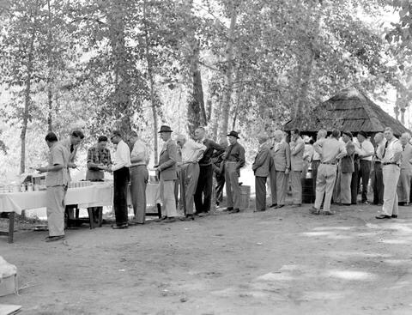

- In late 1800s, the wood products from British Columbia were being shipped around the world. Logging and manufacture of the forest products gave more employment and contribute more value added than any other industrial sector in the British Columbia. In 12008, 89,000 jobs (and higher) relied on the forest industry. This became an important source of income for many communities. However, some workers were laid off when the demand for forest products goes down. Though if the demand is high, then they will rehired again. The industry gained a boost when the expansion of the Canada’s railway system . And in 1900s, the investment was 2$ million dollars. Now after 10 years, it was raised to $65 million dollars. However, the mountain pine beetle in 2000 sky rocked. The pine beetles take the tree and lay their eggs in the bark. This caused a lot of trees to die and increasing the risks of uncontrollable wild fires.
- The Forestry role wasn’t as popular as in the past. It has decreased dramatically and it might get worse. Canada right now isn’t relying on the forestry and logging industry as much now.
- BC hasn’t done really anything huge in order to stop the pine beetles. If the demand of the wood products is low, then BC will starting to chop of some employes. If it's high, then they start to hire some people back.

Fishing:
- Vancouver, Prince Rupert, Washinton state
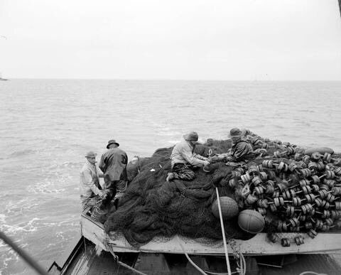

- Fishing has become one of the mainstay economic BC. In 1870s, Fishing became an important part of economy. In 1990, salmon represented 55 percent of the total value of the commercial catch. In 2005, salmon made up just 10 percent of the total cause of the catch.
- It's not as big say forestry, but it has became an economic resource for Canada. It's role will probably be a backup source in case something happens to the main source of Canada’s economy.
- Overfishing is a huge dent in the industry, and it still happens. Even though people know the rules to not overfish, it still happens. Canada has put laws on fishing and mostly people do listen. However, some people don’t listen at all.

