By:Matthew Hetrea

**Royal found dead**

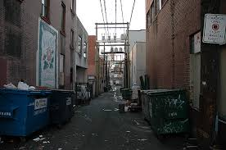

**A 16 year old gang member was murdered last night.**

Last night, (at around 11:30) a boy named Andy was ambushed while taking a short cut to Alfredo’s. He was supposedly attacked by their opposing gang,(The guardians) they stabbed him and tore the knife across his chest and then caused him

Picture taken by: [***www.vagabondish.com***](http://www.vagabondish.com/)

to bleed out. There were a few witnesses at the scene of crime last night. One couple, Angela and Freddy, came across Andy laying down helpless in the alleyway. Freddy was the first to approach the body. We interviewed both and this is what Freddy said,” We were scared to approach the body because it was dark, but when we did, we found out he was stabbed and we were in shock.” Angela stated,” I really wanted to help him but then we saw his Royals jacket and decided not to because we did not want to get involved with the gangs. I feel terrible knowing that part of his death was because of me.” So then the couple left the poor boy to die.