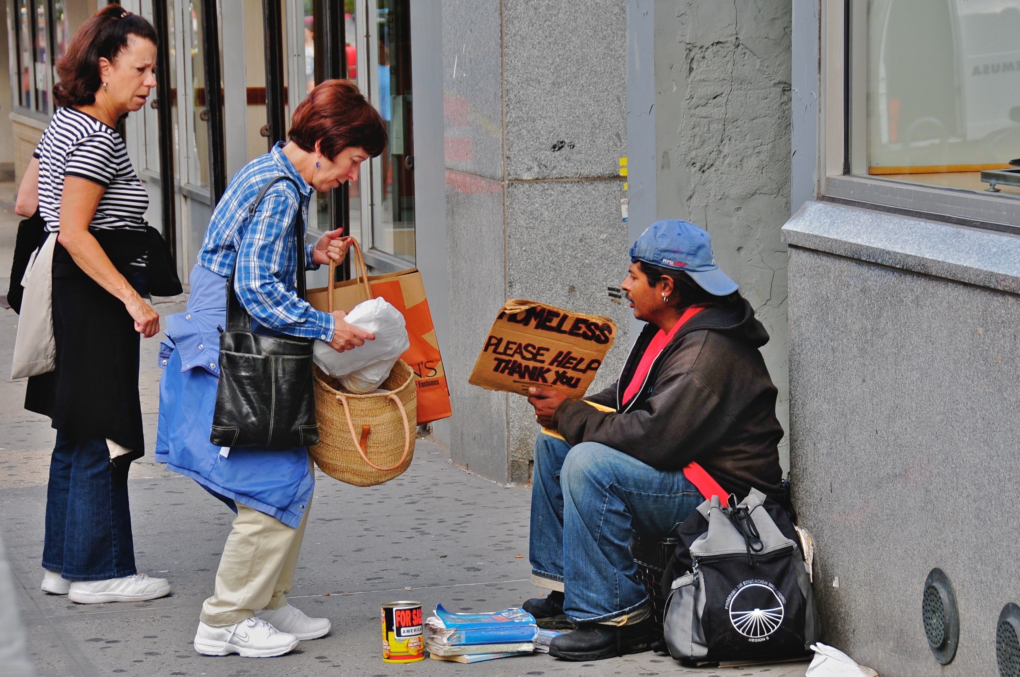
Providing Homes for the Homeless
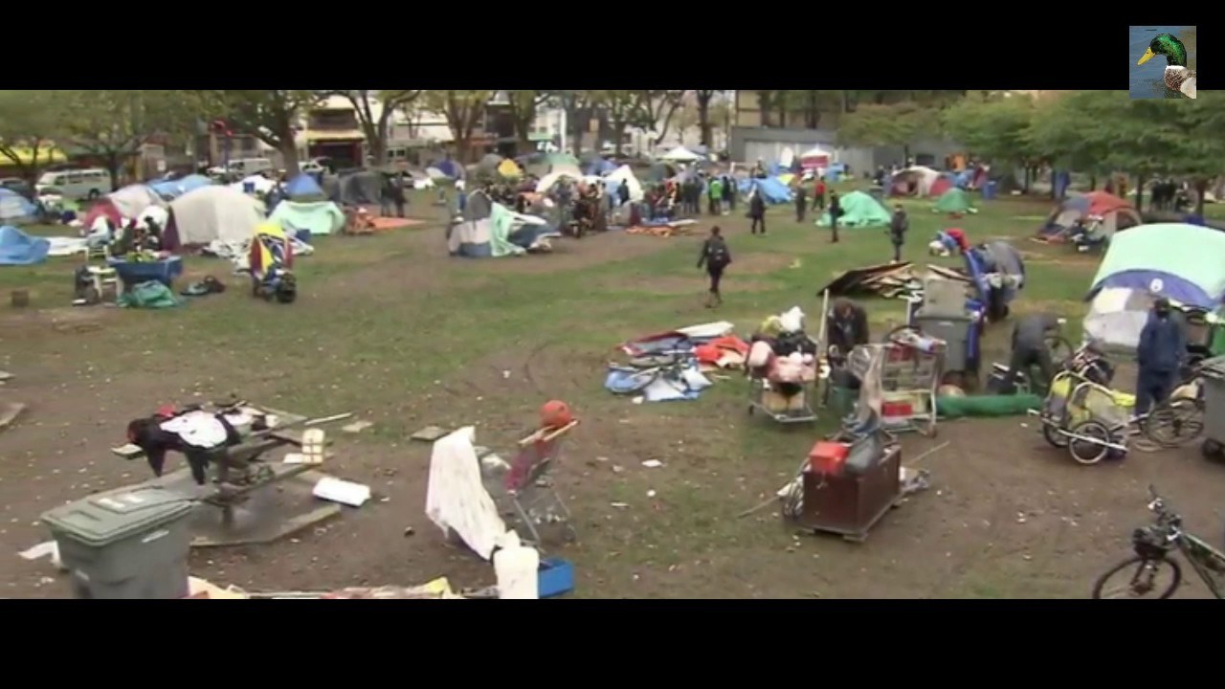
1 - an issue that id like to fix is homelessness
the federal government needs to give homeless homes so they don't have to live on the streets
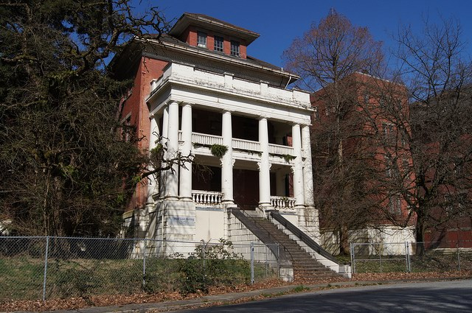
2 - One way to help is to restore Riverview for the poor and the mentally challenged.
In B.C. alone 15500 people in cities and towns around the province are homeless. Many are dying from infections from addiction. issues and other causes
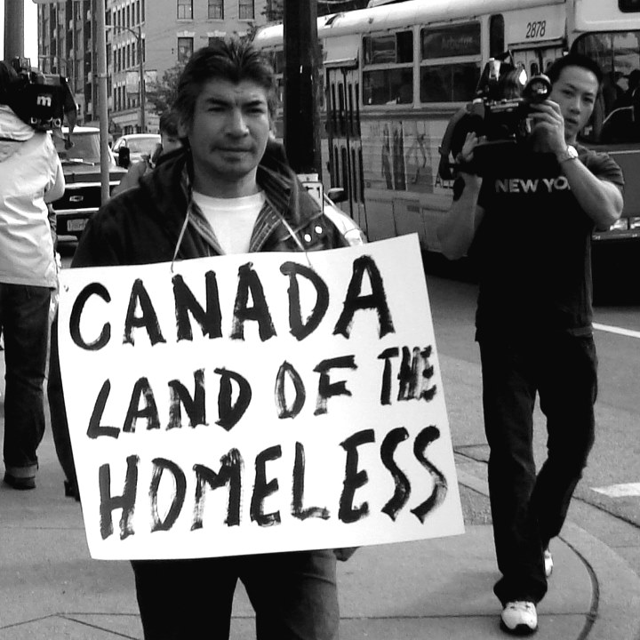
Other residents in maple ridge don't wants homeless people in there community they want it outside.
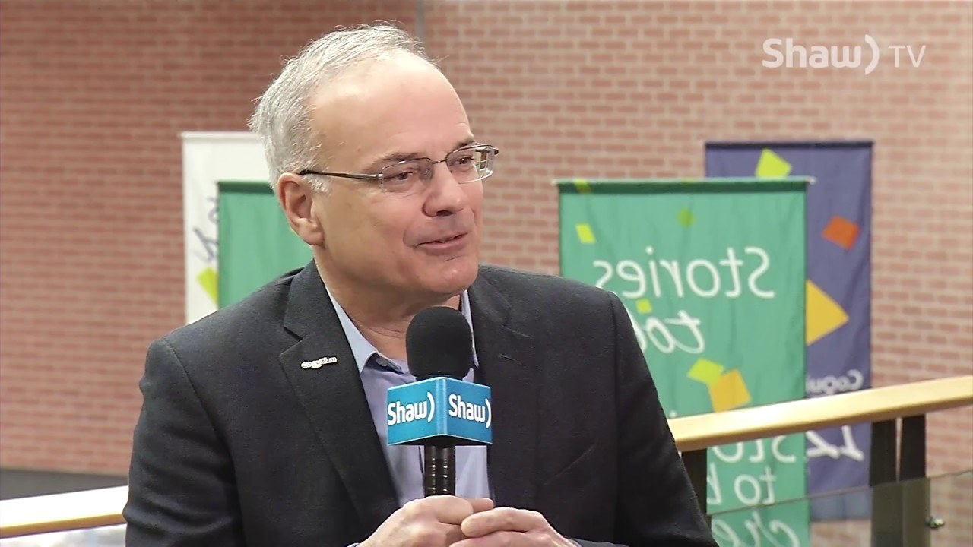
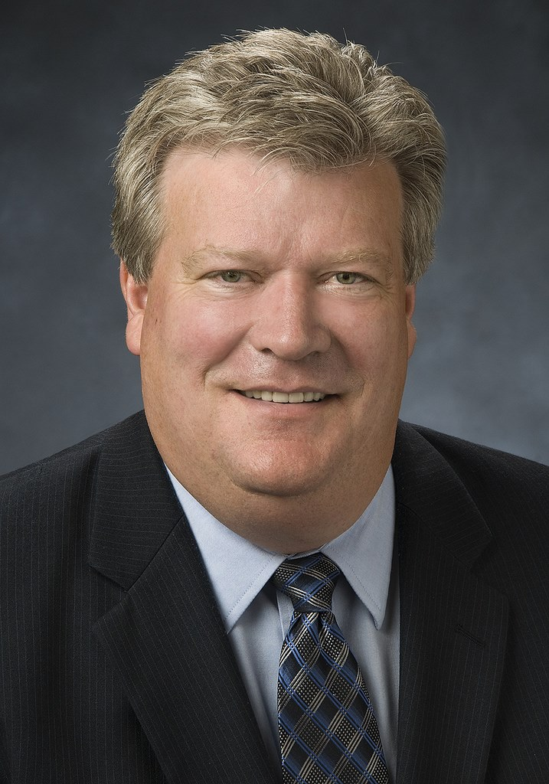
We need to address Richard Stewart the mayor of coquitlam and the housing minister of bc.
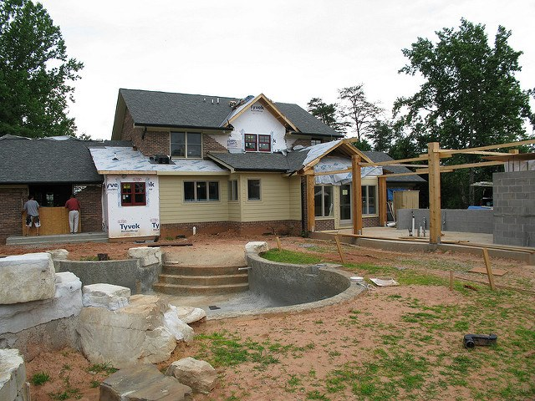
Some possible ways to build a house is to re model an old house or take an empty lot and build a house or take forests to make room or look for places to rent
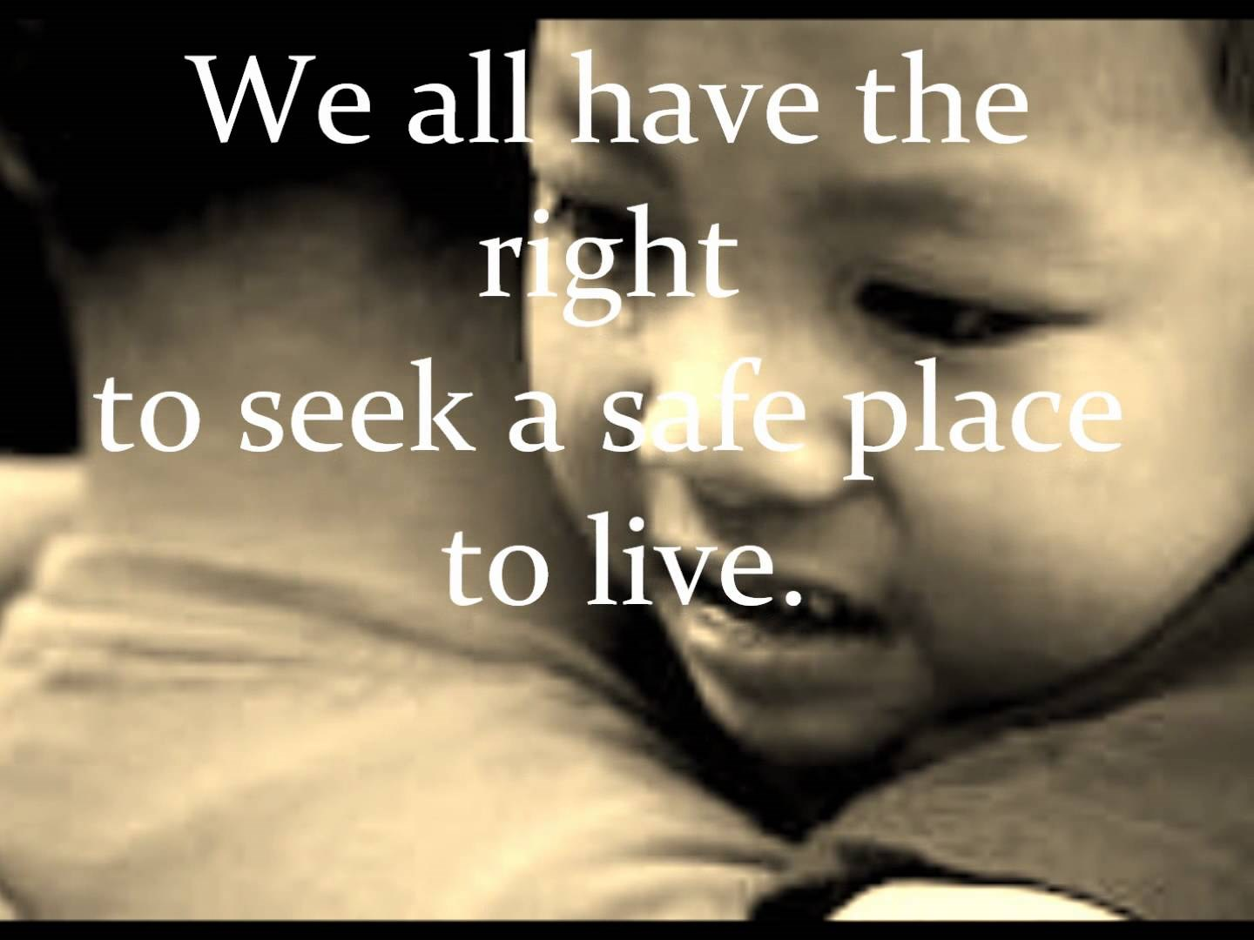
People would look at Canada differently in the way they should.
Refuges would benifet from this change.
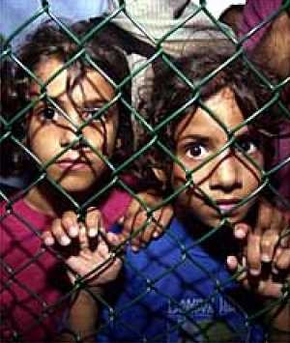
The people would be happy.
The final cost would be 500,0000 for all the buildings for the homeless.
People need jobs to get money and to build homes and some people need dedication and passion in order to work.
1.Restore Riverview by putting rooms and build a cafeteria
2.Take more forests down and build homes for the poor
3.Renting out homes to the homeless that cant find homes
The best way to go is restoring Riverview and then they have a chance to get a real life and a job.
They would be more happier than they were on the streets and they would be safe from the weather.

