**SMART GOAL: Personal**

(Specific, Measurable, Achievable, Realistic, Timely)

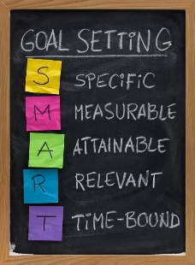 **GOAL STATEMENT:**

I will save up to 3000$ to get a MacBook Pro In 7.5 months

**WHAT DO I NEED TO REACH THIS GOAL? (The steps you**

**must take in order, and the date you wish the step to be**

**completed by.)**

* Must not spend money on things that I won’t use or last for a long time
* Must not spend money on food and eat at home instead

**HOW ARE YOU GOING TO MEASURE THE PROGRESS TOWARDS**

**YOUR GOAL?**

Depending on how well I save money it will be easier to achieve my goal.

**OBSTACLES YOU MIGHT SOLUTIONS**

**FACE**

* Leave debit card at home when leaving so I don’t get to spend money
* Get parents to pay for things temporarily
* May spend money carelessly
* May spend it phone bill, hamster food & supplies, clothes, makeup, food etc.

**WHO ARE YOU GOING TO SHARE YOUR GOAL WITH?**

I’m going to share my goal with parents and friends so that they could prevent me from spending money carelessly

**HOW WILL YOU CELEBRATE YOUR GOAL?**

Once I’ve achieved my goal I’ll be free and get to do shopping again. Also not forget to save money to give money to my parents back

**NEVER GIVE UP!**