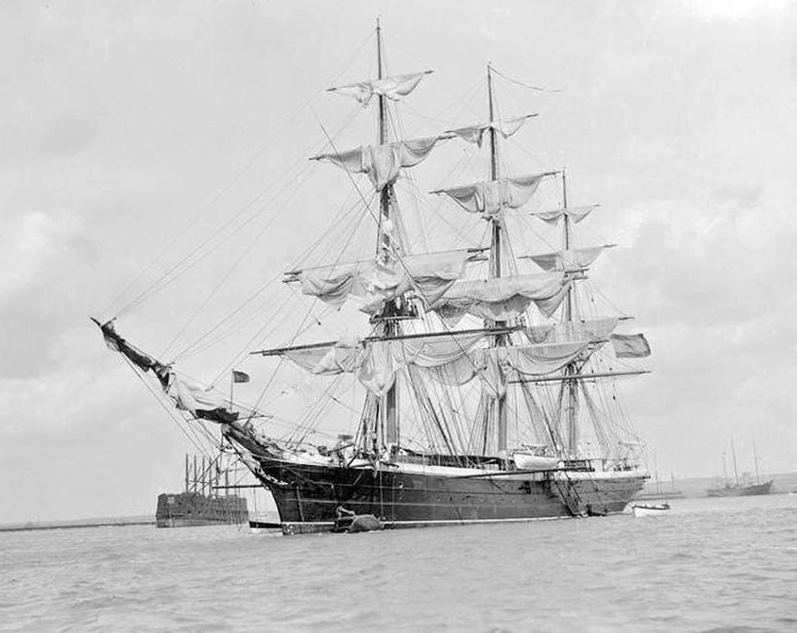

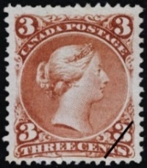
July 28th, 1868, 8:47 AM 2751 Grove road London, England
To my dearest mother,
I arrived here in Nova Scotia, Canada in the city of Halifax just yesterday. The journey here was very long, miserable and dark from being below deck so much. Once I arrived I was happy to be out of those boats and breath in the unfamiliar fresh air. I stopped for the night with the few dollars I brought with me. The hotel was very small and a little run down, but it wasn’t that bad. I went to a small bar below the hotel and ate supper there. While there I met a group of very generous farmers and they told me of a place with a large amount of land that could be bought for so cheap it was almost free to take. These farmers said they were going to start a long journey to this land tomorrow. I asked the farmers and they are willing to allow me to join them along with them on there journey inland. I am leaving on this long and hard journey toward this unknown land early tomorrow morning. I am planning to claim a plot of land from the government (which bought this land from the Hudson Bay company) near the other farmers somewhere within Rupert’s Land, but we are not exactly sure where yet. The farmers I met are also going to teach me to farm! This journey will be tough and we must travel for a long time in a lot of bad conditions but once I get there I plan to stay. I wish you could be here to see this. It is so amazing to finally be out of that old city and be out exploring the world. This is truly, a dream come true and I am so happy to be able to explore new lands. I will most likely not be able to send you a letter for a while as I will be traveling on my journey.
I miss you dearly, your loving son,
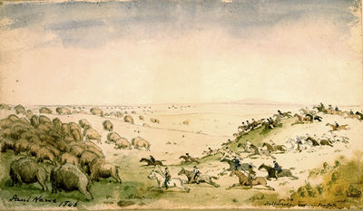

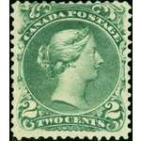
October 3rd, 1869, 4:56 PM 2751 Grove road London, England
To my loving mother,
It is wonderful to final be here. I am happy to final be able to rest and write to you. Me and the other farmers that I have become good friends with made it hear early this morning and we are so happy. After the long and hard journey through the interior (in some parts we had to carry a canoe over our heads so we could cross the lakes and rivers after the long hike with carrying it) we are finally here. It is so beautiful here. There are so many Indians that live here and they are very helpful. Many people believe the Indians are savages, but I am not one of them, they are very helpful with trading any item for food, tools and even clothes. When we first arrived, we met a group of metis people (who are a mix of Cree (a nation within the Indians) and French) and they offered us this wonderful food called pemmican which was made of dried buffalo meat and berries. It was wonderful and nothing like I had ever eaten before. Just a few days ago we were looking for a place to call home and noticed a herd of buffalo and they were very beautiful and massive animals. The heard was huge, there were over one hundred! They look almost like hairy cattle with large horns. Anyways, I have claimed an area of land that is beside the other farmers. It was so cheap, even cheaper than I thought. The farmers began to teach me to till the land and learn to live outside of a busy city like London. My new address is 235 Alexander lane so you can send me letters and I can hear how you are doing. I hope to hear from you soon.
Your son,
P.S. If you can please send something, anything from home because I miss home so much and want something to allow my memories of England to flow.

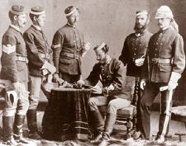

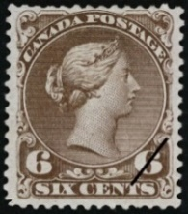
December 5th, 1875, 11:24 AM 2751 Grove road London, England
To my dearest mother,
I know it has been a very long time since I have sent a letter and you are probably very worried. I must assure you that I am fine. I have a lot to catch you up on. To begin with, I began to make some money off my farm and with the creation of the Canadian Pacific Railway coming through a town near me called Winnipeg it will improve my farm even more. With this railway, I might be able to afford new equipment and stop using these rusted and out of date tools, but the railway will not come through here for a few years. I have also started to rebuild my house and make it into a more functional and larger home. Onto the biggest news, I recently applied for a job at the North West Mounted Police and got accepted. I leave for my training in a few months. I wanted to apply ever since the North West Mounted Police got into this village. The law and order here was terrible and nothing was being done to fix it. They call this land the wild west because you could get away with almost anything here from theft, smuggling goods from the United States and even murder! With the arrival of the North West Mounted Police my friends and I can be safe. I applied in the hope that I can be able to help protect this beautiful land from anything that may try to destroy it. I also applied in the hope that I could help the Indians because I fear we are not treating them well. I believe this because we have been slowly pushing them farther west as we move are settlement farther west. While we push them west we push them off their land and take it for ourselves. I truly believe I can help to stop all the crimes by joining the North West Mounted Police. That is all I must say for now and will be in touch. Hope to hear from you soon.
Your loving son,
P.S. Thank you for sending those old painting that I drew as a child. They bring back so many memories.
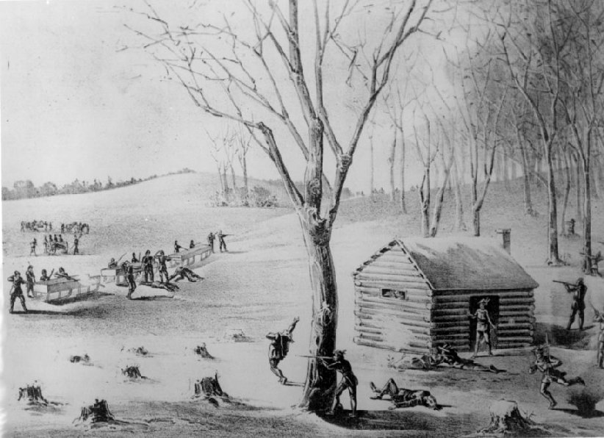

November 17th, 1885, 8:55 AM 2751 Grove road London, England
To my mother,
It has been a long time since I last sent a letter but I have a good reason for not sending you anything. I have had many trips with the North West Mounted Police to bring law and order into the west. It has been a very difficult job and I have put many criminals into prisons with the help of other members of the North West Mounted Police. Almost ten years ago now, in 1876 there was an act that was passed called the Indian act, that at first I believed it was cruel for us to do to the Indians. The act forced the Indians to move onto reserves that are often the worst land that nobody wanted and it also forced their children to go to residential schools and loose all their culture and old way of life. I even heard of children being beaten or going missing from the schools. I did not support this act at first but now I fully support the Indian act. The reason for the changing of my mind was, because earlier this year on march 26 the Indians formed an armed Rebellion against the Canadian government. I was travelling with a group of other North West Mounted Police to a small town called Duck Lake to retrieve arms and ammunition from a store there. While we were collecting the ammunition, we were attacked by a group of Metis people (Metis are descendants of both French and Indian). Twelve of the police in my group were killed and eleven were injured. One of the men killed was a great friend of mine who was one of the farmers that I had met and travelled with on my journey inland. I was so mad at the death of my friend and wanted revenge against those savages. When this rebellion finally ended with the trial of the metis leader (his name was Louis Riel) I was so happy. When I heard that the Louis Riel was accused guilty of treason and sentenced to death I felt even better that my friend could rest in peace with his murderer dead. I hate those Indian savages now and never want them to get anything. I am going to continue and try to get revenge for my friends and never let those Indian savages have anything.
Your dearest son,
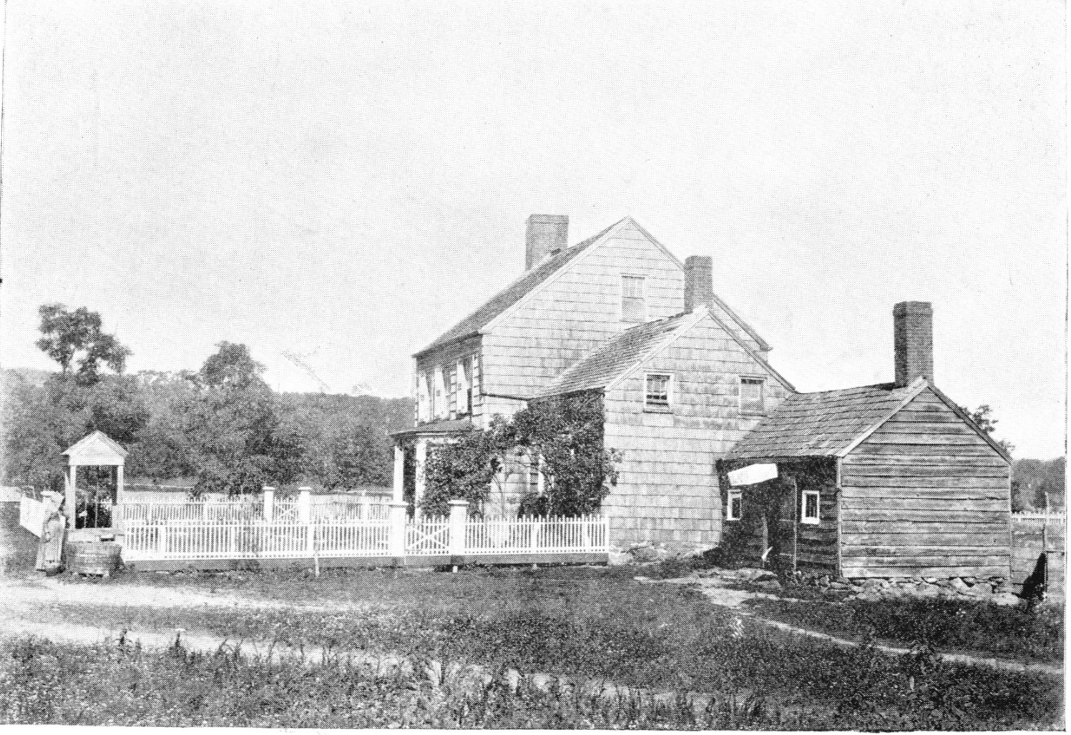

March 23rd, 1888, 10:38 AM 2751 Grove road London, England
To my loving mother,
Life in Canada is still as amazing as the day I got here. Much has changed and I have much to inform you about. Firstly, I met a woman two years ago. Her name is Diane and we are planning to marry early next year. Just so you know she is part Indian. I know who must not agree with my decision but I do not care. She makes me happy and if you do not support my decision I will not change my decision. She is from a small town within Manitoba and moved into the North-West Territory for the inexpensive and good land. We now live on the same land and work together to care for the farm. It has become much easier to take care of the crops and sell them and we have made a larger profit and life is getting easier. It is still a little difficult to help on the farm because of my job as a North West Mounted Police officer. The duties of being an officer have raised so much due to the number of immigrants that are beginning to arrive in this small town. Everything has been kept in order, but it has come with a larger amount of late nights at work watching the city and stopping anything that happens. Almost these immigrants have come to this small town because it is near the city of Regina which is a stop for the Canadian Pacific Railway that was completed three years ago. This railway has also allowed me and Diane to sell our crops at a faster rate and make more of a profit to buy better and more modern tools. I hope to hear from you soon.
Your loving son,

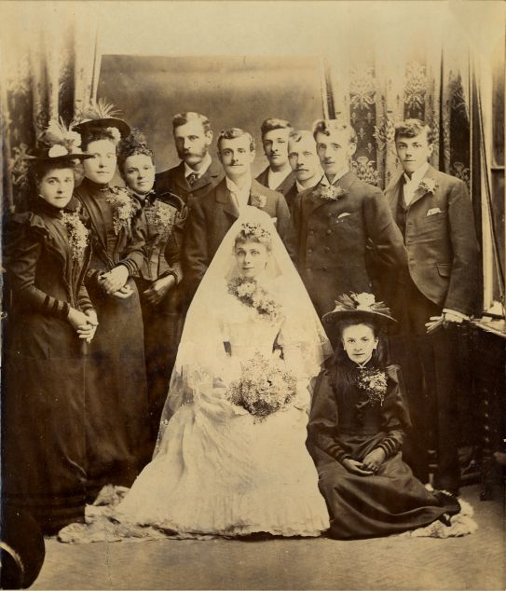

July 4th, 1893, 6:29 PM 2751 Grove road London, England
To my dearest mother,
Since I have last spoke with you I have married and have had a child. He is a you boy who me and Diane have named Fredrick. He was born on June 9th, 1890 at 7:30 AM in our home because there was no hospital near this small town. Also, Congratulations on becoming a grandmother! Anyways, I want to talk to you about how I am worried for my son, because he is part Indian he may be forced to go to a residential school and I have heard of children being abused physically, mentally, and sexually. If they try to take my son to a residential school, I will fight for him to go to a normal school like any other child. Everyone should have the same school and same amount of learning. There was an issue in Manitoba were the French speaking students were forced to lose their language and religion and be forced to learn like the English-speaking people. I want my child to be able to learn about his history and be proud of where he came from not angry. The problem in Manitoba was partly solved, by this I mean if there are ten or more students who spoke another language they could be taught in that language. There has also been an increase of immigrants into the country. Among these immigrants there is many China men. These China men have kept coming and will not stop coming. There has even been a tax that was placed on them called the Chinese head tax where they were charged to enter the country. This tax has been raised but they still come, it has been raised to one hundred dollars and there is even talk of a larger raise in the tax. It has been great to tell you about my life in Canada.
Your son,

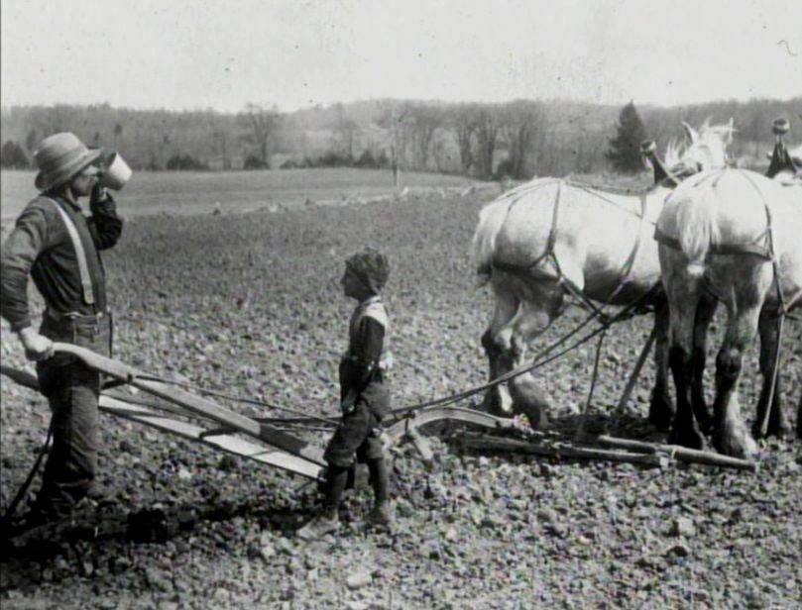

October 3rd, 1897, 2:56 PM 2751 Grove road London, England
To my wonderful mother,
Hello, it feels great to take a break from all the work I am being overwhelmed with and write this letter to you. Much has happened since I last sent you a letter. First of all, I must inform you that Fredrick is doing very well and beginning to learn to farm. There are also, still more China-men arriving into both the city and the bigger city of Regina to the south of us. These immigrants are coming here for many reasons but there are six main reason. They are that there is inexpensive and good farmland everywhere in the North West, the completion of the Canadian Pacific Railway in 1885 allowed them to travel and sell their goods faster, the dominion land act was changed so they only had to pay a fee of ten dollars and stay on the land for three years to own it, the treaties with the Indians freed more land for the settlers by putting the Indians onto reserves, and the fact that the North West Mounted Police was created to bring law and order into the west. These are all great things to happen but these China-men are all taking the jobs because they are willing to work for a much smaller pay. The number of people immigrating to this country is shocking and is making my job as a police officer a lot harder. The growth of population and riots occurring have forced me to have longer and harder hours as an officer to control the people. This makes me worry that I must leave my farm and focus as an officer. This will mean I must teach my family to be good farmers so we can make enough money to sustain a good life.
Your loving some,

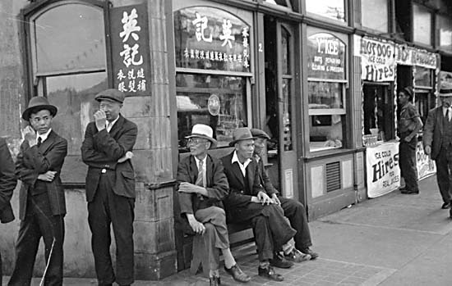

February ^{7th}, 1900, 9:56 AM 2751 Grove road London, England
To my dearest mother,
Much has changed since my last letter I sent. First of all, I have had to stop my work on the farm and focus my work as a North West Mounted Police Officer. I have decided to do this because there has been many offers to me that give me the chance to get a higher rank and higher pay. With higher pay and it will allow my family to live a better life. Last month I taught both Diane and Fredrick everything that they didn’t know about farming so they can keep the farm running in an efficient manor. This will hopefully be a good choice for me and my family. The government has also raised the head takes on the Chinese this year to one hundred dollars. I hope this will keep them out of this country and allow my son to get a good job as he continues to grow up and wont must fight with the China-men. There are beginning to be small amounts of protests among major cities with many China-men in them. I have already been issued to help control the Chinatowns of Vancouver earlier this year to make sure no riots occur but there is still a chance for one to break out. I truly hope that these riots do not grow because I do not want to leave my family and try to contain a large number of dangerous protesters. Even though, if it happens I will still go and stop the riots to protect this great nation and keep it and my family safe.
Your loving son,
P.S. I hope to hear from you soon and read about what is happening in Britain.
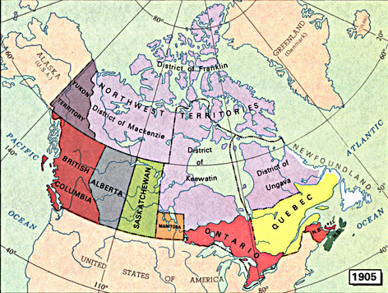

November ^{7th}, 1905, 6:56 AM 2852 James road, London, England
To My Loving Brother
It has been very hard for me to cope with our mother’s death. I have been so sad and have been lacking with work. I have also been having a lot of trouble to sleep because I would wake up from nightmares about mom. I am starting to cope with it better but I just thought I needed to wright a letter to let my feelings flow. My job got much harder with all the immigrants and protests, and I have had little time off. Some days I get so distracted from thinking about mother I am asked to go home and rest. Also, last year in 1904, the North West Mounted Police changed its name to the Royal North-West Mounted Police, and this has been odd for me because I am so use to the old name. Earlier this year Alberta and Saskatchewan joined the dominion of Canada, this has grown our country a lot and It also means that I now live in a small town near Regina, Saskatchewan. This country is so much larger than I ever thought it would become since I heard that the British Colony left the grasp of Britain. Even though these things have happened the only thing that is on my mind is the passing of mom. It was nice to tell you what I was feeling.
I hope you are doing well, your loving brother,

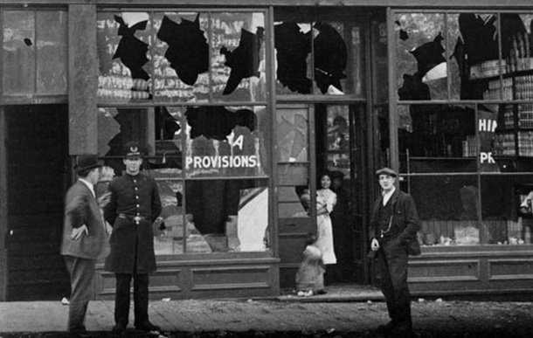

December ^{7th}, 1908, 5:56 PM 2852 James road, London, England
To my dearest brother,
I have been able to cope with mother’s death better and am at work and working well now. There is a new act that was introduced earlier this year that is to try to prevent people in Southern Asia to travel to this country. This act, is called the continues Journey act forced people to only move to Canada if they travel here in one trip without any stop. I believe this is a great rule because it limits the Asians entering our country. With this act paired with the head tax there might finally be a decrease in Asians entering Canada. There was also the largest riot I’ve ever seen. Last year, in Vancouver Canada, me and other RNWMP officers were sent to help contain the largest and most severe anti-Asian riots. I personally don’t believe that the Asians should move here, but I also believe that someone should never destroy another person’s belongings because they worked very hard to get where they are now. All that was happening in these riots was destruction of the Asian community’s businesses and possessions. I am happy for these riots to be over but I fear more might emerge. I also hope for the riots to end so I no longer must be sent to British Colombia to help control the riots and not be away from my family for so long.
Your brother,
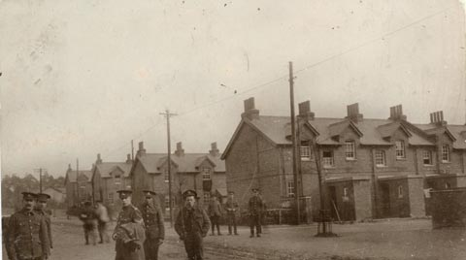

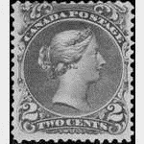
January 20th, 1913, 1:24 PM 2852 James road, London, England
To my loving brother,
Not much has changed since I last sent a letter. I am no longer taking long trips to British Colombia to help control the riots and have had enough free time to spend either playing with my family or working on our farm. Earlier this month I was offered a new job from a member of the Canadian Military. They are looking for trained people to help train new soldiers for the possible risk of the war against Germany. I am thinking of taking this job because the pay is much higher than I am getting currently. Also, I want to play a part in defending both this great nation and my home in Britain if a war starts. The only thing that I don’t like about this job is that I would have to leave my family for a long time to focus on the training of other soldiers. I would not see them for months and in some cases years. If I take this job I would be working at a military base in the province of Alberta. This base was only made last year and is expected to be operational in a minimum of one year. This would be a great job for me but I am not sure if I could handle what I am training people to do. It is called Harvey Barracks and I plan to accept the offer to train new soldiers there.
Your loving Brother,

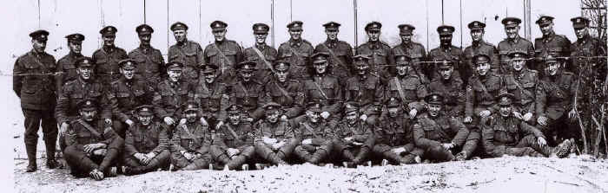

A photo of the members of the tenth Canadian battalion that I trained.

August 5th, 1914, 7:00 AM 2852 James road, London, England
To my loving Brother,
I am sure you have heard the news by now, but just in case you didn’t we are at war with Germany since yesterday when Britain declared war on Germany. Before this happened, I took the job as a military officer to train new soldiers and have been working there for almost a year now. I know work to train both the tenth and fiftieth battalions of the Canadian expeditionary forces. The group of men that I started to train are being prepared to ship out to Europe to fight against Germany. These men work almost like one, they are amazing at getting there training tasks done the at the best at fastest possible rate. They have never failed and hope that that continues into there fighting. I am proud of them for becoming such great fighters, but I am also worried for them Because this is the real thing. Them going off to war reminds me of back in 1885 when me and the other North West Mounted Police officers were fighting the Indians and I watched my friends die. I worry for them to not only see this and go through what I had felt, but I also worry for them to be the ones who have their friends see them murdered. I hope that this “Great War” does not last long and there is peace after. I have also heard people say that this could be the “war to end all wars.” I truly hope that is the case and we don’t have to see the death of many incent young men.
Your brother,
P.S. I worry for your safety because of how close you are to the was. Please be careful and don’t do anything stupid like you have a habit to do.
Citations:
Cranny, M., Jarvis, G., Moles, G., & Seney, B. (2009). Horizons: Canada's Emerging Identity (2nd ed., Vol. 1). Toronto, Ontario: Susan Cox.
Clark, P., & Mckay, R. (1992). Canada Revisited (1st ed., Vol. 1). Edmonton, Alberta: Arnold Publishing Ltd.

