  - English 10 December 11, 2017 Maria Benitez
To Kill A Mockingbird – Timeline
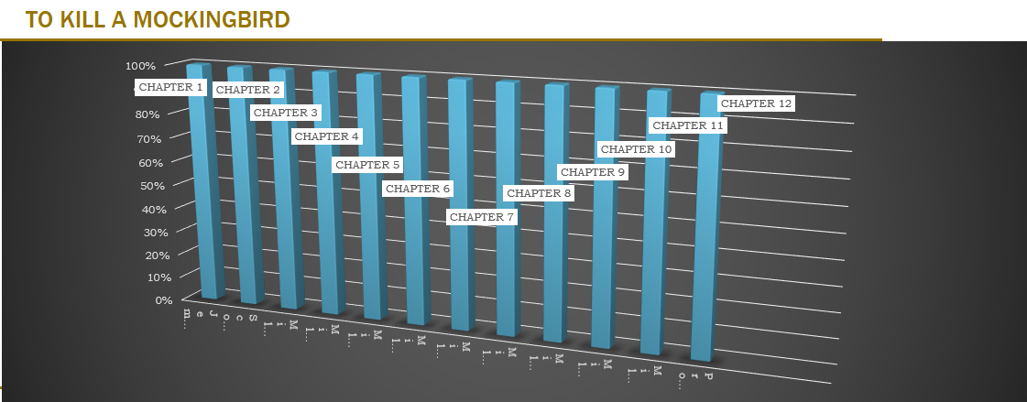
Chapter 1: Scout and Jem Finch meet Dill for the first time. They also decide to make Boo Radley come out of the house. It was a happy moment, they meet new people, but then it turns into a mystery, Boo Radley.
Chapter 2: Dill returns home, and Scout Finch starts the 1st grade at school. The prejudice and the persecution themes less serious at this point of the novel. Scout was mad, angry because she couldn’t
Chapter 3: Jem invites Walter Cunningham for dinner.
Chapter 4: While on their way home, Scout and Jem Finch find chewing gum in the Radley’s oak tree. Later then, they both find a box with 2 polished pennies. Scout, Jem and Dill were playing, and accidentally Scout rolls into the Radley’s place. Example of prejudice.
Chapter 5: Dill, Jem and Scout decide to try to slip a note to Boo Radley, they have an interest in him and they want to find out if he exists within the house.
Chapter 6: Jem, Scout, and Dill try to look in Boo’s window. Nathan Radley fires a shotgun. This key event links extremely well with the themes of 'Prejudice and Persecution' because Mr. Nathan Radley then assumes that it was a Negro who he shot at, even though he was unable to tell what skin colour the person was. A powerful example of prejudice.
Chapter 7: Scout starts 2nd grade. Jem and Scout find soap carvings of a boy and girl in the knothole, they find a spelling medal, they find a pocket watch, chain, and knife, and later on the knothole is filled with cement, Tom Robinson is arrested.
Chapter 8: Mrs. Radley dies, Snow. Jem turns the snowman into a caricature of Mr. Avery, Boo puts a blanket around Scout’s shoulders, and Atticus agrees to defend Tom Robinson.
Chapter 9: Cousin Francis calls Atticus a “nigger lover”; Scout fights him. She finds out her father is defending a nigger lover. This shows how Scout is growing up in a society where Negroes are despised and shunned and how most children get the impression that Negroes are bad, even though they are not. This leads to a society full of prejudice.
Chapter 10: A mad dog appears on the Finch's street. It's still far off, and Heck Tate, the sheriff of Maycomb, says only Atticus is marksmen enough to hit the dog from such a distance. Atticus kills the dog in one shot. Scout and Jem, astonished, learn that when Atticus was young he was the best shot in the county. Scout wants to brag at school, but Jem says not to: if Atticus was proud of it he would have told them.
Chapter 11: Mrs. Dubose condemns Atticus for defending Tom Robinson. Jem, enraged, rips the flowers off her camellia bushes. As punishment, Atticus makes Jem go and read to Mrs. Dubose each afternoon. Scout goes with him. One afternoon, during their reading session, Mrs. Dubose dies.
Chapter 12: Summer arrives, but Scout is devastated when Dill doesn't arrive because his mother got married again. Also, Atticus has to leave for two weeks to serve in the state legislature. Jem & Scout go to Calpurnia’s church; Aunt Alexandra moves in. When they went to church with Calpurnia, Lula criticized Calpurnia for bringing white children to 'coloured church'. She is clearly not happy that Calpurnia has brought white children to a 'coloured church'. For once in the novel, instead of the Negros being criticized, it is white children.

