Science App Review
Define:
In chemistry, we have been learning a lot about scientific formulas, iconic charges, the periodic table, etc. My problems are usually that I don’t understand how to write formulas, name the compounds, or I’m not sure if my answer is good. Also I often lose my paper with the periodic table. And talking about periodic table, to me, the English is a little difficult to me, and sometimes I forget how to write the elements names, or how do you call it in English, cause not all of them are the same in Spanish. My task is to find an app that has the periodic table of the elements and their definitions, and most important details. Also an app that can help me doing formulae, and helps me know their names.
Dream:
An app that has the periodic table of the elements and their most important details, definitions.
An app that has pictures of the elements so I will know better how the elements are.
An app that helps me with the formulae, and with their names.
An app that can work without internet, wherever I am.
Deliver:
So I went to the Google Play store and I took about 3 days to test and find a really good and useful app. I found 2 apps that have a really good functionality. They are really helpful for my chemistry classes and also these 2 apps help me remember the elements and their definitions. One app gives me all the needed information about the elements. The other gives me a full explanation about the formulas, etc.

1st App* Isotope/ Periodic table.
With this app, you can explore the periodic table of the elements with a really high quality on images. It’s easy to find elements and all the elements contains their most relevant information. It’s designed for phones and tablets only. This was exactly what I was looking for.
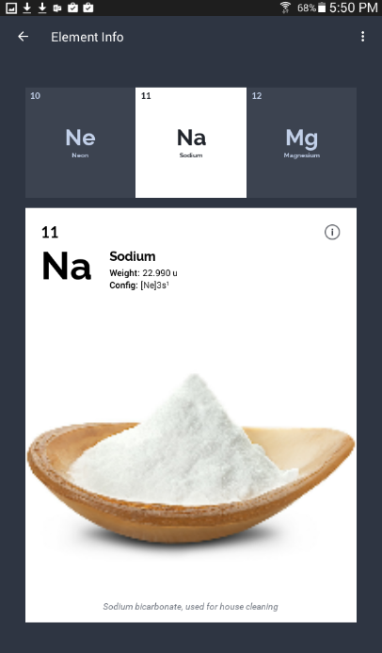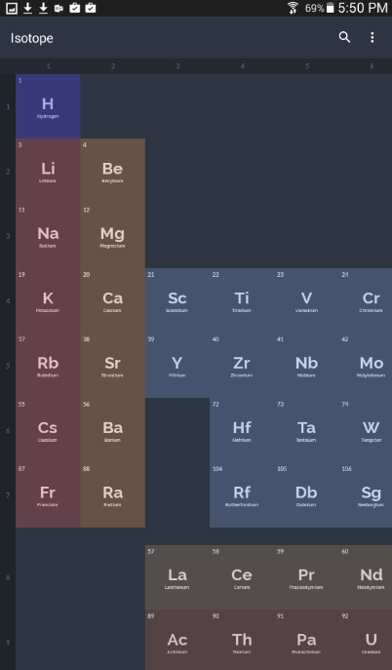

2nd App* Complete Chemistry
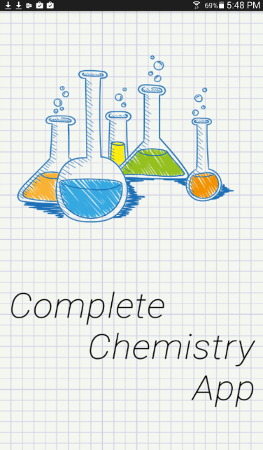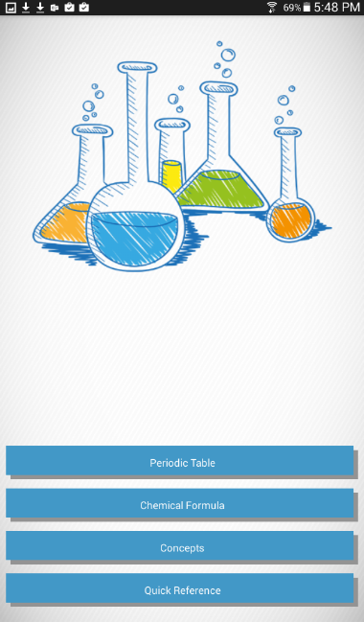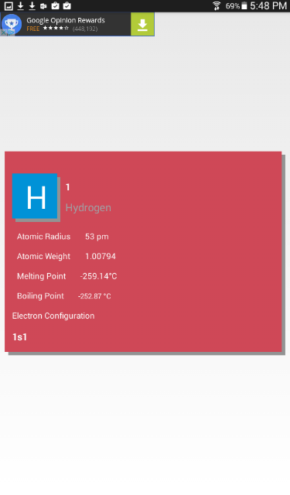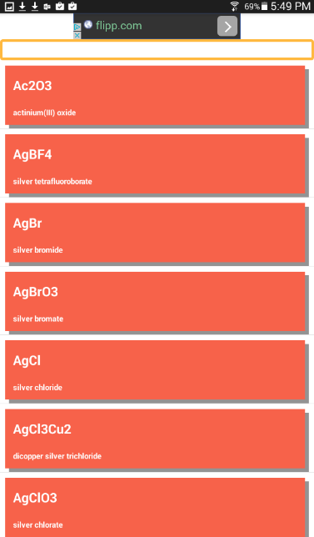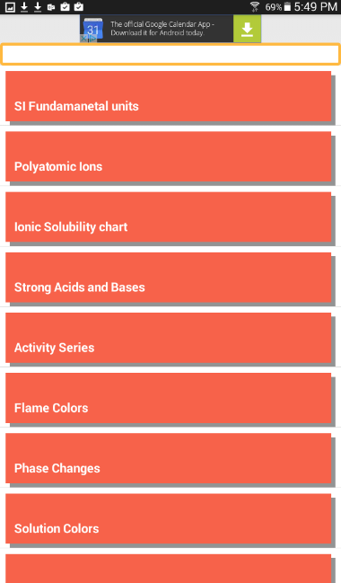
This app is a useful resource for almost everything! It has all the concepts like formulas, periodic table, and everything I needed. Also a handy search feature which makes the app super easy.
With these 2 apps I have learned a lot more, and now I understand a little bit more about the formulas and ionic charges. They are really helpful.
I really liked these 2 apps and I think that I will use them a lot for this class. They worked really well, and maybe the only problem that I found was that there is a lot of ads but that’s ok, it doesn’t make your phone/tablet slower. These 2 apps help users to understand a lot the elements, and to see all the formulas. You learn a lot, and you can work faster than having to go to Google and look for a hundred of different pages just to find the answer to your all of your questions. It’s really easy to use and to understand the functionality of the app. It also has a search engine and pictures of the 70% of the elements.

