Digital Footprint Assignement
On the internet, a digital footprint is the trail, traces or footprints that people leave online. Traces that can leave personal information about yourself available to others online. Our digital footprints can tell where we have been, with who, where we are going and things like that. And anyone, everyone can tell a great deal about you via Facebook, Twitter, Instagram, etc.
And how might my digital footprint affect my future, well, lets say you are applying for college, or university, or even a job. They can simply go see your digital footprint and see if you have a food coalification. They can go see what you have been doing your life, and things like that. It can affect your reputation, your business, your future jobs, etc.
Some strategies that you can use to keep an appropriate and safe digital footprint are
-Keep personal details safe
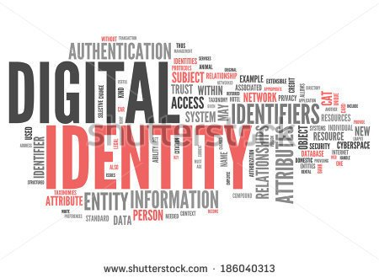
-Think before you post
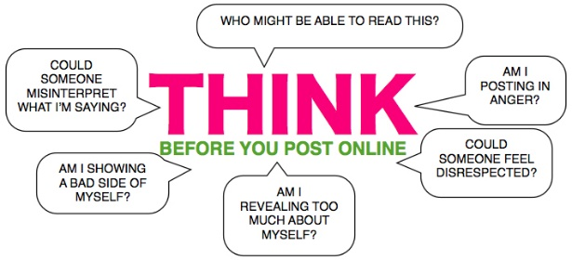
-Don’t share usernames or passwords with anyone
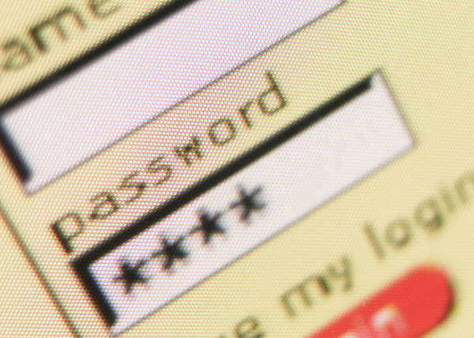
-Protect your personal data
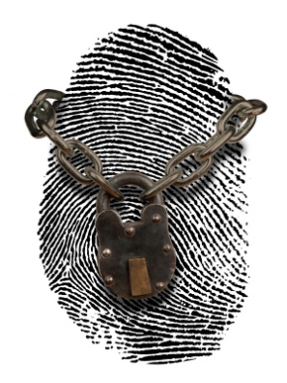
-Google yourself
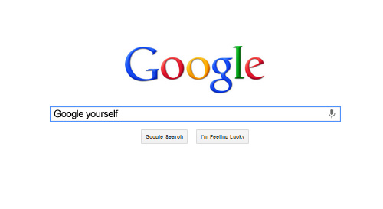
-Is it necessary
- Would my family feel good after seeing this
Its really important to think before you post, you never know what might happen, it could be permanent, or it could be revelant.
When I first googled myself, well, I couldn’t find me, and still, cant find me, but, I have googled my friends, and they appear, and their personal data too. So I decided to talk them a little bit more about their digital footprint, and that everyone can see almost everything that they post, or things like where do they live, where do they study, etc. Now they are being careful, and their accounts are private too, and they are not accepting people that they don’t know, because you never know if that person could be a predator, or someone really bad. I have been talking about this with my family too. My little brothers were really interested about it. And they have shared this to their friends too. Im really happy everyone is getting the advice about their Digital Footprint.You need to protect your reputation, even if you don’t have anything to hide. And you need to decide how your personal information is shared, too.
The internet is not a bad thing, is just about how we use it.

Maria Jose Benitez.

Sources
https://www.commonsensemedia.org/videos/digital-footprint
http://www.internetsociety.org/your-digital-footprint
http://ikeepsafe.org/digital-citizenship/your-digital-footprint/
Pictures Links
http://www.educatorstechnology.com/2013/04/a-great-guide-on-teaching-students.html
https://www.bing.com/images/search?q=+digital+footprint+&view=detailv2&&id=3E8C6ED9D8E74DAD960DA3B7046BF48B5A3EE3D2&selectedIndex=13&ccid=qJL26QE3&simid=608011815160186336&thid=OIP.Ma892f6e901370e658817806c51a278a9o0&ajaxhist=0
https://www.bing.com/images/search?q=digital+footprint+pictures&view=detailv2&&id=0859F9A70B3E227464C5231CB11DFCA2732A112E&selectedIndex=13&ccid=K%2bsJ582P&simid=608030725898962345&thid=OIP.M2beb09e7cd8f0efb108eb0a449d4eb58o0&ajaxhist=0
http://whscounselingcenter.com/wp-content/uploads/2013/08/College-Application.jpg

https://www.bing.com/images/search?q=+protect+identity+picture&view=detailv2&&id=5E3D66ADB09085D734FC9963FA5AADE72C870850&selectedIndex=1&ccid=ZRC3elcm&simid=608036786102009881&thid=OIP.M6510b77a5726138712cbab6703d62ed6H0&ajaxhist=0
http://gdj.gdj.netdna-cdn.com/wp-content/uploads/2013/06/Google-Yourself.jpg
http://4euw4i17vsw42om1eh2xergdk4q.wpengine.netdna-cdn.com/wp-content/uploads/2015/11/hands-woman-laptop-notebook-810x541.jpg
http://thumbs.dreamstime.com/z/funny-shocked-family-cartoon-illustration-shoked-frightened-expressions-33406675.jpg

