Tasteful memories
MAKENA LAU

When I think of amazing Chinese food the first thing that always comes to mind is a small local place called “Wah Wing”. Ever since I was little my family and I always went there, to us it was tradition. Having food so close to me that reminds me of my family and culture shares a sense of emotion and warmth in my heart. Most of my family lives in Malaysia so I rarely get to see them, this delicious food reminds me of the memories I share with the ones I love the most.
As you open the door to the beautiful cultured restaurant, you notice that the atmosphere is decorated in draped in cultural accent with gold Asian lettering, surrounding mirrors and perfectly set rounded tables, within the first twenty seconds you embrace a sense of warmth and feeling welcomed. The hostess guides you to your table as you can hear the small conversation going on around you with a quiet yet beautiful soft sounding song in the background. As you’re flipping the pages on the menu wondering what to order a sudden smell comes upon the tip of your nose and you remember that your most favourite meal to eat here are the “spicy green beans”, the thought of this godly invention just makes my mouth water, and I know once I finish my plate I will be done wanting more. The waiter comes and as you struggle to remember all the delightful food you were going to order you end up ordering more than expected and soon realize that you will definitely be taking food home with you to eat days and days after that. As you wait for your food to arrive to your table you sit there chatting amongst each other drinking from the fun colored polka doted ice cold cups of water, you start picturing all the food you ordered and your stomach turns into the grand canyon, the jealousy in your brain of the food coming out from the kitchen and going to the other tables causes you to go insane. The food comes out right before you were about to lose your mind, it arrives plate after plate to your table with each one looking better than the last. The first bite was like the gates of heaven just opened up and it was extraordinary, the best thing you have ever tasted in your life, you go back for another bite and another and another. Until you realize you’ve eaten almost twice your body weight in food you struggle to eat that last bite, but you know you must because it was just so good, and then you realize you still have a couple more plates filled with food that you must claim your defeat and take them to go, they start to clear your plates quickly after you ask you waiter for the bill. When the bill comes you are surprised that it comes with a fortune cookie, did you forget the best part? Having a cookie tell you your future, you open the cookie that could change your life right there and all it says is “the morning before is the day after tonight” your very confused but wow that changed your life. You walk to the counter to pay your bill; the food is a little pricy, but it is definitely worth the empty wallet. As you start to walk out of the restaurant you feel as if a piece of you is missing. The moments you cherish eating these yummy delights around your love ones will be moments you will never forget, the food is a bit pricy but it is worth it in the end and the kind service will leave you with a smile on your face. The smell will carry out with you for days and you will remember the sight of those amazing green beans in your dreams. Do you dare come back another night, the answer every time is yes?

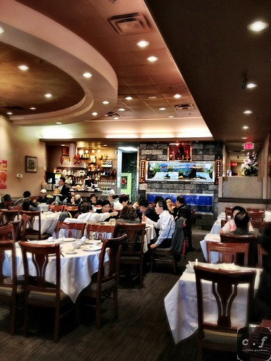

YELP REVIEW
This is a casual Chinese restaurant in Port Coquitlam, BC. The food is a bit pricy but worth it, the menu has many options to choose from and the food will never leave you feeling upset. As soon as you walk through the door you get greeted by the staff with a kind smile. This restaurant will always meet your Chinese food sweet tooth.

