Question: How does one recover from a tragic past?
Source: The Watch
In the short story “The Watch” by Ellie Wiesel, the author recovers from his tragic past by revisiting his home where he was taken from and brought to a concentration camp, before he was taken him and his family buried there valuables in there backyard to hopefully one day recover there happiness and memories of before they were taken from there home. As Elie Wiesel removed the dirt to find his treasure, “My hands claw the earth, impervious to cold fatigue and pain” (Wiesel, pg 3) the author shows that no matter what he will dig the whole yard just until he finds his watch. Unburying his watch brought the memories of his family who he had lost in the camps, the author uses the watch to symbolize himself and what he went through. The author recovers from his tragic past by leaving the watch behind to leave his past life of cruelty within the camps to create a new one. As Elie Wiesel walked away from his past “the sun was rising… For a moment I thought I heard the chanting of schoolboys studying Talmud ” (wiesel, pg 5) the author shows that the painful past can be forgotten but the Jewish culture will always be there. Ellie Wiesel was to soon learn what the near future holds for him.
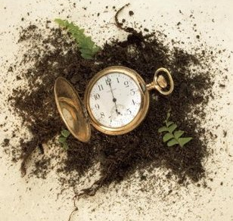
( https://images.gr-assets.com/books/1392084878l/20767461.jpg )

