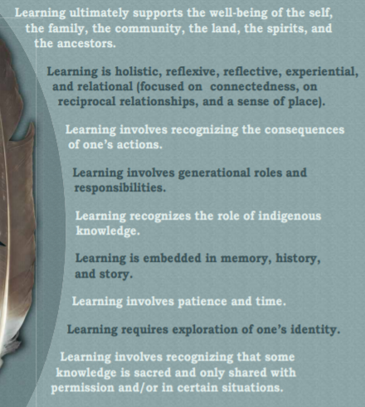
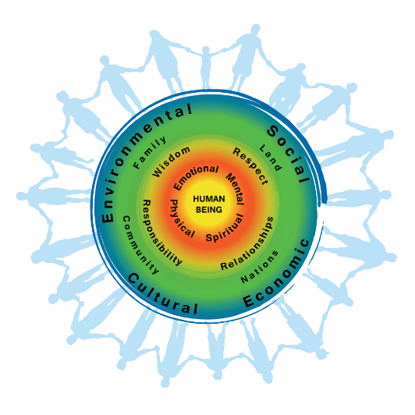
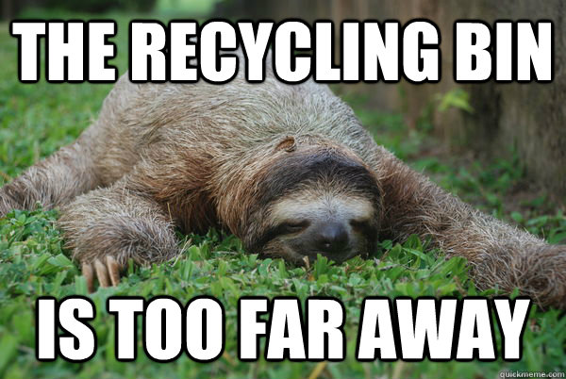

(interconnection) The first people’s principals of learning relates to our experiment because, for our experiments that we are working on we took roses and put them separately in each cup, one with water, one with sugar water and one with salt water and we found of the different effects that the different substances would cause on the roses and like it says in the First people’s principals that when we recognize the consequence of us changing the water that were learning how it will affect our roses and in bigger circumstances the world. We noticed how everything is interconnected and how if you add or substance or change the slightest thing can affect a lot in bigger and smaller situations. And through our experiment we had to take roles and responsibility in how we would create the experiment and continue collecting data each day. We had to wait to collect the data and it took time for the roses to show an affect we learned how to have patience, we learned by exploring the scientific capabilities.
( sustainability) Through the entire process we had to keep track and reflect on how we started all the way to the finish. In our natural world, we may not have sugar water in our rivers and lakes but we do have salt water and we are learning how that will change our environment and if it will eventually kill all the plants because of sea levels rising. So in our environment we have to make sure that everything is stable and at the same level through out time. The formation of everything that we learned will impact how in the future it could impact others and within our experiment we learned that one of the roses lived longer rather then the other ones and in the future instead of using growth products in your plants you could simple use a natural product other then a fake substitute and that could keep the levels of the environment naturally stable.

