Basketball – Almost every single year I’ve done school basketball except one year were my knee was badly injured. Shooting is one of my favorite things in basketball to do, other then dribbling, one of the main things I need to approve on is blocking people. Last year on my basketball team we only one a few games and lost really badly at the final game, we lost 44-3 the other team was the highest team to beat so they were really good.
Soccer- When I was little I loved to play the game were people can throw stuff at you in a violent way with no punishment…softball. Until around the age of 7 I played softball but from the age of 7 on I’ve become a huge soccer fanatic, I play on a Port Coquitlam division 3 team with a few of my friends, I usually play striker or in other words forward but many times I either play goalie or other positions.
My socer team last year.
Travelling- I travel a lot with my family, I’ve gotten to dip my feet in the nice sandy clear water of Mexico 13 times. I’ve gotten to ride a huge elephant in Malaysia where my dad was born. I’ve been able to explore many of the great wonders of Canada, and some with not just my family but my friends too. I’ve been on a few crew ships a couple in the Caribbean.
I took this picture at Stanley park with my friends.
Music- Music plays a huge roll in my life, from the way the beat just makes you have to move, to the quiet relaxing sounds that just sooth you. Almost all the music I listen too is rap music, the verses seem to put me in a trance. Every verse carries its own message and meaning
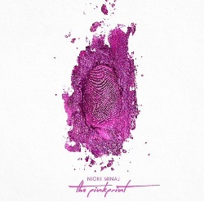 This is my favorite album by Nicki Minaj
Netflix- From the movies that make you die from laughter to the sad romantic movies that just make you have to shed a tear, movies are still movies, and that’s why I love them they’re are so many different types of movies out there for every single mood that you could be having. My favorite type of movie is the one were things are exploding, people are getting shot and things are destroyed. Action movies just seem to entertain me, maybe its from the way that a normal human being couldn’t do that.

