Name: Maebel BLK: D
Penny Lab
Purpose: To determine how many drops of water fit on one side of a
penny.
Hypothesis: If the liquid is placed on the penny it will decrease the surface cohesion, then the penny will hold less drops of water because it will make a slippery barrier that will go between the hydrogen and oxygen molecules.

Materials: (List all the materials used in the experiment)
- 8 pennies
- Two glass beakers (one is 50 mL containing water and 100 mL containing soap solution)
- Eye dropper
- Forceps
- Two paper towels

Procedure:
Part A: Perform a CONTROL test for comparison with later results.

Step 1: Rinse a penny in tap water and dry completely.
Step 2: Place the penny on paper towel.
Step 3: Use an eye dropper to place drops of WATER on the penny (one at a time) until ANY amount of water runs over the edge of the penny.
Step 4: Record the number of drops for that trial in the table.
Repeat Steps 1 - 4 three more times before calculating your average.

Number of drops  TRIAL 1 | Number of drops  TRIAL 2 | Number of drops  TRIAL 3 | Number of drops  TRIAL 4 | AVERAGE Number of drops
23 | 24 | 19 | 21 | 22

Part B: Perform tests with the TESTING LIQUID.

Step 1: Start with a “clean” penny. Rinse the penny in tap water and dry completely. Be sure to remove as much residue as possible - without using soap!
Step 2: Hold the penny with the tweezers provided, then dip it into the TESTING LIQUID. Allow extra liquid
to drip off the penny into the container before proceeding to the next step.
Step 3: Place penny on dry spot on a paper towel. Place drops of WATER on the penny (one at a time) until ANY amount of water runs over the edge of the penny.
Step 4: Record your observations and the number of drops for that trial in the table.
Repeat Steps 1 - 4 three more times before calculating the average.

TRIAL 1 | TRIAL 2 | TRIAL 3 | TRIAL 4 | AVERAGE
9 | 9 | 8 | 8 | 9
Observations:
Soap solution
Part One: Labelled Diagram of observations:  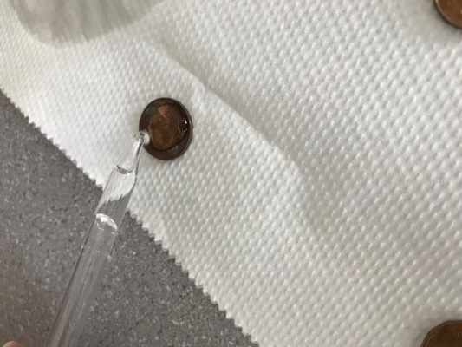  Dry penny  Eye dropper | Part Two: Labelled Diagram of observations:  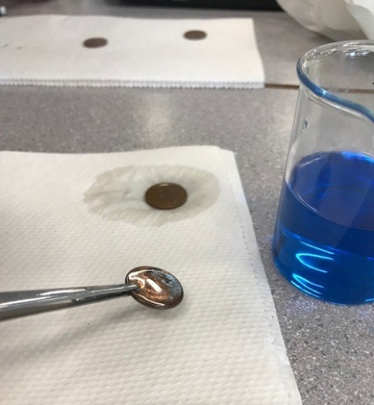  Forceps  Soap- soaked penny
- Description:  - Dropped water would make a ‘dome-like shape’ on the penny  - Penny was a rusty brown  - Water stayed on the penny longer  - Spilled water took up more space  - Water was transparent | Description:  - Took less amount of water on penny  - Dilooted the soap  - Spilled water took up less space  - Liquid was blue
Results:
Group # | Average Number of water Drops on the Control Penny | Average Number of Drops on the  Penny submersed in the soap solution
Group One | 20 | 9
Group Two | 25 | 8
Group Three | 26 | 6
Group Four | 23 | 7
Group Five | 22 | 9
Group Six | 14 | 5
Class Average: | 22 | 7

Conclusion:

This experiment investigated how many water drops can fit onto a Canadian penny with water and a soap solution.

To study the problem, the class did two trials of four pennies, where groups dropped water onto one group of four pennies, and one group of pennies dipped into the soap solution. Afterwards, there was a class average of how many drops were placed on the regular penny and the one dipped in the soap solution. Results showed that the regular penny held more water than the penny dipped in the soap solution. This proved that the hypothesis that if the liquid (soap solution) is placed on the penny it will decrease the surface cohesion, then the penny will hold less drops of water because it will make a slippery barrier that will do between the hydrogen and oxygen molecules.

How cohesion and surface tension come into play is the different between the regular penny and the penny dipped into the soap solution. In the class, most had a massive difference between the regular penny and the latter. How the class result could have been similar is the average amount of water that was dropped onto the pennies. Why there could have been difference is the inconsistent handling, and drops of water onto, the pennies

- To extend this experiment:
different variations of degrees of soap solutions could have been used. Instead of dipping four pennies into one soap solution, the class could use various degrees of soap in water. A certain amount of soap may hold more water than another.

- Questions about the experiment include (optional for this lab):
What soap to water solution would hold more drops of water on a penny?

- Finally, if the experiment was repeated, some changes to improve the experimental design:
having more consistent results within the groups. Groups could be given specific amounts to drop water, and an even amount of group members throughout the class.

Post 2 photos (penny with water only and penny with testing liquid) and your conclusion to your edublog site. Tag “Science10pennylab_Feb2018”

