My Dream Life:
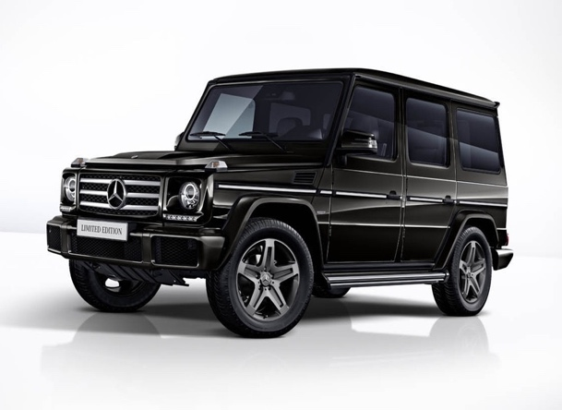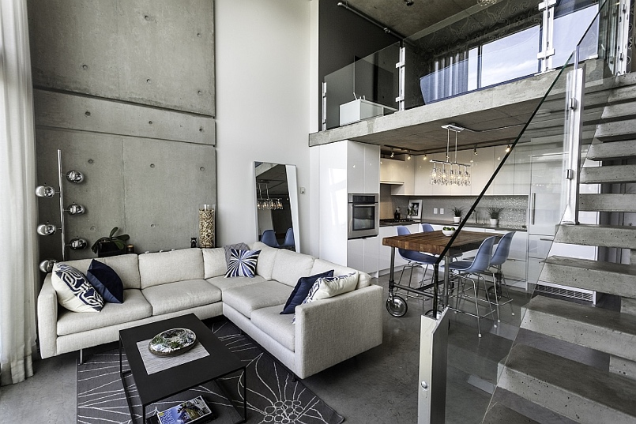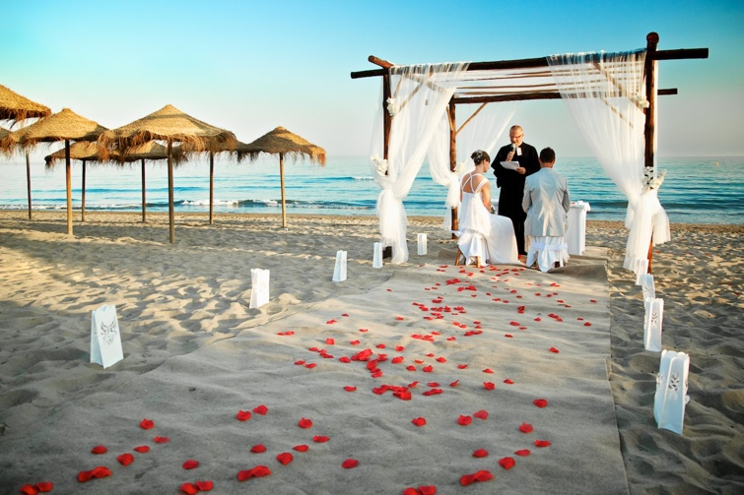
My Dream Lifestyle:

In my ideal life I would we living in West Vancouver in a modern loft with my husband Justin Bieber and my Pomeranian dog. I would get married on the beach in Maui, Hawaii and take frequent trips to any tropical place like Bora Bora, Bali and Punta Cana. I would get around the city in my Mercedes G-Wagon and play soccer regularly as it is my favorite thing to do other than travel. I would want to live a very luxury life and travel a ton to many new places. My regular day would consist of playing soccer, hanging out downtown, and shopping.

Surgeons annual income: $390,079-$641,950

Prices:
Car (Mercedes G-Wagon) = 224,195
Gas = $140.00 per fill
House (loft) = $1.2m
Wedding = $200,000
Child = $14,000
Travel to (2 weeks) = 4,000 per person
Dog = $600-$1,500

