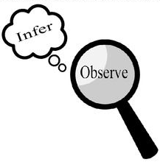
Observations and Inferences
Science 10 Name: Luka Mladenovic BLK: C

OBJECT | OBSERVATIONS  Words that describe the object | INFERENCES  Ie: Where might the object come from? Possible uses? Etc. | QUESTIONS YOU HAVE ABOUT THE OBJECT
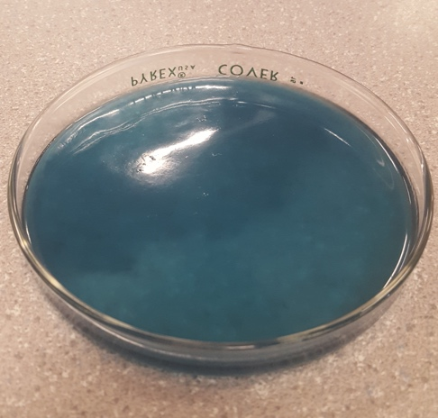 | Translucent  Blue  Liquid  Thick  Smells like soap/detergent  Moves slowly | It is probably a laundry detergent.  You can use it to wash clothes  It is not supposed to be drank.  It is made up of strong chemicals.  It was poured from a bigger container. | What brand is this?  What gives it it’s smell?  How old is this?  What chemicals give it it’s color?  Is it a mixture of chemicals?
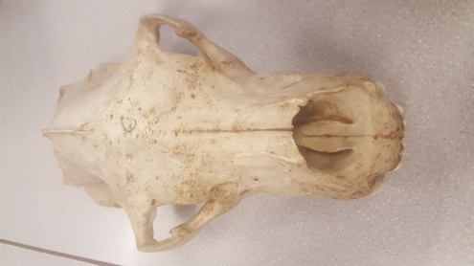 | It’s a bone  Dusty  Long two teeth  Big head and nose  Old  Jaw that sticks out on each side  Long head | It could maybe come from a k9  Maybe tiger  Its teeth are for hunting and killing based on sharpness  It is some type of dog descendant  The rest of the body has been separated from itself | Why such big jaws?  Is this animal living or extinct?  What animal does it belong to?  Why are one of its teeth chipped?  What kinds of animals did it hunt?  Was this animal a carnivore?
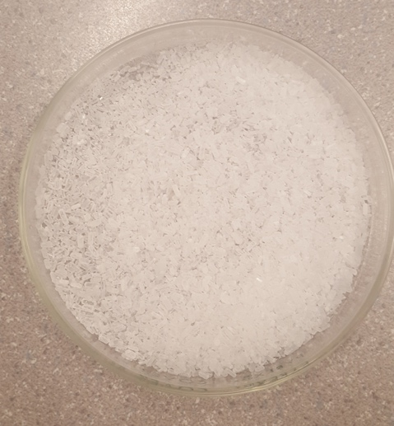 | White crystal texture  Looks like salt  Small pieces  Multiple pieces  Translucent until bunched together  It’s a solid  Very light | Salt before graining  Crystals  Easy to obtain  Easy to buy/cheap to buy  It’s a type of mineral | Is this edible?  Can you buy it?  Is it quartz?  Is it salt?  Where did you get it from?
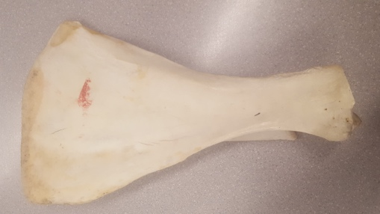 | Flat on one side, curved on the other  It has a  White/Pale  Has a red mark on it?  It’s a bone | It has been broken off  It is very old  It belongs to a big animal  It looks like a fin from an aquatic animal  The rest of the body has been separated from itself | How old is this object?  Is the animal extinct?  What Bone was this used for on the body?  What animal had this bone?  What did this animal eat?

Observations/Inferences Assignment Assessment
Name: _____________________
Ex: Excellent VG: Very Good G: Good S: Satisfactory IN: Improvement is needed
Criteria | IN | S | G | VG | Ex
The following is included
- All 4 Images included
Observations:
- A minimum of 5 detailed observations made
Inferences:
- Thoughtful and logical inferences made
Questions:
- 2 thoughtful and logical questions made
- Spelling/grammar
- Assignment was completed on time
/10

