Float Your Boat Challenge
By: Luka Mladenovic
Group Members: Carson, Molly, Brooke, Luka.
Science 10 Block C

Problem: To make a boat that can float and hold a number of pennies with limited supplies

Hypothesis: If the base of the boat is big in surface area, then the boat will hold the greatest quantity of pennies because it’s big enough to hold a lot of pennies.

Observations:
- 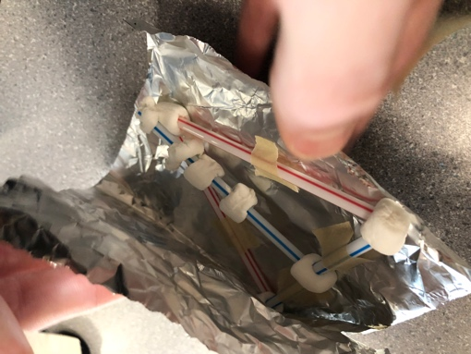 Inside of our boat.
- 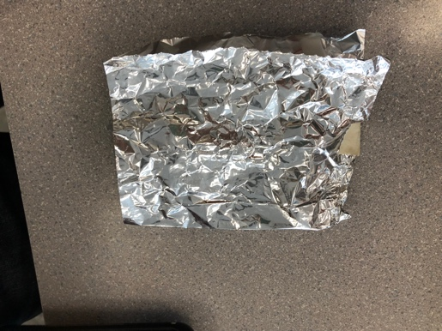 Front of our boat.
- 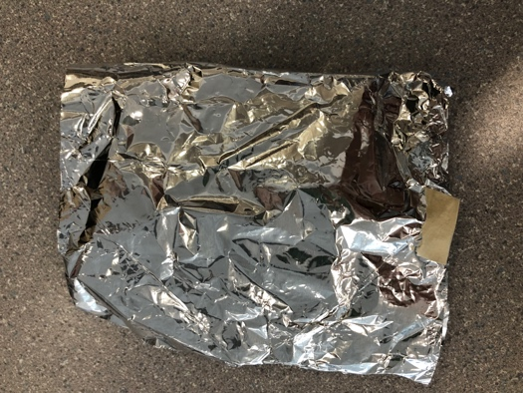 Back of our boat.
- 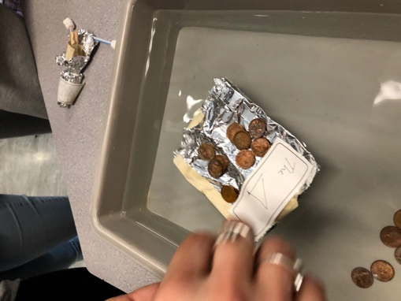 Our boat holding pennies in water.

Results and Conclusions:
The boat held 20 pennies

The original thinking and reasoning behind the design was to use a triangle base because it was the sturdiest shape therefore allowing it to have a stronger platform while holding coins. A lot of the material that others used towards walls, we used towards a base thinking that it would have a stronger hold for the coins.

If the following challenge was repeated, to improve the boat design, the following changes would be made. We would put more of an emphasis on sealing a wall and leave more room for the middle because water was leaking in from open holes from the sides, and there wasn’t enough space in the middle for the coins to be distributed properly without making it topple with such little weight added.

