Float Your Boat Challenge
By: Lina Pan
Group Members: Jason, Ashiana, Sabastain
Science 10 Block D

Problem:
Hypothesis: Use an “If… (independent variable) then… (dependent variable) because” statement.
If the structure is shaped in a large surface area in the bottom that kind of strong way then the boat will hold the greateat quantity of pennies because the larger the surface area, the larger the volume
Observations: Insert 3 pictures of the boat design and label them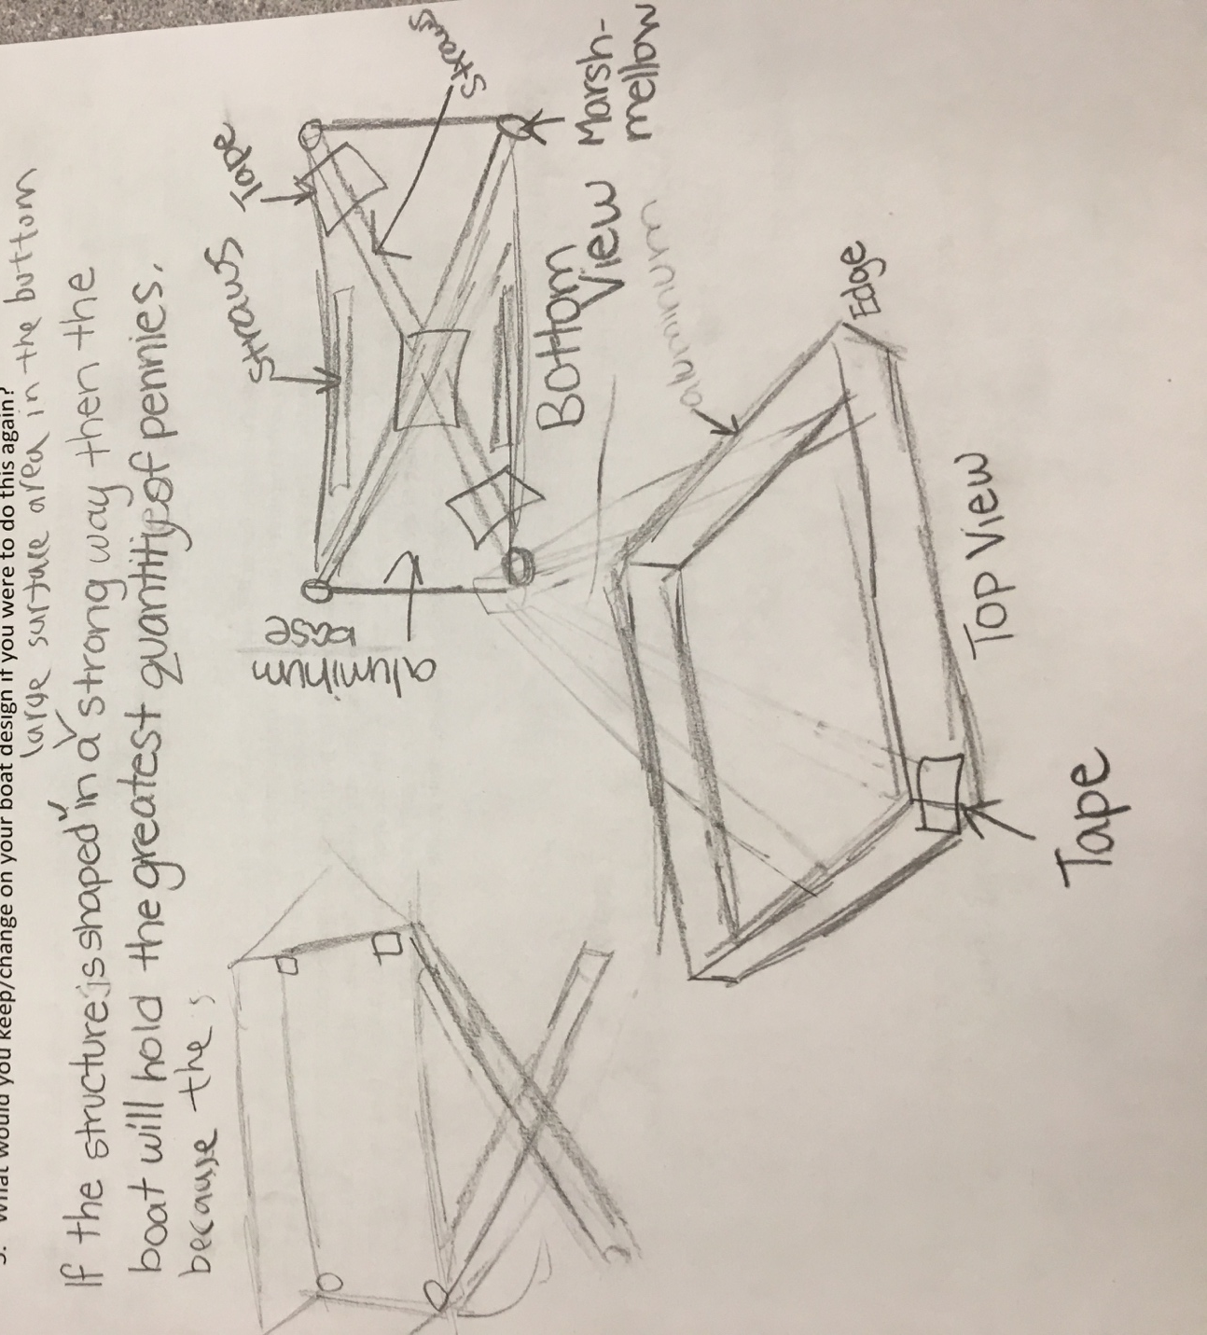
- Top view
- Bottom view
- Picture during the challenge
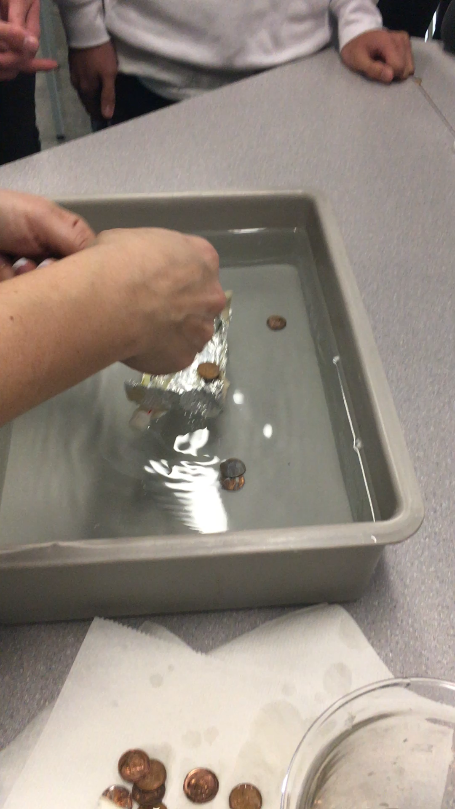

Results and Conclusions:
The boat held （42 pennies）

The original thinking and reasoning behind the design was （The shape of a ship, and then the general area of the bottom of the larger boat, you can carry the weight and the greater the number of goods ）stronger the base and surface was traingle

If the following challenge was repeated, to improve the boat design, the following changes would be made（The straws will be placed horizontally under the boat and the height of the waterline will be increased with the remaining straws and marshmallows）because（The greater the draft of the hull, the greater the capacity of the ship to carry the cargo）

Upload this document to your Edublog and Tag your post “floatyourboatdurandsc10blkD” add your block letter “C or D”

