Name: Lina Pan BLK: D
Penny Lab
Purpose: To determine how many drops of water fit on one side of a
penny.
Hypothesis:
If the liquid placed on the penny decreases the surface cohesion, then the penny will hold less drops of water, because the different liquid have different density

Materials:
8 pennies ，4 paper towel, tweezers，dropper，50ml soup solution，20ml water
Procedure:
Part A: Perform a CONTROL test for comparison with later results.

Step 1: Rinse a penny in tap water and dry completely.
Step 2: Place the penny on paper towel.
Step 3: Use an eye dropper to place drops of WATER on the penny (one at a time) until ANY amount of water runs over the edge of the penny.
Step 4: Record the number of drops for that trial in the table.
Repeat Steps 1 - 4 three more times before calculating your average.

Number of drops  TRIAL 1 | Number of drops  TRIAL 2 | Number of drops  TRIAL 3 | Number of drops  TRIAL 4 | AVERAGE Number of drops
19 | 22 | 21 | 16 | 19.5

Part B: Perform tests with the TESTING LIQUID.

Step 1: Start with a “clean” penny. Rinse the penny in tap water and dry completely. Be sure to remove as much residue as possible - without using soap!
Step 2: Hold the penny with the tweezers provided, then dip it into the TESTING LIQUID. Allow extra liquid
to drip off the penny into the container before proceeding to the next step.
Step 3: Place penny on dry spot on a paper towel. Place drops of WATER on the penny (one at a time) until ANY amount of water runs over the edge of the penny.
Step 4: Record your observations and the number of drops for that trial in the table.
Repeat Steps 1 - 4 three more times before calculating the average.

TRIAL 1 | TRIAL 2 | TRIAL 3 | TRIAL 4 | AVERAGE
8 | 9 | 10 | 9 | 9
Observations:
Part One: Labelled Diagram of observations: | Part Two: Labelled Diagram of observations:  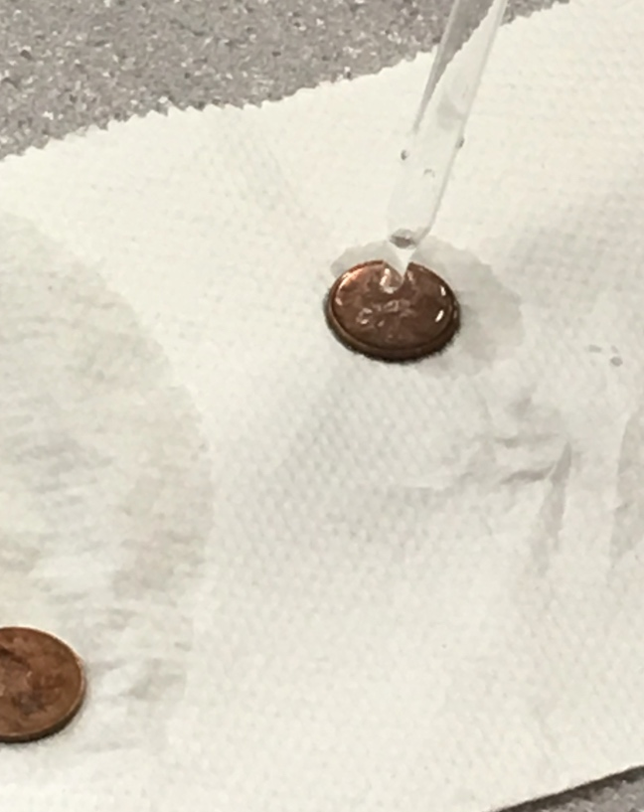
Description:  A penny that has been washed can drip more water while dripping with a dropper. However, because water is not enough, it is more difficult to squeeze | Description:  A penny that has been washed and after soaking in the soap solution, the amount of drip was significantly lower than before. Guess may be related to the density of different liquids
Results:
Group # | Average Number of water Drops on the Control Penny | Average Number of Drops on the  Penny submersed in the soap solution
Group One | 20 | 9
Group Two | 25 | 8
Group Three | 26 | 6
Group Four | 23 | 7
Group Five | 22 | 9
Group Six | 14 | 5
Class Average: | 21.66666 = 22 | 7

Conclusion:
This experiment investigated Whether the different liquid will affect the amount of penny drip.
In order to study the problem that the same penny, the amount of drip directly with a plastic pipette, and a penny soaked in soap with a plastic pipe drip quantity is different? Why did this happen?
Results showed Penny drip soaked in soapy liquid No ordinary penny drip more. Penny cohesion of the soapy liquid did not touch more
This proved that the hypothesis that if the liquid placed on the penny decreases the surface cohesion then the penny will hold less drops of water was supported because different liquids have different density, cohesion is also different. This experiment works on cohesion and surface tension. Because under the same conditions, the density and the condensing force are changed by the soapy solution, and the comparison is made. In addition, each experiment was carried out four times, and the accuracy was more secure.
To extend this experiment Under the action of surface tension, the droplet always tries to keep the sphere. So we don't use paint, we don't use brushes, we use liquid specific surface tension, water to draw, although it's a little bit easier but it's also very interesting.
Questions about the experiment include that We experimented indoors. If the temperature changes, the water tension will change or not? Because penny surface area is not large, if replaced by a larger surface area or smaller objects, water surface tension will change?
Finally, if the experiment was repeated, some changes to improve the experimental design could be don’t change the penny and water, and then can be more in touch some take the reagent testing, can also change the beaker and add a little water in the beaker, because the rubber head behind the dropper to the water pressure is not enough, water is not very convenient.

