
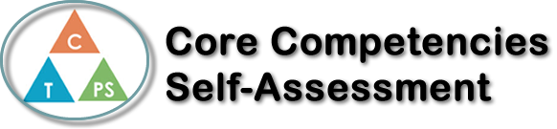
Name: Liam Campbell | Date: November 7, 2017

  How does the artifact you selected demonstrate strengths & growth in the communication competency?  In what ways might you further develop your communication competency? | Self-Reflection  In our Podcast project, a friend and I talked about the Turkish Invasion of Cyprus, and I think it turned out pretty well.  We didn’t want to make it all scripted, as that’s typically not how a podcast works; there’s usually actual conversations and debates that occur, so we had notes on the topic, and read them off before freely talking about them. I think it ended out pretty well, considering we did it all in one take.

x

How does the artifact you selected demonstrate strengths & growth in the thinking competencies?

In what ways might you further develop your thinking competencies?


How does the artifact you selected demonstrate strengths & growth in the personal & social competencies?

In what ways might you further develop your personal & social competencies?

Publish Your Self Assessment
You will now attach and/or embed your self-assessment to the bottom of the blog post with the artifact you have chosen. You may choose to make this post private or public. After placing your artifact on a blog post, follow the instructions below.
- Categories - Self-Assessment
- Tags - Now tag your post using the tag that corresponds to the competency that you have written about. You can choose more than one. Please use lower case letters and be exact.
  - #creativethinkingcc
  - #communicationcc
  - #criticalthinkingcc
  - #socialresponsibilitycc
  - #personalidentitycc
  - #personalawarenesscc
- Use the Add Document button located at the top of your post page and embed your self-assessment at the bottom of your blog post.
- Publish

