What does your digital footprint say about you ?
Your digital footprint can affect you in many ways. If it's positive then it can be a good way for people to learn about you. For example if you run an animal shelter that might help get a job in the future. But just say the results are not the best. Yes you thought those pictures of you and your drunk friends that you took years ago were gone but no. Years later you go to apply for a job, you worked hard in school and you when to college every thing is working perfectly for you until they Google your Facebook profile you thought you had kept hidden. Your digital foot print is like a permanent marker that can never be erased. So it turns out you don't get the job and the job went to the person who never had any social media and you thought was a loser. Now you regret posting everything you did for the last few years.
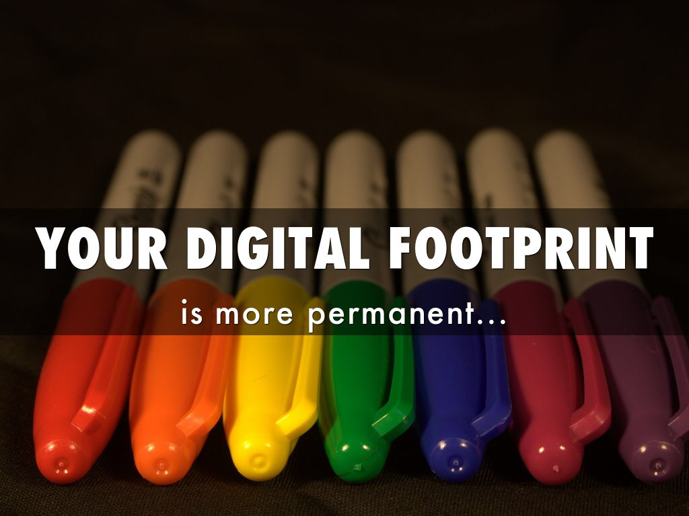
Another example is, is just say you run a dog rescue organization and you only post pictures of all the dogs you rescue with you what dogs need to be adopted. If you applied to work for the humane society to help protect abused and neglected animals. They can Google you and try to find out as much as they can about you, they find out you love dogs, you rescue them and find homes for them. You get hired. Not saying if you post a few photos of you and your friends having fun but the point is, is be safe and watch. What you post because you never know if it could come back to find you later.

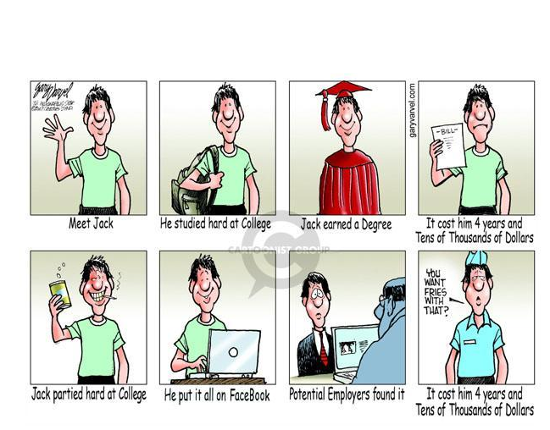
How to keep your digital foot print safe
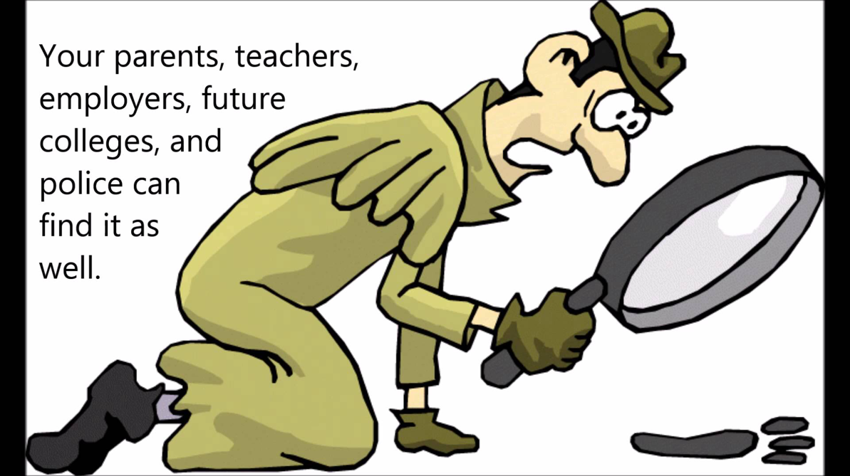
Keep your personal details safe and don't share them. If you must share them for some reason keep them private so only some can view. Always check the site you are at and don't just give your phone number and info to something you think is safe. Google the site and check it out and make sure you can trust it. This is your personal information we are talking about you don't give it to anyone. Or just watch what you post if it's ok then fine but if you post something you don't think is a great thing don't do it. . Don’t let people pressure you into posting pictures your not comfturble in posting. Look at the big picture and always think about any negatives that could come from your post. Even adding comments to websites or articles that require you to use your own name can show up on the Internet. Always use a password name or something unidentifiable that could not come back to you. It’s great to have our own opinions but a future employer may not share the same view as you and may think our options are offensive.
What I leaned about digital footprints
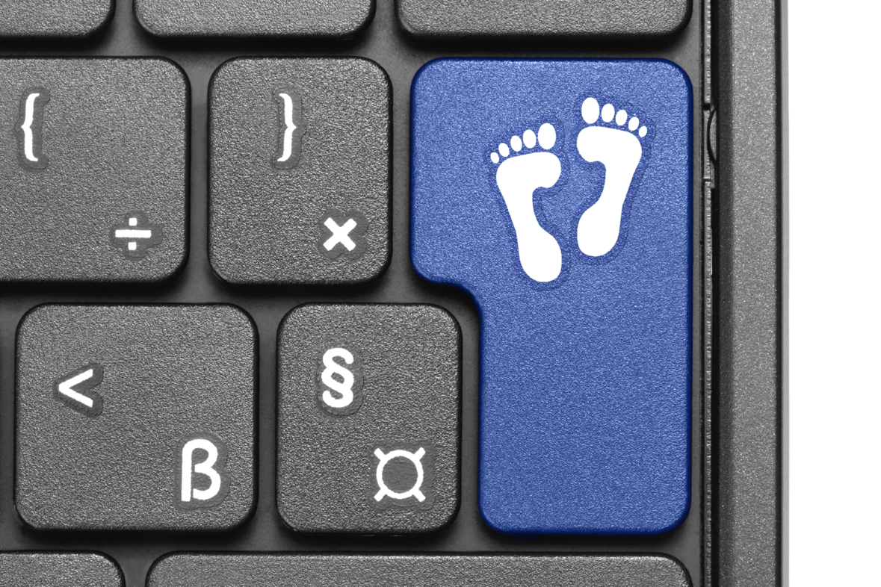
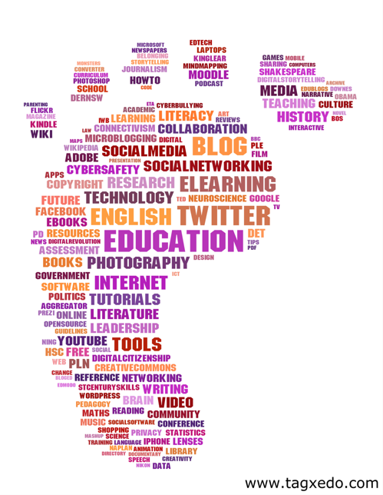
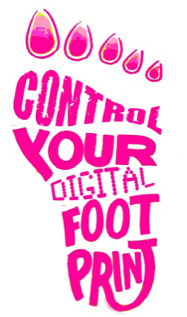
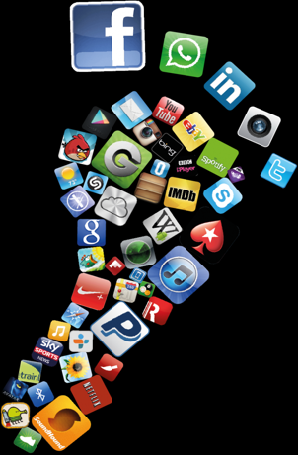
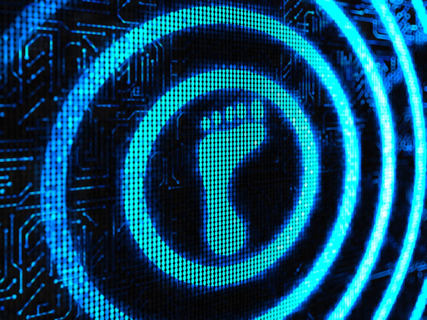
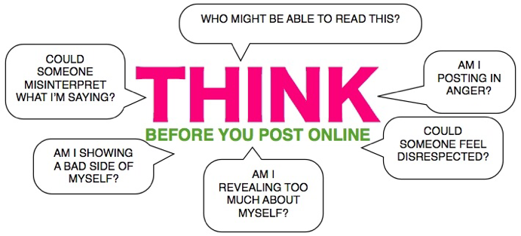
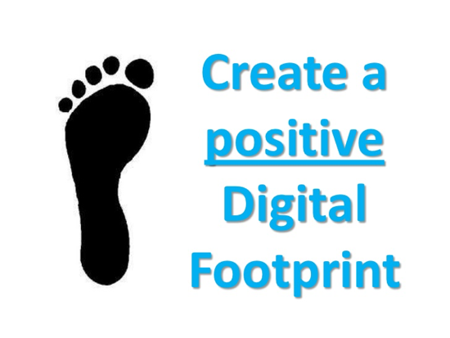
I learned that anything you post on line good or bad it will come back to you no matter how many years have gone by. Do we really need social media ? Social media can be good and bad in many cases it ends up bad. It can hurt your job opportunities in the future but it can also promote them if the things online are positive. I think it's ok to use social media but you just have to know the rules and be safe. The scary part is that anyone can look you up even if you don't have any social media. Just say when you where young your aunt posted a picture of you on her page. You might not even know this picture is online. But already at a young age your digital footprint begins and will only grow but it's up to you how you want to shape it and what it looks like. If I were to tell people about this I would suggest a social media awareness week and have a session that just talks about online safety and what can happen if your not careful. Why do we even want to post pictures of our selves publicly ? Why do we risk that stuff happening to us ?.
MY DIGITAL FOOTPRINT
I have researched my name and nothing has come up about me where I live and what I like to do. Maybe this is because I only have 1 social media and that's Pinterest. When I do use social media I never use my full name or my name. To me this helps protect you and your identity. I never put any of my personal information out and use a cod name. A lot of people ask why I don't have a lot of social media, that's because I never really liked it. I never found the thought of your face and your personal information being open to everyone a good thing. For me I don't post pictures of my self or others.
How I would tell people
I would suggest a school social media awareness week where we have people come in and set up demos of a bad social media site and a safe one. A school wide awareness week could help people get a real understanding of what could happen and how to be safe with it.

