
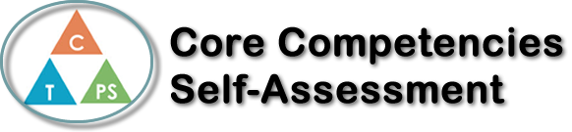
Name: Lauren Jadot | Date: 07/12/17

  How does the artifact you selected demonstrate strengths & growth in the communication competency?  In what ways might you further develop your communication competency? | Personal Awareness  Tell me about one of your learning goals. (Prompt: Something you want to get better at or learn how to do.) How did you come to that goal? Tell me about something you are doing to help you work on that goal?  I would like to be fluent in French. I am proficient to the point where I can hold a relatively boring conversation. My siblings are very fluent, and I feel left out when they are speaking to each other and I can’t understand them. The only disadvantage I can see is my hearing, seeing as how I can’t discern certain sounds and tones. In order to become fluent, it would take a lot of time dedicated to figuring out the sounds that I can’t hear.  What do you do to help yourself when you are feeling a bit discouraged about your work?  When concerning first aid, I try to think about the situations in which my skills would be beneficial, to give myself incentives and motivation to continue learning. Some concepts were hard for me to grasp, though I believe tried my best. I feel as if I have improved my ability to persevere.  In conclusion, I feel like I didn’t deserve to pass the first aid exam. I didn’t study as much as other people did, and still I passed with flying colors. I don’t understand why I passed, to be honest.


How does the artifact you selected demonstrate strengths & growth in the thinking competencies?

In what ways might you further develop your thinking competencies?


How does the artifact you selected demonstrate strengths & growth in the personal & social competencies?

In what ways might you further develop your personal & social competencies?

