Initial assignment
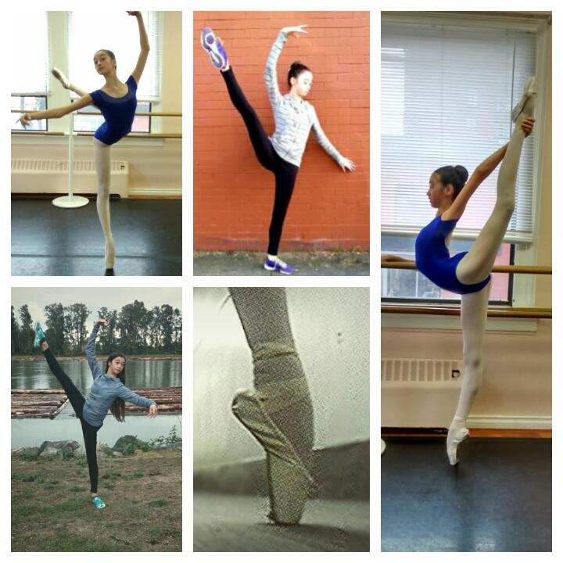
Ballet is probably one of the most important things in my life. These are just a few photos of me while I’m dancing. To me, ballet isn’t just exercise or sports. It’s my passion. It helps me let go, forget, and escape. The first time I stepped into the Goh ballet (my current ballet school), I was terrified, and excited. I remember walking in and feeling the heavy and sticky atmosphere. The hard work and dedication was imminent through the stench of sweat. To my left, dancers in a class were leaping into the air, how a frog bounds off lily pads with strong legs, as they pushed off of the marley. Students ran past me to get to the water fountain, parched and panting like dogs. A few girls that I walked by were on the ground and tending to their swollen, blistered and bleeding feet. The pain of pointe shoes came quickly, through countless hours of rehearsals through turning, and quick footwork, and for all that, you get two minutes onstage. And yet I love it, the sweet torture of perfecting every single tiny detail, something as small has how you hold your fingers. One day I see myself preforming for an audience of thousands, though they never see the difficulty of the steps because making it look effortless is what matters most. The girls on the floor were in preparation for their next class. Classwork is just as- if not more demanding. It is when all the technique is taught. It’s when you feel your muscles tightening and releasing like an elastic being pulled and twisted. But through all the harshness and pain, many find great comfort and freedom in dance as I do. The feeling of being onstage, it always feels familiar like an old friend, but it’s also foreign at the same time. Lights dim, people fall silent. The moment is yours. I dance, I let go, I do everything more than I ever could. I reach my arms out as if to take hold to a rope for my life, I kick my legs high with the strength of a boxer. Every time I dance like this, I become a better version of myself. I accept that this is what I want to do with my life. In these moments, I realize what it is to me. A passion, a lifestyle, an obsession, an addiction, it is art. It’s me.

