Food and you assignment:
Yelp review: Amazing food and service, loved the comforting style of the restaurant!
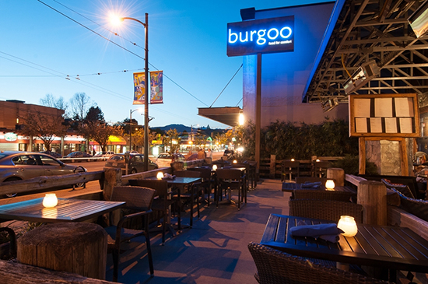

Comfort food meets fine dining- Burgoo has it all
The Burgoo restaurant in Mount Pleasant is by far one of the best and most innovative restaurants in Vancouver. The location is easy to find with a big blue glowing sign welcoming you. The dining area isn’t the biggest, but the coziness adds to the warm atmosphere and comfort food style. When you walk in, the rustic décor makes you feel at home, with elegant wood tables and a quiet mini waterfall waiting to greet you. The dim lighting creates an intimate experience, and candles on the table make the perfect date night restaurant. When I entered, the aromas from the kitchen were delightful, mixed with spice and herbs. I couldn’t wait to look and order from the menu! We were seated at our table and the soft leather binding of the menu felt very professional for a place that was all about comfort food. Burgoo features different types of comfort food from around the world, which I think is a very interesting concept. You can try a bit of everything from around the world! When we got our food, by far the best appetizer they had was baked salmon cakes with hollandaise sauce. The flavour of the salmon, with the creamy and rich sauce, topped with green onions makes the perfect opener to an amazing evening. But the true stars of the menu were the entrees, including baked mac and cheese, jambalaya, and my personal favourite- the ratatouille. The vegetables were deliciously seasoned with olive oil and herbs, baked and put in an elegant white dish and topped with parmesan cheese. One thing I liked particularly was the beautiful plating of our food. On our appetizer, the pink of the salmon and the soft yellow of the sauce was very appealing to the eyes. Perhaps the highlight of the evening was when our dessert came, a chocolate mousse topped with whipped cream and a single mint leaf. The mousse was airy, creamy and of course delicious. With our waitress, the service was welcoming and helpful, and accommodated to requests about seating and food. Their hospitality truly made the experience feel like home. The whole idea of Burgoo is comfort food, elevated- and that theme was very prominent and enjoyable. The overall mood in the restaurant was surprisingly relaxed, considering the quality of the restaurant. Glasses clinked at the sound of a party celebrating, and we heard the laughter and conversation from a group of friends who had gathered here. When we got our bill it was fairly priced, at around 25- 30$ per person. Burgoo was well worth the trip to Vancouver, it’s definitely now one of my favourite restaurants, and probably always will be.

Proofread by Nick

