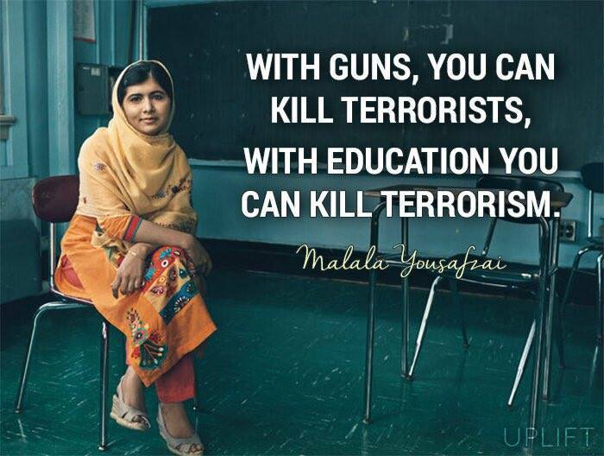

Malala Marches Toward the Nobel Peace Prize
By Aryn Baker @arynebakerOct. 09, 20130

Robin Utrecht / Xinhua / Zuma Press
Malala Yousafzai speaks after winning this year's International Children's Peace Prize at The Hague, on Sept. 6, 2013.
This Friday, the Nobel committee announces the 2013 recipient of the Nobel Peace Prize. As far as global opinion is concerned, the award is a 16-year-old Pakistani girl’s to lose.
Long before she became a global symbol of children’s education, Malala Yousufzai was one girl squirming under the thumb of the Pakistani Taliban, whose draconian interpretation of Islamic law saw girls’ schools closed in her hometown of Mingora in early 2009. In a frank and witty blog published on the BBC Urdu website under a pseudonym, Malala, then 11-years-old, chafed at the new regulations that limited her freedom, stopped her from learning and kept her from seeing her friends. The pseudonym, of course, was meant to protect her identity, but it was not long before her private persona—the outspoken daughter of a prominent school administrator—meshed with her public one, and she took her demand that a girls’ right to education be recognized across Pakistan to a national audience, appearing several times on TV talk shows and eventually in an international documentary. “I wanted to speak up for my rights,” she told the BBC on Monday, when reminiscing about her early activism. “And also I didn’t want my future to be just sitting in a room and be imprisoned in my four walls and just cooking and giving birth to children. I didn’t want to see my life in that way.”
Malala’s adolescent campaign to educate her country’s girls might have stuttered along with little more than a condescending pat on the head for years—after all, Pakistan, riven by insurgencies, beset by economic crisis and threatened by the advance of a fundamentalist uprising in the tribal areas along the Afghan border, was simply struggling to maintain status quo—but for the fact that the Taliban tried to keep her quiet. On Oct. 9, 2012, long after Malala’s quest had faded from national headlines, a gunman bounded into her school bus one afternoon and shot her point blank in the face. That Malala survived, with her mind, her voice and her luminous smile still intact, is nothing short of miraculous. Whether that miracle is attributable to God, as Malala says, or to the doctors in Pakistan who performed the initial surgery to relieve swelling on the brain and the surgeons in Birmingham, England who followed up with reconstructive surgery and rehabilitation therapy, is immaterial compared to what she did next. She kept fighting.
Less than four months after the shooting, Malala appeared in a video announcing that she was taking her campaign for girl’s education global through a new charity: “I want every girl, every child to be educated. And for that reason, we have organized Malala Fund.” On March 19, 2013, she returned to school, this time in Birmingham. On July 12, her 16th birthday, she appeared before the United Nations at a specially-convened assembly of 1000 youth leaders to exhort nations to make education a priority. “Let us pick up our books and our pens. They are our most powerful weapons,” she said in a voice ringing with strength and conviction. “One child, one teacher, one book and one pen can change the world. Education is the only solution. Education first.”
By winning the Nobel Peace Prize, Malala would join a long list of recipients that have sought to achieve peace through human development, from Muhammad Yunus and Grameen Bank in 2006 to Médecins Sans Frontières in 1999. To Malala, peace and education are inextricable; without one, you can’t have the other. “I hope that a day will come [when] the people of Pakistan will be free, they will have their rights, there will be peace and every girl and every boy will be going to school,” she told the BBC. Peace, she suggested, starts with a conversation. “The best way to solve problems and to fight against war is through dialogue,” she told the BBC, an exhortation that she hopes her Taliban attackers will follow as well. “They must do what they want through dialogue,” she said. “Killing people, torturing people and flogging people … it’s totally against Islam. They are misusing the name of Islam.”
A Pakistani Taliban spokesman quickly rejoined with a threat, telling AFP “We will target her again and attack whenever we have the chance.” It’s a threat that Malala easily shrugs off. “I don’t know why, but hearing I was being targeted did not worry me,” she wrote about earlier Taliban threats against her and her family in her recently-released autobiography, I Am Malala: The Girl Who Stood Up for Education and Was Shot by the Taliban. “It seemed to me that everyone knows they will die one day. So I should do whatever I want to do.” In an appearance Tuesday on Jon Stewart’s The Daily Show, after he offered to adopt her, Malala recounted an early conversation she had with herself when she first heard of Taliban threats to her life, when she was 12. First, she said, she thought she would hit any Taliban attacker with her shoe—a comment that drew hearty chuckles. She added: “I said to myself, if you hit a Talib with your shoe, there will be no difference between you and the Talib. You must not treat others with that much cruelty and harshness. You must fight others, but through peace and through dialogue and through education.” Then, she said to herself, “I will tell him how important education is and that I even want education for [his] children as well.” Even Stewart choked up.
Little seems to have changed in the wake of the shooting. “I was spared for a reason — to use my life for helping people,” she writes in her book. In the BBC interview, she reiterated her desire to return to Pakistan one day to become a politician. One that will make education compulsory for both boys and girls. If anything, she says, the Taliban attack only amplified her voice. “When I was shot they thought the people would be silenced, they thought that no one would talk,” she told the BBC. “I think they might be repenting why they shot Malala.”
Read more: http://world.time.com/2013/10/09/malala-marches-on-toward-the-nobel-peace-prize/#ixzz2hKtWgKmg

