Sophisticated Chinese Food

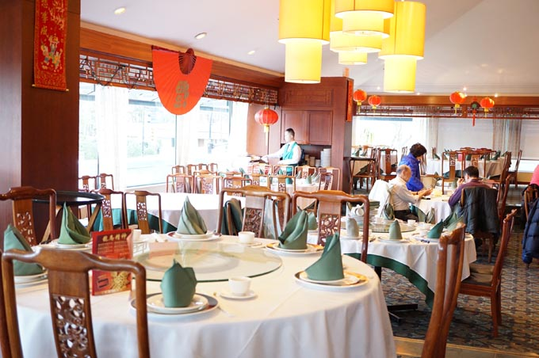
China is home to beautiful food and culture. Through Chinese restaurants, like Kirin, we can experience a bit of China. My uncle married a Chinese lady, so I was invited to eat a fancy Chinese dinner at Kirin restaurant in Vancouver. The entrance to the restaurant was luxurious with a jade coloured material behind the Kirin sign. As you enter the carpeted area, you begin to see all the lobster and crabs in their tanks, ready to be eaten. The room was filled with the colour red and gold. The walls covered with windows displaying the downtown area. But, this was only the restaurant wasn’t why I came. I came for the food and my uncle. Speaking of the food, it was out of this world. I ate many meals at my time in Kirin. Suckling pig was a meal I remember fondly. The meat was cold, but it made up for it with this one crunchy side. They served bird’s nest soup. Before this point, I had never heard of bird’s nest. Fortunately for me, there was an older Chinese man at my table that tolled me the origins of bird’s nest. He said in Taiwan, they have farms with some plant, a bunch of trees, and a bunch of birds. The birds would go and eat the plants and chew it, then spit it out. The bird would form a nest out of the spit as it hardened. Final the farmers would come to collect the bird’s nest for eating. The soup wasn’t bad as you may think. The nest lost its form and became noodle like. It had a cool different taste to the fluid. Like many foods I ate here, I also have never heard of pickled jellyfish. This was the most interesting food I had here. The Jelly fish was in strips. It was like very firm Jell-O and though not crisp, it was chewy in a crunchy way. It didn’t really taste like munch, but I enjoyed it anyway. Another meal I got was spinach with a sea pickle. The sea pickle was just this tube of meat. I ate it and its texture was kind of stringy from what I remember. Everyone has heard of deep-fried chicken, but have you heard of deep-fried shrimp? None of these dishes compare to the glory that is the deep-fried shrimp on a lobster pincher. This maybe the best food I have had in my life. You have this crunchy and juicy shrimp ball you eat off the lobster pincher, and when you are all done that, you get the lobster meat inside the claw. But, with all this great food would come with a great price from what I can imagine. They had a decent selection of Drinks. They had some pop and they had a bar, but I did not use it. Later in the meal they brought some sparkling drink that I enjoyed a lot. I loved my experience at Kirin Restaurant. I wish to go again soon.
Proof read by: Nicholas
YELP
China is home to some of the best food. Kirin brings a part of China to Canada. The deep-fried shrimp is a must try.

