War of 1812 Discussion Questions

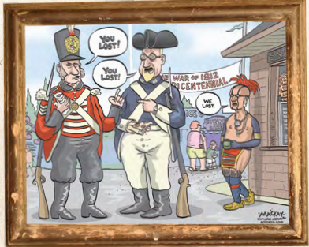
- Based on the political cartoon above, what do you think it is saying about the War of 1812? Do you agree? Why or why not?

- What were some of the main causes of the War of 1812? Which of these causes would be considered long term and which would be short term?

- What are some of the results of the War of 1812? How did these results impact Canada as we now know it?

- What are some of the key events that occurred in the War of 1812?

- What role did the First Nations people play in the War of 1812?

- Why were Americans not completely supportive of the decision to go to war? Why did Americans living in British North America not support the American military?

- In your opinion, who won the War of 1812? Give 3 reasons why you feel this way.

