Java Basics Assignment
Java is an Object Oriented Language. What does this mean? Provide a real world example that you can show to demonstrate that you understand this. How is this different from a procedural language?
What is the difference between a “Class” and an “Object”?
There are four basic principles or “pillars” of Object Oriented Programming (OOP). What are the principles? Give a brief example or explanation of each. Some of the concepts can be challenging to understand so try your best.
Java has 8 primitive variable types. What are they? Provide the name and a brief explanation of each.
What is a method and what is the purpose of them?
What is the difference between making a class public or private?
How are semi-colons used in Java?
What are some important loops to know in Java? When would you use the different loops?
What is the purpose of the “Curly Braces” in Java?

Algorithm challenge:
Understanding how to create and read algorithms is an important skill for programmers to have. Try out these algorithm problems to see how well you can do!
Question 1:
A person wants to use a lawnmower. The person goes to a lockable shed, opens the shed door, removes each object, in turn, that may be in the way and pushes the lawnmower out of the shed. Which of the following algorithms best describes this task?
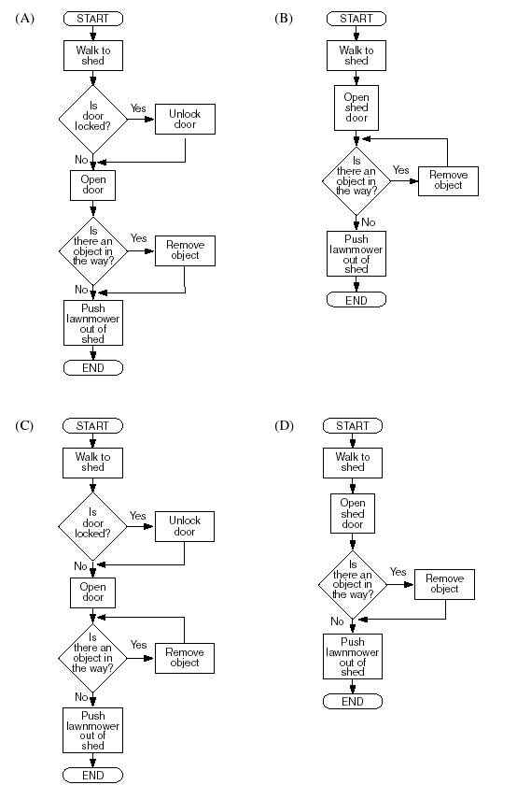

Question 2:
In a buyer rewards scheme, customers accumulate points each time they purchase goods. There are four levels of rewards: Bronze, Silver, Gold and Platinum, depending upon the number of accumulated points. The algorithm below is used to calculate the reward level each time a purchase is made.
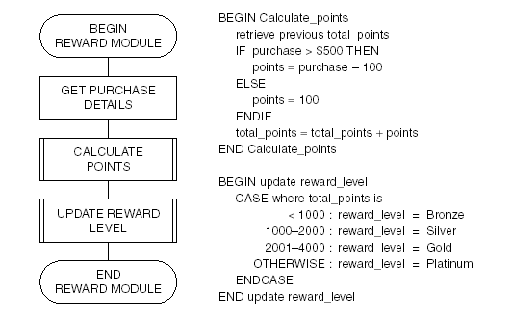
A customer who has already accumulated 700 points makes new purchases of $500 and $1300.
Their new reward level will be
(A) Bronze.
(B) Silver.
(C) Gold.
(D) Platinum.

Question 3:

READ A
READ B
REPEAT
SET C TO (A+B)/2
PRINT C
READ A
READ B
UNTIL A = 0

The following values are entered in sequence
4 6 2 0 0 8 3 5.

Which of the following shows the correct output?
(A) 5
(B) 51
(C) 514
(D) 5144

Question 5:
BEGIN
set A = 2
WHILE A < 7
read B
set A = A + B
print A
ENDWHILE
END
If the values available for B in the above algorithm are 1, 3, 1, 1, 5, then the output from the algorithm would be
(A) 3, 6, 7
(B) 3, 6, 7, 8
(C) 2, 3, 6, 7
(D) 3, 5, 3, 4, 7

Question 6. Two players take turns until they guess a secret number. After each guess the player is told if the guess is too low, too high, or correct.
The algorithm that best illustrates this game is
