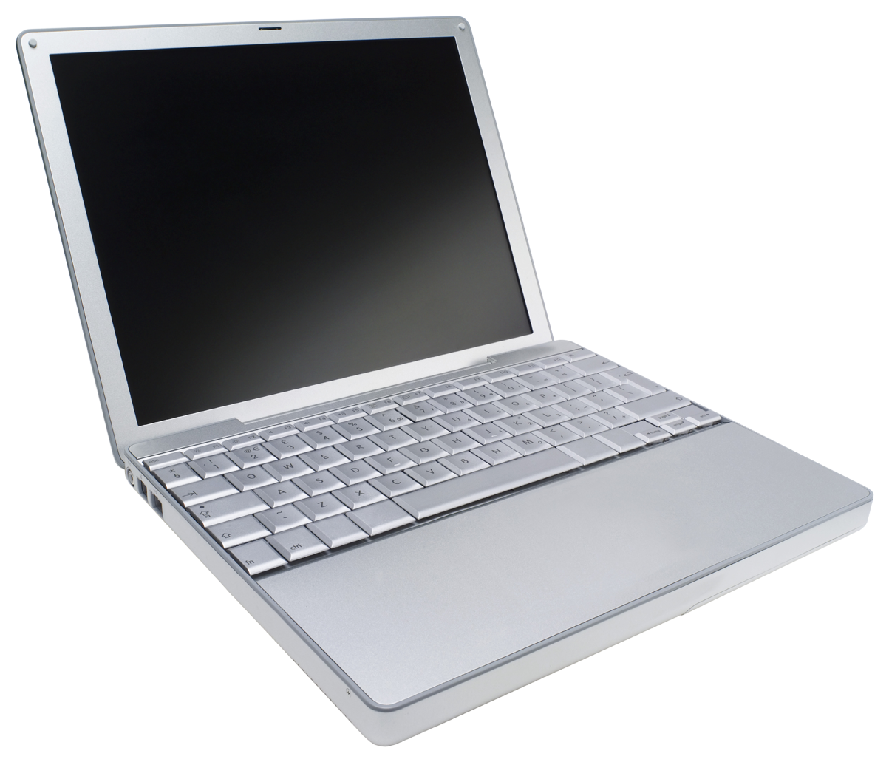
ICT Programming 11 Course Outline
Riverside Secondary Mr. Jamieson kjamieson@sd43.bc.ca
Welcome to Programming 11. You’ve made an excellent choice by deciding to take this course. Programming skills are becoming more and more important in today’s world and this course is designed to give you an introduction into the world of programming. Learning to program will help develop many skills that can be applied into any field not just coding. Programming really focuses on developing analytical and problem solving abilities.

Course Description
ICT 11 will introduce the basic components of computer programming with a focus on Java and HTML. Based on the ability of the class this may also lead into an introduction in mobile app development. Students will learn to use logic and problem solving strategies to gain an understanding of how a program works.

Students will be given the opportunity to work with multiple different platforms and interfaces throughout the course as they continue to develop their skills and abilities.

Course Evaluation:
Each unit will entail a number of smaller, guided assignments in addition to a larger ongoing project. Students are encouraged to challenge themselves and to go ahead of the pace of the class as this will provide them with the most opportunity for learning.

Guided Projects | 20 %
Projects | 40 %
Test and Quizzes | 10%
Independent Study | 15%
Personal Blog/Website/Team Support | 15%

Student Expectations
- Be courteous and respectful during class time
- Arrive to class on time, ready to work
- Take personal responsibility for work and participation
- Work as a group to solve problems. Your classmates will be a great resource
- Ask for help as many times as you need to find success
- If you have your own device that you would like to bring and use in class you are more than welcome to.
- Please avoid eating and drinking anything other than a capped bottle at your work station

