Animaila

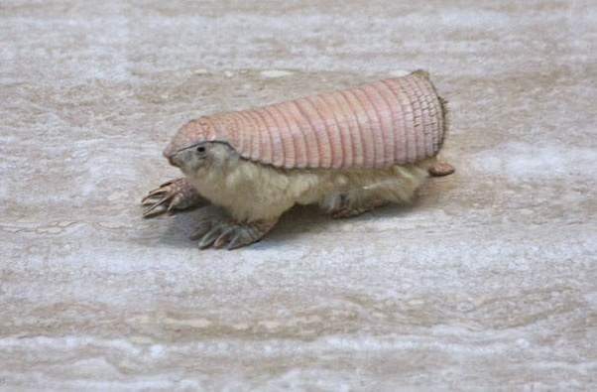
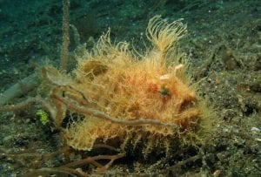
- Striated frogfish 2. Pink fairy armadillo

These animals both come from the kingdom of Animaila and in the phylum of chrodata. All animals are multicellular, eukaryotes and most have tissues, organs, and organ systems but they have no cell walls.
Plantae
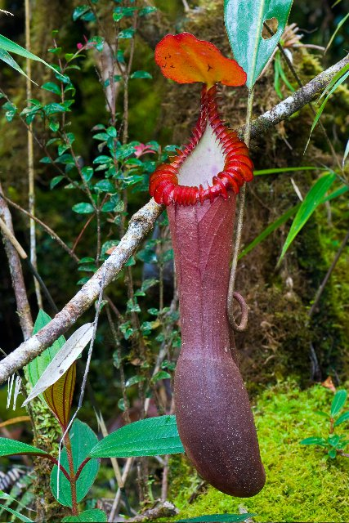
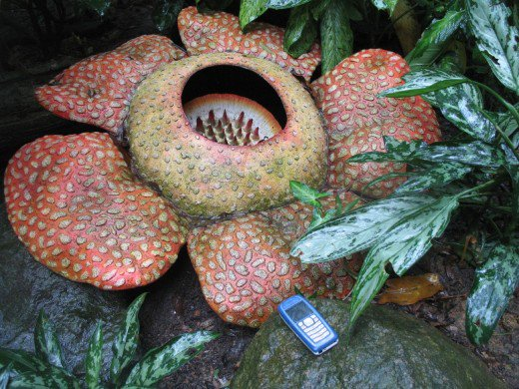
- Rafflesia 2. Nepenthes

These plants are part of the plantae kingdom. They both have cell walls and eukaryotes, autotroph, and multicellular. They also need the following for survival – sunlight, gas exchange, water and minerals, as well as movement of water and nutrients.
Protista
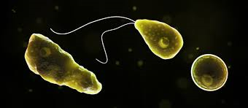
- Wakame 2. Naegleria fowleri

These Protista are both eckaryotes and mostly or some multicellular, Both live and grow in watery habits.
Fungi
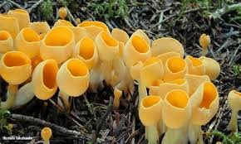
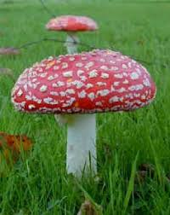
- Basidiomycetes 2. Sac

Fungi all have cell walls, hyphae, mycelium, and fruiting bodies which reproductive structure. Fungi spread quite a bit but they need the proper temperature, moisture and food to be able to spread.

Archaebacteria

- Lokiarchaeota 2. Thaumarchaeota
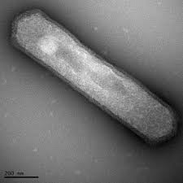
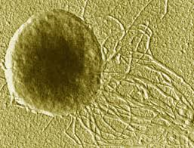

These Archaebacteria are prokaryotes and have cell walls that lack peptidoglycan. They live in extremely harsh environments.

Eubacteria

- Cyanobacteria 2. Proteobacteria
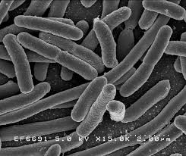
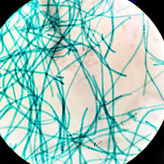

These Eubacteria are prokaryotes and cell walls that contain peptidoglycan which is sugar and amino acid molecule. They live almost everywhere and can cause diseases

frogfishw.quora.com/What-are-some-weird-animals
https://wwhttps://en.wikipedia.org/wiki/Striated
https://www.quora.com/What-are-some-weird-animals
https://owlcation.com/stem/10-Most-Wacky-Plants-of-the-World
https://en.wikipedia.org/wiki/Rafflesia
https://en.wikipedia.org/wiki/Nepenthes

