DUNKIRK

**Location: Dunkirk, France**

**May 26 – June 4, 1940 (second world war)**

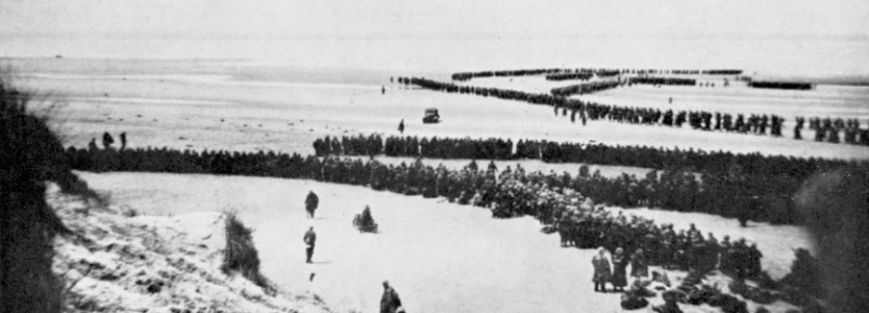

The German army trapped the British and France armies on the beaches around Dunkirk

The Battle was fought between the Allies and Nazi Germany

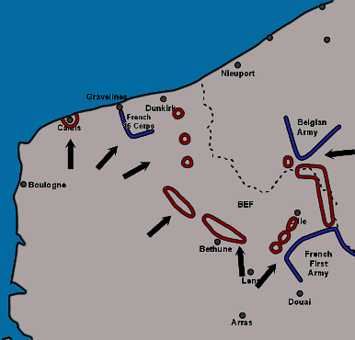

**330,000 men were trapped on the beaches and were sitting targets for the Germans.**

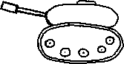

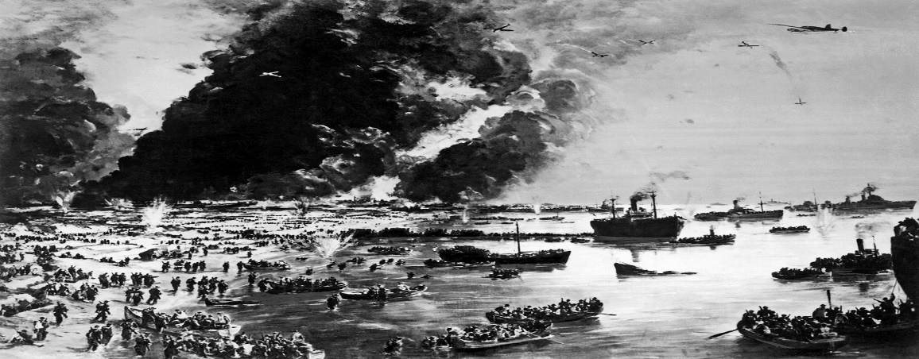

**Allies had 18,000 killed Germany had estimated 20,000 killed and wounded 100 tanks and 156 aircrafts**

**Hundreds of boats joined the nary to cross the English Channel**

