You won’t believe what this restaurant puts in its FOOD!

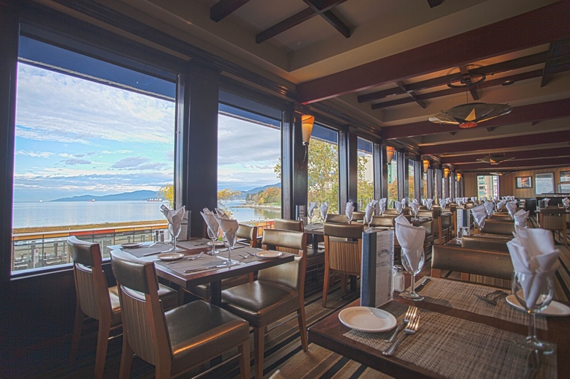
The building looks nice from the outside whit a great park right across the road and a grand entrance but when you walk in, you immediately notice the tall ceilings, the enormous brick fireplace, and wooden beams scattered thought the restaurant. The Boat House is a very open and atmospheric restaurant. When walking in, one is immediately approached my one of the extremely polite staff and seated, if there is no seats available they kindly ask you to wait it’s never too long. While waiting I like to walk outside and sit on the dock and enjoy the sea breeze. The experience is premium, as you are given time to talk, socialize but it’s not long before your food arrives. If one is in a rush this is not the restaurant for you. The food is superb, Almost anything on the menu will be high quality. Personally, I enjoy the crab and sea food because for me this is a special occasion restaurant. I have dined there on Birthdays and Father’s Day or Mother’s Day. It’s perfect of those types of occasions. The atmosphere is very friendly and welcoming, it’s like a summer cabin. The waiters, staff are nice and friendly. The thing that I think is perfect about the boathouse is the location in Port Moody right next to the water. The people that made the building had this in mind and it shows with the large windows letting in ample amount of natural light. But with this great new and great food and quality comes a price it is well worth it but if you are not looking to spend triple digits for 3-4 for dinner this is not the place for you. It is a very nice restaurant with great food and a beautiful interior and it’s great for occasions and I would suggest it or at least try it!

Yelp review.
The boat house is an amazing restaurant if you are in the port moody area especially if you are traveling and looking for a superb dinner! I have been there a few times and the service is always welcoming and the area is beautiful. The location is right on the water and if you can get a spot nest to the window you can see their amazing garden and the breathtaking scenery. The food just adds to the premium feel of this restaurant they are famous for their steaks but personally I love the crab. Keep in mind when I was there the prices were high but justified. In conclusion if you are in the area and willing so spend money for a great meal the boat hose is the place to go.

