**SMART GOAL: Personal**

(Specific, Measurable, Achievable, Realistic, Timely)

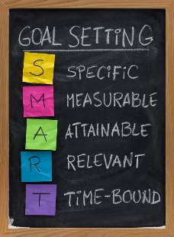 **GOAL STATEMENT:**

I want to draw better.

**WHAT DO I NEED TO REACH THIS GOAL? (The steps you**

**must take in order, and the date you wish the step to be**

**completed by.)**

I will draw every day for 6 minutes if after the 6 minutes I want stop I can or I can continue until I’m finished drawing. This will motivate me to draw just a little every day and the 6 minutes makes it so it’s not a chore but I still have the option to continue.

**HOW ARE YOU GOING TO MEASURE THE PROGRESS TOWARDS**

**YOUR GOAL?**

If I can draw original things without reference that look good to other people. I will finish my goal by filling up a notebook with drawings and other

**OBSTACLES YOU MIGHT SOLUTIONS**

**FACE**

I will practice.

I will reference while am starting and I will get inspiration.

I cant draw.

I’m not creative.

**WHO ARE YOU GOING TO SHARE YOUR GOAL WITH?**

My parents and my friends.

**HOW WILL YOU CELEBRATE YOUR GOAL?**

I will enjoy my drawings and I will treat myself with a new note book

**NEVER GIVE UP!**